Vocabulary: Distance Formula

dictionary2

**Vocabulary**

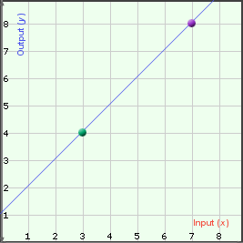

***x***

***y***

**(3, 4)**

* Coordinates – a set of numbers that names the location of a point.
  + In the two-dimensional coordinate plane, it takes two numbers (*x*, *y*) to specify a location.
  + The (*x*, *y*) coordinates of a point are called an *ordered pair*.
  + The coordinates of the point in the figure shown to the right are (3, 4).
* Distance formula – a formula that can be used to find the distance *d* between two points with coordinates (*x*1*, x*2) and (*y*1*, y*2).
  + The distance formula is *d* = .

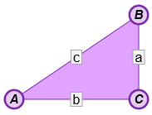

* Hypotenuse – the side of a right triangle opposite the right angle.
* Pythagorean Theorem – a theorem stating that, for any right triangle, *a*2 + *b*2 = *c*2, where *a* and *b* are the lengths of the legs of the triangle and *c* is the length of the hypotenuse.