Name: ______________________________________ Date: ________________________

Student Exploration: Distance-Time Graphs

Vocabulary: speed, y-intercept

Prior Knowledge Questions (Do these BEFORE using the Gizmo.)
Max ran 100 feet in 10 seconds. Molly ran 60 feet in 5 seconds.

- Who ran farther, Max or Molly? ________________

- Who ran faster? ________________ Explain: ____________________________________

_________________________________________________________________________

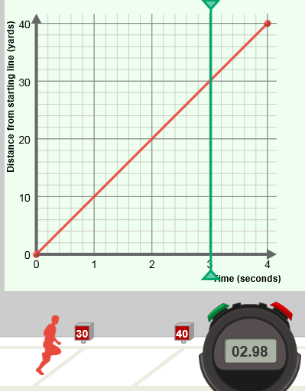
Gizmo Warm-up
The Distance-Time Graphs Gizmo shows a graph and a runner on a track. You can control the motion of the runner by manipulating the graph (drag the red dots).

Check that Number of points is 2, and that under Runner 1 both Show graph and Show animation are turned on.

The graph should look like the one shown to the right – one point at (0, 0) and the other point at (4, 40).

- Click the green Start button on the stopwatch.

What happens? _______________________________

____________________________________________

- Click the red Reset button on the stopwatch. The vertical green probe on the graph allows you to see a snapshot of the runner at any point in time. Drag it back and forth. As you do, watch the runner and the stopwatch.

  - What was the position of the runner at 1 second? ____________________________

  - What are the coordinates of the point on the graph that tells you this? ____________

  - When was the runner on the 30-yard line? _________________________________

  - What are the coordinates of the point on the graph that tells you this? ____________

Activity A:  Runner position | Get the Gizmo ready:  - Click the red Reset button on the stopwatch.  - Be sure the Number of points is 2. | 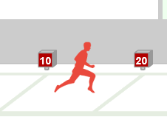

In the Gizmo, run the “race” many times with a variety of different graphs. (The red points on the graph can be dragged vertically.) Pay attention to what the graph tells you about the runner.

- If a distance-time graph contains the point (4, 15), what does that tell you about the runner? (Be specific, and answer in a complete sentence.) _________________________________
_________________________________________________________________________
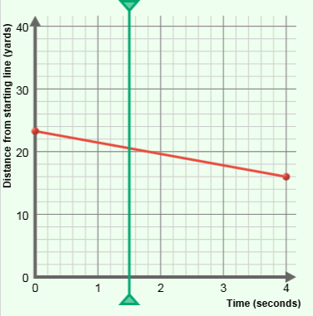

- Look at the graph to the right. Notice where the green probe is. If you could see the runner and the stopwatch at this moment, what would you see?

________________________________________________

________________________________________________

________________________________________________

- Look at the image below, from the Gizmo. What must be true about this runner’s graph?

_________________________________________________________________________

_________________________________________________________________________

- The point on the graph that lies on the y-axis (vertical axis) is called the y-intercept. What does the y-intercept tell you about the runner?

_________________________________________________________________________
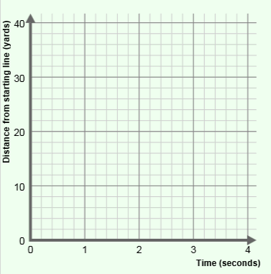

- In the Gizmo, set the Number of points to 3. Then create a graph of a runner who starts at the 20-yard line, runs to the 40-yard line, and finishes at the 30-yard line.

  - Sketch your graph to the right.

  - What is the y-intercept of your graph? ____________

Activity B:  Runner direction and speed | Get the Gizmo ready:  - Click the red Reset button on the stopwatch. | 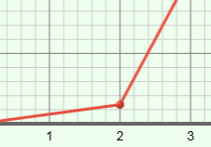

Run the Gizmo several times with different types of graphs. (Remember, the red points on the graph can be dragged vertically.) Pay attention to the speed and direction of the runner.

- Create a graph of a runner that is running forward (from left to right) in the Gizmo. Sketch your graph to the right.

If the runner is moving from left to right in the Gizmo, how does the graph always look?

__________________________________________________

__________________________________________________

- Click the red Reset button. Create a graph of a runner that is running from right to left. Sketch it to the right.

How does the graph always look if the runner is moving from right to left in the Gizmo?

__________________________________________________

__________________________________________________

- Change the Number of points to 5. Create a graph of a runner that runs left-to-right for one second, rests for two seconds, and then continues running in the same direction. Sketch the graph to the right.

How does a graph show a runner at rest? ________________

__________________________________________________

- In general, how does a distance-time graph show you which direction the runner is moving?

_________________________________________________________________________

_________________________________________________________________________

_________________________________________________________________________

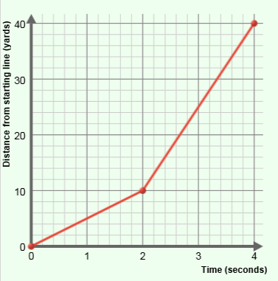
(Activity B continued on next page)
Activity B (continued from previous page)

- With Number of points set to 3, create the graph shown at right. Your graph should include (0, 0), (2, 10), and (4, 40).

- Where does the runner start? ____________________

- Where will he be after 2 seconds? ________________

- Where will he be after 4 seconds? ________________

- In which time interval do you think the runner will be moving most quickly? (Circle your answer below.)

0 to 2 seconds 2 to 4 seconds

- Click the Start button and watch the animation. What about the runner changed after 2 seconds of running? ________________________________________________________
_________________________________________________________________________

- Speed is a measure of how fast something is moving. To calculate speed, divide the distance by the time. In the Gizmo, the units of speed are yards per second (y/s).

  - In the first 2 seconds, how far did the runner go? ____________________________

  - In this time interval, how far did the runner go each second? ___________________

  - In this time interval, what was the runner’s speed? ___________________________

- Now look at the last two seconds represented on the graph.

- In the last 2 seconds, how far did the runner go? ____________________________

- In this time interval, how far did the runner go each second? ___________________

- In this time interval, what was the runner’s speed? ___________________________

- Click the Reset button. Experiment with a variety of graphs, focusing on the speed of the runner. In general, how can you estimate the speed of the runner by looking at a graph?

_________________________________________________________________________

_________________________________________________________________________

_________________________________________________________________________

Activity C:  Two runners, two graphs | Get the Gizmo ready:  - Click Reset.  - Under Runner 2, turn on Show graph and Show animation. | 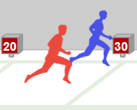

- Experiment with the Gizmo to create each of the following results. (You can use any number of points in your graphs.) Each time you find a solution, click the camera () next to the graph. Right-click the image, and click Copy. Then paste the image into a blank document. Label all five images.
- Runner 1 wins the race.
- Runner 2 wins the race.
- Runner 2 catches up to and passes runner 1.
- Runner 2 is going in the opposite direction as runner 1.
- Each runner goes at a different speed, but both reach the finish line together.

- Based on your experiments, answer the following questions.

- How does the graph show if a runner gets a head start? ______________________

___________________________________________________________________

- How does the graph show which runner is faster? ___________________________

___________________________________________________________________

- How does the graph show which runner wins the race? _______________________

___________________________________________________________________

- How does the graph show a runner going back and forth? _____________________

___________________________________________________________________

- What does it mean when the two runners’ graphs cross? _____________________
___________________________________________________________________

- Challenge: For Runner 2, turn off Show graph. Click New to generate a new random graph that you can’t see for Runner 2. Click Start, and watch her run. Then try to adjust the graph for Runner 1 so that his movements match the movements of Runner 2.

Turn on Show graph to check each answer. (For a greater challenge, increase the Number of points before selecting New.)

(Activity C continued on next page)
Activity C (continued from previous page)

- Challenge: Use the Gizmo to model and solve the following word problems. Write the solutions in the spaces below. Sketch the graph you made to solve the question in the space to the right of each question.

    - A dog is chasing a cat towards a tree. The cat has a 10-yard lead and runs at a speed of 6 yards per second. The dog runs at a speed of 8 yards per second. The tree is 30 yards away from the dog’s starting position. Which animal will reach the tree first?

_____________________________________________

    - A police officer is chasing a purse-snatcher down a street. The thief starts 9 yards ahead of the officer and can run 20 yards in 4 seconds (5 y/s). The police officer can run 32 yards in 4 seconds (8 y/s). How long will it take the officer to catch the thief?

_____________________________________________

    - In a football game, one team kicks off to the other. At the moment the receiver catches the ball, he is 40 yards from the nearest tackler. The receiver runs left to right at a speed of 10 yards per second (10 y/s). The tackler runs right to left at a speed of 6 yards per second.

How long does it take before they collide? ___________

How far does the receiver go? _____________________

    - A tortoise challenges a hare to a four-hour race. The hare is so confident of winning that he allows the tortoise to start with a 10-mile lead. The hare runs at a speed of 14 miles per hour, but stops for a two-hour nap in the middle of the race. The tortoise plods along at 4 miles per hour the whole race. Who gets farther in four hours?

_____________________________________________

- How are distance-time graphs useful? Explain, and if possible discuss your answer with your teacher and classmates.

_________________________________________________________________________

_________________________________________________________________________

_________________________________________________________________________

