Name: ______________________________________ Date: ________________________

Student Exploration: Distance-Time and Velocity-Time Graphs

[NOTE TO TEACHERS AND STUDENTS: This lesson was designed as a follow-up to the Distance-Time Graphs Gizmo. We recommend you complete that activity before this one.]
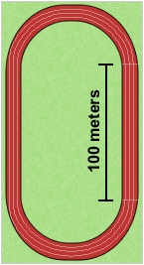

Vocabulary: displacement, distance traveled, slope, speed, velocity

Prior Knowledge Questions (Do these BEFORE using the Gizmo.)
Dora runs one lap around the track, finishing where she started. Clark runs a 100-meter dash along the straight side of the track.

- Which runner traveled a greater distance? __________________

- Which runner had a greater change in position, start to finish?

____________________________________________________

Gizmo Warm-up
The Distance-Time Graphs Gizmo shows a dynamic graph of the position of a runner over time. The Distance-Time and Velocity-Time Graphs Gizmo includes that same graph and adds two new ones: a velocity vs. time graph and a distance traveled vs. time graph.

The graph shown below (and in the Gizmo) shows a runner’s position (or distance from the starting line) over time. This is most commonly called a position-time graph.
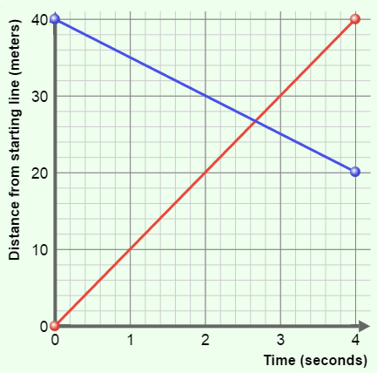

Check that the Number of Points is 2. Turn on Show graph and Show animation for both Runner 1 and Runner 2.

- Drag the points to create the graph shown to the right.
  - Runner 1’s line (the red one) should have endpoints at (0, 0) and (4, 40).
  - Runner 2’s line (the blue one) should have endpoints at (0, 40) and (4, 20).

- Click the green Start button on the stopwatch. Watch the two runners carefully. In what two ways are the runners’ motions different? _________________________________________
_________________________________________________________________________

_________________________________________________________________________

Activity A:  Velocity-time graphs | Get the Gizmo ready:  - Click the red Reset button on the stopwatch.  - Change the Number of Points to 5.  - Turn off Show graph and Show animation for Runner 2. | 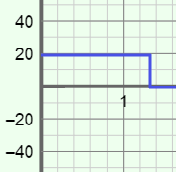

Speed is a measure of how fast an object moves, regardless of direction. Speed can never be negative. Velocity describes both speed and direction, and can be positive or negative.
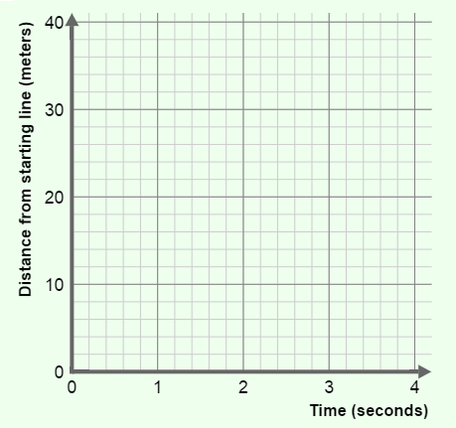

- In the Gizmo, make a position-time graph for Runner 1 with the following features:
- There is at least one major change in speed.
- There is at least one major change in direction.

Click the green Start button and watch the runner run. Adjust your graph if needed to meet the requirements.

Sketch your graph to the right.

- Where was the runner each second? Based on your graph, fill in all except the final column in the table below. (Leave the velocity column blank for now.) Label any numbers with units.

Time | Position at end of time interval (m) | Distance moved this time interval (m) | To the left or right? | Velocity this time interval (m/s)
0 – 1 sec
1 – 2 sec
2 – 3 sec
3 – 4 sec

- To calculate the velocity for each time interval, first calculate the speed of the runner in that interval (speed = distance ÷ time). If the direction is left to right, velocity is positive. If the direction is right to left, velocity is negative.

Fill in the velocity column of the table above. Use units (m/s).

When this runner is running to the left (negative velocity), what does his position-time graph look like?

_________________________________________________________________________

_________________________________________________________________________

(Activity A continued on next page)
Activity A (continued from previous page)

- Slope is the steepness of a graph. To find the slope of a line, divide the change in y-value (rise) by the change in x-value (run). Like velocity, slope can be positive, zero, or negative.

Fill in the slope of each segment of your position-time graph, along with the runner’s velocity during each time interval, in the table below.

Time interval | Slope | Velocity (m/s)
0 sec – 1 sec
1 sec – 2 sec
2 sec – 3 sec
3 sec – 4 sec

- Examine your velocities and the position-time graph you made. How is the slope of a position-time graph related to the velocity of the runner? ____________________________
_________________________________________________________________________

- On the left side of the Gizmo, select the VELOCITY-TIME GRAPH tab. Use the green probes to compare the velocity-time graph to the position-time graph.

- How does a velocity-time graph show that a runner is moving fast? ______________

___________________________________________________________________

___________________________________________________________________

- How does a velocity-time graph show that a runner is moving from left to right?

___________________________________________________________________

___________________________________________________________________
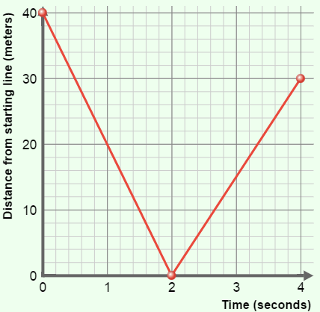
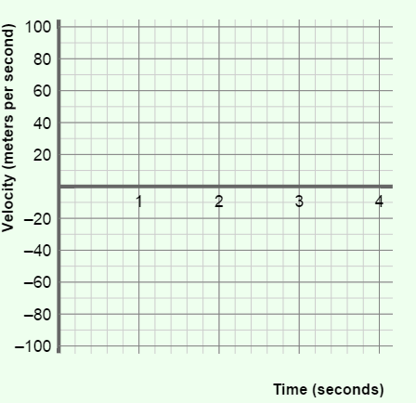

- To the right is a position-time graph of a runner.

First, sketch what you think his velocity-time graph will look like on the blank axes at the far right.

Then check your answer in the Gizmo.

Activity B:  Velocity and position | Get the Gizmo ready:  - Set the Number of Points to 3.  - Turn on Show graph and Show animation for both Runner 1 and Runner 2. | 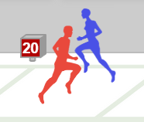

- In the Gizmo, make the position-time graphs shown below. Click the green Start button and watch the runners run. Sketch what you think their velocity-time graphs look like on the second set of axes. (If you can, use a red line for runner 1, and a blue line for runner 2.)

Then select the VELOCITY-TIME GRAPH tab in the Gizmo. Sketch the actual graph on the third set of axes below.
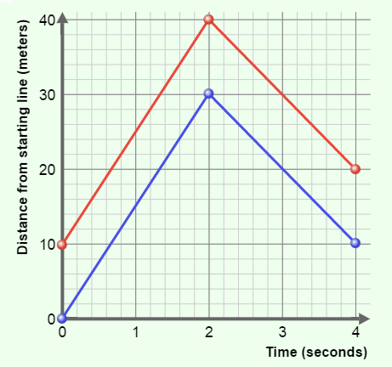

Position-time graph Velocity-time (predicted) Velocity-time (actual)

- Make any position-time graphs you want for Runners 1 and 2. Sketch them below. Then do the same thing – sketch what you think their velocity-time graphs look like, and then check.

Position-time graph Velocity-time (predicted) Velocity-time (actual)

- Compare the velocity-time graphs to their related position-time graphs.

    - When do two different position-time graphs have matching velocity-time graphs?

___________________________________________________________________

    - What information is missing from a velocity-time graph? ______________________

___________________________________________________________________

Activity C:  Distance and displacement | Get the Gizmo ready:  - Turn off Show graph and Show animation for Runner 2. | 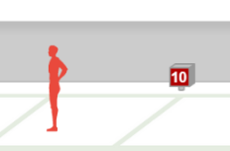
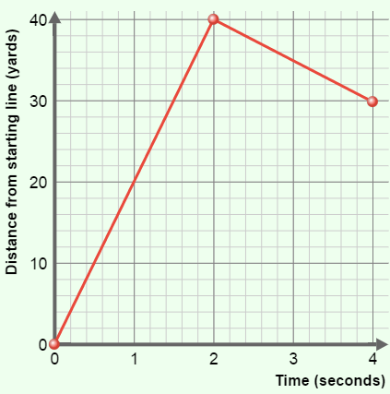
- Create the position-time graph for Runner 1 shown at right. Then fill in the blanks below to describe what you think the runner will do, based on that graph.

The runner will run _________ meters in the first 2 seconds, with a velocity of _________ m/s. His direction will be from ______________ to ______________.
Then he will run ________ meters in the next 2 seconds, with a velocity of _________ m/s. His direction will be from ______________ to ______________.
Click the green Start button and watch the runner go. Were you correct? _______________

- Two students, Gina and Walter, are discussing the runner whose graph is shown above.
- Gina says the runner moved more than 40 meters.
- Walter says the runner moved less than 40 meters.

- Who do you think is right? _______________________

- Explain your answer. __________________________________________________
___________________________________________________________________
___________________________________________________________________
___________________________________________________________________

- On top of the left half of the Gizmo, select the DISTANCE TRAVELED tab.

- What was the total distance traveled by the runner after 4 seconds? ____________

- Displacement is equal to the difference between the starting and ending positions. Displacement to the right is positive while displacement to the left is negative.

What is the displacement shown by the graph at the top of the page? ____________

(Activity C continued on next page)
Activity C (continued from previous page)
- In the Gizmo, create a position-time graph of a runner with these characteristics:
- travels a distance of 60 meters in 4 seconds
- has a displacement of +10 meters

Sketch your graph on the blank axes to the right.

- Look at the graph you made in question 4. Think about the speed of that runner.

- What was the runner’s speed for the first 2 seconds? ___________________

- What was the runner’s speed for the last 2 seconds? ___________________

- What was the runner’s average speed over all 4 seconds? ___________________

- Now think about the velocity of the runner in question 4.

- What was the runner’s velocity for the first 2 seconds? ___________________

- What was the runner’s velocity for the last 2 seconds? ___________________

- What was the runner’s average velocity over all 4 seconds? ___________________

- Suppose you knew the time, displacement, and total distance traveled for a runner.

- How would you calculate the runner’s average speed? _______________________

___________________________________________________________________

- How would you calculate the runner’s average velocity? ______________________

___________________________________________________________________

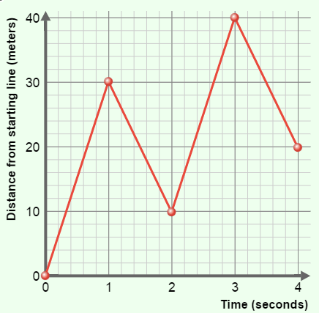
- To the right is a graph of a runner. Calculate the values below for this runner. Include appropriate units.

- Distance traveled: _______________________

- Displacement: __________________________

- Average speed: _________________________

- Average velocity: ________________________

