Name: Date:

**Student Exploration:** **Dividing Fractions**

**Vocabulary:** divisor, dividend, fraction, quotient, reciprocal, simplify

**Prior Knowledge Questions** (Do these BEFORE using the Gizmo.)

1. Kyle has two 6-foot long boards. He cuts one of the boards into 2-foot pieces.
   1. How many pieces does he cut?
   2. A **fraction** is the relationship between a part and a whole. What fraction of this board is each 2-foot piece?
2. He cuts the other 6-foot board into -foot pieces. How many pieces does he make?

**Gizmo Warm-up**

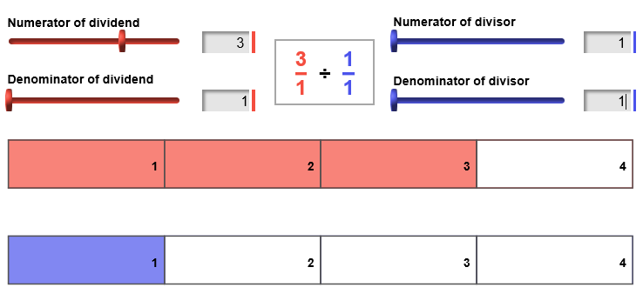In the *Dividing Fractions* Gizmo, you use area models to divide two fractions. The red model represents the **dividend**. The blue model represents the **divisor**.

The numerators and denominators can be changed by dragging the sliders. (Or, click in the text field next to a slider, type a number, and hit **Enter**.)

1. Set the dividend to  and the divisor to  to model  ÷ , or 3 ÷ 1, as shown above.
2. How many 1’s (blue areas) does it take to make 3 (the red area)?
3. What is 3 ÷ 1?
4. Turn on **Show ruler**. Drag the **Divisions per unit** slider to 1 so each unit on the ruler is the same length as each unit in the divisor. Then use the ruler to measure the dividend.
5. Change the divisor to . Look at the ruler. It shows the number of ’s in one 3. How many one-halves (blue areas) does it take to make 3 (the red area)?
6. What is 3 ÷ ?

|  |  |  |
| --- | --- | --- |
| **Activity A:**  **Finding the quotient** | Get the Gizmo ready:   * Turn off **Show ruler**. | 212SE2 |

1. With the dividend set to , set the divisor to . This models the expression 3 ÷ .
2. How many ’s does it take to make 3?
3. What is 3 ÷ ?
4. What do you think 3 ÷  equals? Why?

1. Model 3 ÷  in the Gizmo. Turn on **Show calculation**. Fill in the equation at the right to show the product that is equivalent to 3 ÷ .

•

=

1. Switching the numerator and denominator of a fraction gives you the **reciprocal**. How can you use a reciprocal to divide fractions?
2. Turn off **Show calculation**. Set the dividend to  and the divisor to 3.
3. What do you think  ÷ 3 equals? Why?

1. What product gives you this quotient? Check in the Gizmo.
2. You have now done division by a fraction less than one (3 ÷ ) and by a number greater than one ( ÷ 3). What do you notice about the quotients?

**(Activity A continued on next page)**

**Activity A (continued from previous page)**

1. Turn off **Show calculation**. Set the dividend to  and the divisor to .
2. What is  ÷ ? How do you know?

1. What product gives you this quotient? Check in the Gizmo.
2. Turn off **Show calculation**. Model the quotient  ÷ .
3. What would you estimate the quotient above to equal?

Why?

1. Turn on **Show ruler** and set **Divisions per unit** to 2. Then use the ruler to find the quotient. Fill in the equation below to show the quotient.

 ÷  = • =

1. Turn on **Show calculation**. Notice that the final answer is a mixed number. Explain how the mixed number is shown by the ruler.
2. Compare the denominator of the quotient and the divisions per unit on the ruler. What do you notice?
3. Find each quotient, written in simplest form and as a mixed number when possible. Write all your steps below each problem. Then check your answers in the Gizmo.
4.  ÷ 
5.  ÷ 

|  |  |  |
| --- | --- | --- |
| **Activity B:**  **Finding missing numbers** | Get the Gizmo ready:   * Turn on **Show ruler**. * Set **Divisions per unit** to 1. * Turn off **Show calculations**. | 212SE3 |



÷

= 2

4

1. The quotient of the two fractions shown in the equation at the right is 2. The numerator of the divisor is missing.
   1. In the Gizmo, model the equation above. Drag the **Numerator of divisor** slider until the quotient is 2. Fill in the equation above with the missing numerator.
   2. Turn on **Show calculation** to check your answer. How can you use a product to find the missing number?



÷

=



3

1. Turn off **Show calculation**. The quotient of the two fractions shown at the right is . The numerator of the dividend is missing.
   * 1. What is the quotient  written as an improper fraction?
     2. Be sure **Show ruler** is turned on. What will **Divisions per unit** need to be set to in order to model this quotient? Explain:
     3. In the Gizmo, model the equation to the right. Use the model to fill in the missing numbers in the equation. Then check your answer in the Gizmo.



÷

=

=



3

3

1. Fill in the blanks. Write all your steps below each problem. Then check in the Gizmo.

2

7

4

1.  ÷ = 
2. ÷  = 
3. ÷  = 