Name: Date:

**Student Exploration:** **Dividing Mixed Numbers**

**Vocabulary:** mixed number, quotient, reciprocal

**Prior Knowledge Questions** (Do these BEFORE using the Gizmo.)

1. Kara has 6 cups of flour. She uses 1 cups of flour for one batch of muffins. How many batches can she make from the flour she has? __________ Explain.
2. She finds 3 more cups of flour. How many more batches can she make? __________

**Gizmo Overview**

In the *Dividing Mixed Numbers* Gizmo™, you will divide **mixed numbers** (a whole number combined with a fraction), step-by-step. Here’s how the Gizmo looks at first:

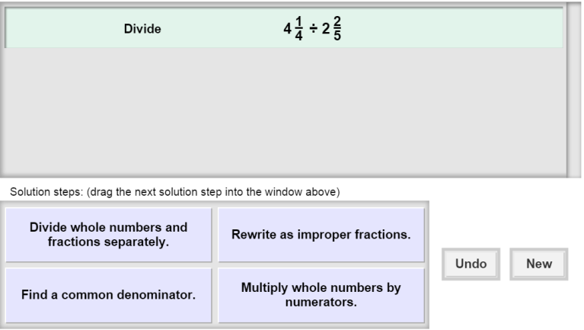The expression for you to divide is here.

The tiles give you four choices for the next step. Choose the one you think is correct and drag it into the white area above.

Click **New** to go to a different problem.

Click **Undo** to undo your last choice.

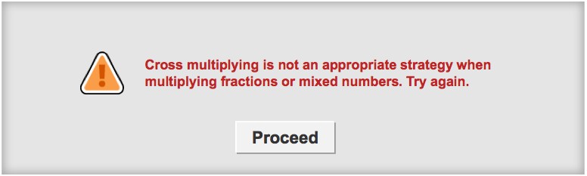

Read your feedback in the Gizmo. (No feedback is given for correct answers.)

Click **Proceed** to go to the next step.

Continue until you find the **quotient** (the result of division). Then click **New** for a new problem to work on.

|  |  |  |
| --- | --- | --- |
| **Activity:**  **Finding the quotient** | Get the Gizmo ready:   * You should see the expression  ÷ . If not, click **Refresh** in your browser. | 160SE3 |

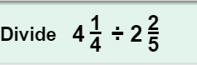

1. When you begin, you should see the expression shown to the right at the top of the Gizmo.
2. Choose the description that you think goes with the correct first step. If your choice is incorrect, read the given feedback and try again. What is the correct first step?

1. The expression shown should now be  ÷ . Do you need to find a common denominator to find the quotient of two fractions? ___________ Why or why not?

1. Dividing by a fraction is the same as multiplying by its **reciprocal** (fraction with the numerator and denominator flipped). What is the reciprocal of ?

 ÷  =

1. Continue to choose the correct steps until you get to the final answer. Fill in the equation at the right to show the quotient.

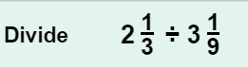

1. Click **New**. You should now see the expression shown at the right in the Gizmo.
2. What is the correct first step, in words?
3. Fill in the equation to show the improper fractions you are dividing. Then fill in the equivalent multiplication after the “flip and multiply” step.

÷

•

=

1. Fill in the equation at the right to show the quotient.  ÷  =
2. Click **New**. Work through more problems in the Gizmo. Be sure to read the feedback in the Gizmo along the way.

**(Activity continued on next page)**

**Activity (continued from previous page)**

1. Find each quotient below. Write all your steps in the space below each problem.
2.  ÷ 
3.  ÷ 
4. 6 ÷ 
5.  ÷ 