Name: ______________________________________ Date: ________________________

Student Exploration: Effect of Environment on New Life Form

Vocabulary: controlled experiment, hypothesis, variable

Prior Knowledge Question (Do this BEFORE using the Gizmo.)
Johnny likes to watch the birds that visit his birdfeeder. His favorite bird is the cardinal. How could Johnny determine which kind of birdseed cardinals prefer? Explain your answer in detail.

____________________________________________________________________________

____________________________________________________________________________

____________________________________________________________________________

____________________________________________________________________________

Gizmo Warm-up
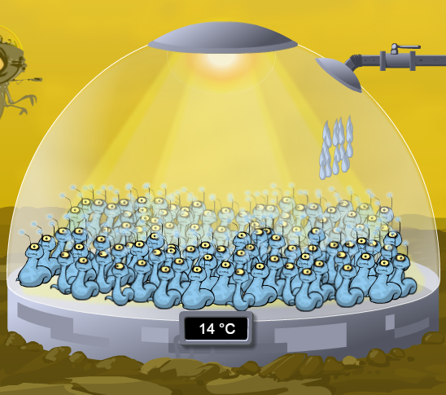
Imagine a new alien life form has just been discovered on a nearby planet. Your job is to study this new life form. The Effect of Environment on New Life Form Gizmo shows 100 individuals that have been transported from the planet to your laboratory.

- The new life form can have three shapes: thin, medium, and thick. How many of each shape are there now?

Thin: _______ Medium: _______ Thick: _______

- Click Play (). Do the numbers of each type of alien change over time? ______________

- Click Reset (). A variable is something that can be changed in an experiment. Look on the SIMULATION pane. What are the three variables you can change in your laboratory?

_________________________________________________________________________

- Which of these variables do you think will have the greatest effect on the aliens? Explain.

_________________________________________________________________________

_________________________________________________________________________

Activity:  Controlling variables | Get the Gizmo ready:  - Click Reset.  - Select the BAR CHART tab.  - Turn on Show numerical values. | 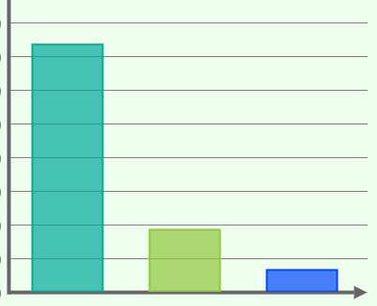

Question: What variables control the shape of the alien life forms?

- Record: Record the starting numbers of thin, medium, and thick aliens:

Thin: _______ Medium: _______ Thick: _______

- Observe: Change the Light to 0 hours/day, the Water to 1 drops/hr, and the Temp. to
0 °C. Click Play, and observe the aliens until the numbers are stable. Click Pause.

    - How many of each type of alien are there now?

Thin: _______ Medium: _______ Thick: _______

    - Click Reset. Change the Light to 24 hours/day, the Water to 20 drops/hr, and the Temp. to 30 °C. Click Play. How many of each type of alien are there now?

Thin: _______ Medium: _______ Thick: _______

- Analyze: From the observations you made above, can you state exactly why the aliens changed their shape? Why or why not?

_________________________________________________________________________

_________________________________________________________________________

_________________________________________________________________________

_________________________________________________________________________

- Form a hypothesis: A hypothesis is a proposed explanation for an observation. Hypotheses must be testable. Write a hypothesis about what causes the aliens to change their shape.

_________________________________________________________________________

_________________________________________________________________________

_________________________________________________________________________

_________________________________________________________________________

(Activity continued on next page)
Activity (continued from previous page)

- Design an experiment: A controlled experiment is an experiment in which only one variable is changed at a time.

Describe a controlled experiment you could use to test your hypothesis. ________________

_________________________________________________________________________

_________________________________________________________________________

- Run the Gizmo: Run a controlled experiment to test your hypothesis. Describe the results of your experiment below.

_________________________________________________________________________

_________________________________________________________________________

- Run the Gizmo: Run controlled experiments to determine the effect of each variable.

    - How does changing the amount of light affect the aliens? _____________________

___________________________________________________________________

    - How does changing the amount of water affect the aliens? ____________________

___________________________________________________________________

    - How does changing the temperature affect the aliens? ________________________

___________________________________________________________________

- Draw conclusions: Which variable or variables affected the aliens? ____________________

_________________________________________________________________________

- Think and discuss: Why is it important to only change one variable at a time? If possible, discuss your answer with your classmates and teacher.

_________________________________________________________________________

_________________________________________________________________________

_________________________________________________________________________

_________________________________________________________________________

