Vocabulary: Element Builder

Vocabulary
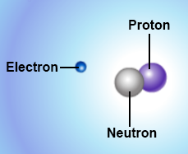

- Atom – the basic unit of matter.
  - An atom is the smallest particle of an element that still has all the properties of the element.
  - Atoms are made up of smaller particles called protons, neutrons, and electrons. The smaller electrons orbit around a central nucleus of protons and neutrons.

- Atomic number – the number of protons in the nucleus of an atom.
  - Elements are distinguished from one another by their atomic numbers.

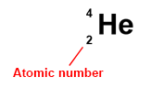
  - For example, any atom with two protons is an atom of helium.
  - The symbol for the atomic number is Z.
  - In an element symbol, the atomic number is shown at lower left.

- Electron – a negatively charged particle that moves around the nucleus.
  - The mass of an electron is less than one thousandth of the mass of a proton.

- Electron dot diagram – a diagram that shows the element symbol surrounded by dots representing valence electrons.
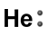
  - For example, the electron dot diagram at right shows that neutral helium atoms have two valence electrons.

- Element – a pure substance that cannot be broken down into simpler substances by ordinary chemical means.
  - Elements are made of one type of atom.
  - Atoms of different elements are distinguished by the number of protons in the nucleus. For example, all carbon atoms have 6 protons.

- Energy level – a particular region where electrons can orbit a nucleus.

- Ion – an atom or molecule that has an electrical charge because it has gained or lost electrons.

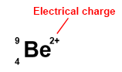
  - An atom with more protons than electrons is a positively charged ion, or cation.
  - An atom with more electrons than protons is a negatively charged ion, or anion.
  - In an element symbol, the electric charge is shown at upper right.
- Isotope – one of several forms of the same element.
  - All isotopes of a given element have the same number of protons, but differ in the number of neutrons.
  - Most isotopes are radioactive. Usually only one or two stable isotopes exist for a given element.

- Mass number – the number of protons plus neutrons in the nucleus of an atom.
  - For example, the mass number of helium is 4 (2 protons and 2 neutrons).
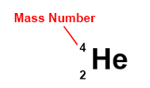
  - The symbol for the mass number is A.
  - In an element symbol, the mass number is shown at upper left.

- Neutron – a particle with no charge located in the nucleus of an atom.
  - Neutrons have slightly more mass than protons.
  - The number of neutrons is described by the neutron number, N.
  - To find the number of neutrons, subtract the atomic number from the mass number.

- Nucleus – the positively charged, dense center of an atom.
  - The nucleus contains protons and neutrons.

- Periodic table – a chart that organizes the chemical elements based on their properties.

- Proton – a positively charged particle located in the nucleus of an atom.
  - Protons have slightly less mass than neutrons.
  - The number of protons determines the element.

- Radioactive – capable of releasing radiation.
  - In a radioactive atom, the nucleus can spontaneously decay and emit particles and/or light. These emissions are called radiation.
  - The energy released by radioactive substances can be harnessed to produce electricity in a nuclear power plant. This energy also can be used to create a massive explosion in a nuclear bomb.
  - If the emissions change the number of protons in the nucleus, the atom becomes a different element.

- Valence electrons – electrons found in the outermost energy level of an atom.

