Name: Date:

Student Exploration: Elevator Operator

Vocabulary: coordinates, horizontal axis, line graph, slope, vertical axis

Prior Knowledge Questions (Do these BEFORE using the Gizmo.)

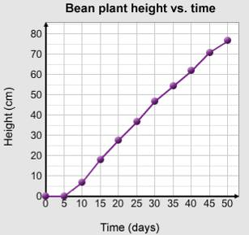
Line graphs are often used to show how a value changes over time. For example, the line graph below shows the height of a bean plant over time.

- The horizontal axis is the number line at the bottom of this graph, running left-to-right. What does it measure?

__________________________________________

- The vertical axis is the number line on the left of this graph, running up-and-down. What does it measure?

__________________________________________

- According to the graph, how tall was the bean plant on day 40? ______________________

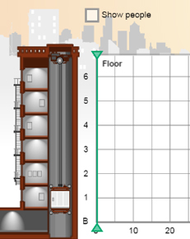
Gizmo Warm-up
The questions above used a line graph about the height of a bean plant. In the Elevator Operator Gizmo, you will operate an elevator in an old apartment building in New York City. A line graph will show where your elevator goes, over time.

- Click the up button ( ) to start the elevator, and then click Pause. How does the graph look as the elevator is rising?

______________________________________________

- Click Continue, and then click the stop button ( ). After a few seconds, click down ( ). Watch the graph being drawn in the Gizmo, as the elevator moves.

  - How does the graph look while the elevator is stopped? _______________________

  - How does the graph look while the elevator is going down?

___________________________________________________________________

Activity A:  Locating the elevator | Get the Gizmo ready:  - Make sure you are in Drive mode.  - Click Reset. | 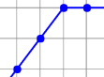

For your first day of work, your supervisor wants you to keep a detailed record of where you go in the elevator, and when. You can make a line graph to show this information.

- Click the up, down, and stop buttons until 100 seconds have passed. Draw the graph here.
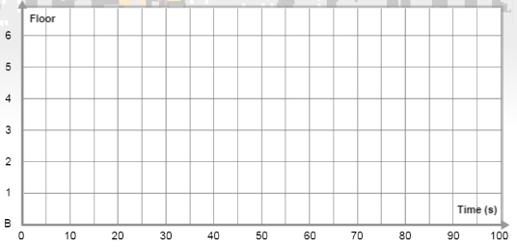
  - What floor was the elevator on after 10 seconds? ____________
  - What floor was the elevator on after 50 seconds? ____________
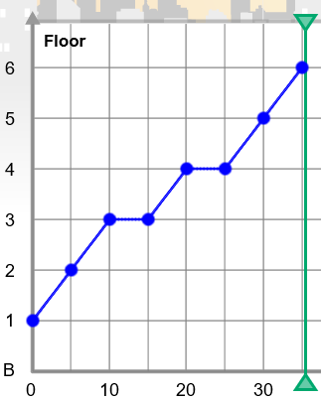
A
B
C
D
Time (s)
- The coordinates of a point describe the point’s location. For example, the coordinates of point A on this graph are (10, 3). This means: after 10 seconds, the elevator was on the 3rd floor.

List the coordinates of the other 3 points.

Point B: (___, ___) Point C: (___, ___) Point D: (___, ___)

What do the coordinates of point B tell you about the elevator?

__________________________________________________

_________________________________________________________________________

- Click Reset. Create a graph for 100 seconds in which the elevator visits every floor at least once. Draw the graph here.

  - Pick four points on your graph, and label them A, B, C, and D.

  - List the coordinates of each point:

Point A: (____, ____)

Point B: (____, ____) Point C: (____, ____) Point D: (____, ____)

  - Explain what the graph tells you about how the elevator moved. ________________

___________________________________________________________________

___________________________________________________________________

Activity B:  Morning passengers | Get the Gizmo ready:  - Make sure you are in Drive mode.  - Click Reset.  - Turn on Show people, and select Morning.

Every morning, the residents of 1064 Columbus Ave. have the same schedule. For example, Mr. McCready on the 3rd floor always goes to the first floor to get the morning paper.

- Use the elevator buttons to pick up Mr. McCready (the orange man) on the 3rd floor, and drop him off on the 1st floor. (Hint: Click the stop button ( ) to open the elevator doors.)

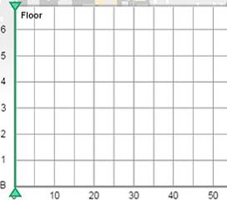
Sketch this graph to the right. (To see the elevator motion again, click Replay or drag the vertical gray time probe.)

  - On your sketch, label the following points:
  - McCready gets in (“M in”).
  - McCready gets out (“M out”).

  - What are the coordinates of “M in”? (____, ____)

  - What are the coordinates of “M out? (____, ____)

The other residents also keep a regular schedule. Henry Choi one the 2nd floor goes to the 6th floor to babysit his two nieces. Mrs. Spinelli on the 5th floor brings her laundry to the basement.

- Click Reset. Use the elevator buttons to pick up and drop off Mr. McCready (orange), Henry Choi (green), and Mrs. Spinelli (purple) where they want to go. Sketch the graph below.
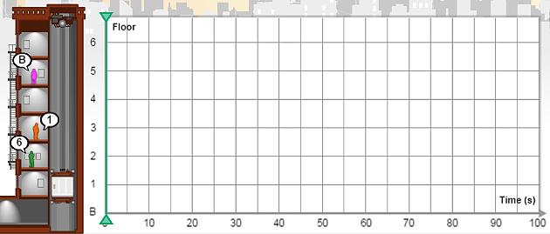

- Drag the vertical time probe back and forth along the graph. On your sketch above, label the following points. Then write the coordinates of each point below.

- McCready gets in (“M in”): (____, ____)
- Henry gets in (“H in”): (____, ____)
- Spinelli gets in (“S in”): (____, ____)
- McCready gets out (“M out”): (____, ___)
- Henry gets out (“H out”): (____, ___)
- Spinelli gets out (“S out”): (____, ___)

Activity C:  Automatic elevator | Get the Gizmo ready:  - Click Reset. Turn off Show people.  - Switch from Drive mode to Program mode.

The residents of 1064 Columbus Ave. have such regular schedules that you decide to program the elevator to pick them up and drop them off.

- First, you need to practice programming the elevator. In Program mode, create a path by dragging blue segments to the graph. Press Play ( ) and watch the elevator go.

- Click Reset ( ) and Clear. Create a path using at least one of each segment. Press Play and watch the motion. In each blank box, sketch the segment that goes with the description.

  - Elevator going up quickly.

  - Elevator going up slowly.

  - Elevator going down quickly.
  - Elevator going down slowly.

  - Elevator stopping for 5 seconds.

  - Elevator stopping for 10 seconds.

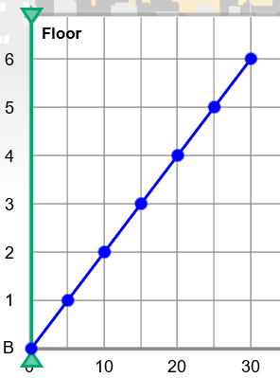
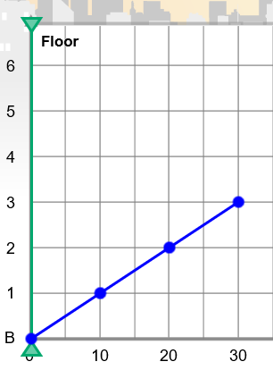
A
B
- The slope of a line is how steep it is. Compare these graphs and answer the questions below.

- Which graph has a steeper slope? ________

- Fill in: Graph A shows an elevator that traveled _______ floors in _______ seconds.
- Fill in: Graph B shows an elevator that traveled _______ floors in _______ seconds.
- Explain why a steeper slope means a faster elevator. ________________________

___________________________________________________________________

___________________________________________________________________

- Click Reset and Clear. Select Show people, and Evening.

Program the elevator to take Mr. McCready, Henry Choi, and Mrs. Spinelli back to their apartments in the evening.

After you succeed, sketch the graph to the right.

