Vocabulary: Ellipses

dictionary2

**Vocabulary**

**Ellipse**

* Conic section – a curve formed by the intersection of a plane and one or two right circular cones.
* For example, the intersection of the plane and the cone shown to the right is an ellipse.
* Ellipse – the set of all points in a plane for which the sum of the distances from two fixed points, the foci, is constant.

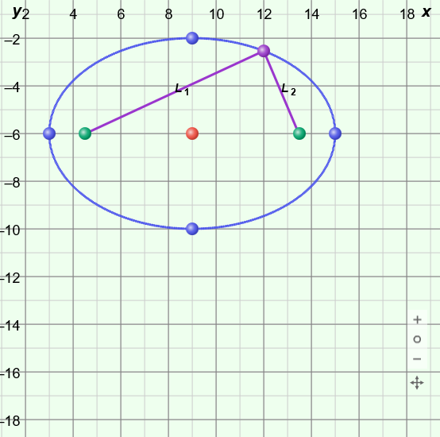

**2*a***

**2*b***

* For all (*x*, *y*) points on the ellipse to the right,   
  *L*1 + *L*2 = 2*a*, where *a* is the distance from the center to one of the major axis vertices.
* Foci of an ellipse (focus points) – the two fixed points, located on the major axis, that define the ellipse.
  + The sum of the distances from these two points to any point on the ellipse is constant and equal to 2*a*.
* Major axis – the line segment through the two foci with endpoints on the ellipse.
  + The length of the major axis is 2*a* units.
* Minor axis – the line segment through the center of the ellipse, perpendicular to the major axis, with endpoints on the ellipse.
* The length of the minor axis is 2*b* units.

***a***

***c***

***b***

* Pythagorean Theorem – a theorem stating that, for any right triangle, *a*2 + *b*2 = *c*2, where *a* and *b* are the lengths of the legs of the triangle and *c* is the length of the hypotenuse.
* Standard form of the equation of an ellipse – the equation representing a set of points in the coordinate plane for which the sum of the distances from two fixed points, the foci, is constant.
  + If the major axis is horizontal, standard form is  +  = 1.
  + If the major axis is vertical, standard form is  +  = 1.
  + In either case, the point (*h*, *k*) is the center of the ellipse, 2*a* is the length of the major axis, and 2*b* is the length of the minor axis.
* Vertices of an ellipse – the endpoints of the major and minor axes, located on the ellipse.