Vocabulary: Energy of a Pendulum

Vocabulary

- Conservation of energy – the principle that the total energy in a closed system remains constant.

- Gravitational potential energy – potential energy that depends on an object’s position within a gravitational field such as that exerted by Earth.
  - Gravitational potential energy is represented by several symbols: GPE, PE, or U.
  - On Earth, an object’s gravitational potential energy depends on the object’s weight and height above Earth’s surface.
  - The formula for gravitational potential energy is GPE = wh or GPE = mgh.
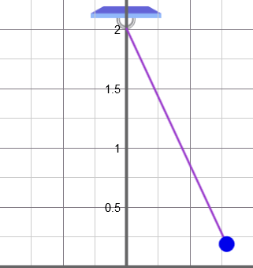

Pendulum

- Kinetic energy – energy of motion.
  - Kinetic energy is represented by the symbol KE or simply K.
  - The formula for kinetic energy is KE = mv² ÷ 2.

- Pendulum – a weight that can swing freely.

- Potential energy – the energy an object has because of its position or shape.
  - Potential energy that is dependent on an object’s position above earth is known as gravitational potential energy.
  - Potential energy that is dependent on an object’s shape (such as a stretched rubber band) is known as elastic potential energy.

- Velocity – the speed and direction of a moving object.
  - The velocity of an object can be described by a vector.

