Name: Date:

**Student Exploration:** **Equivalent Fractions**

**Vocabulary:** denominator, equivalent, fraction, numerator, simplify, unit fraction, whole

**Prior Knowledge Questions** (Do these BEFORE using the Gizmo.)

1. Suppose you are in the tile business. You have to lay three rows of tiles in the area shown to the right. Here is what your customer wants: (Sketch how you would do this to the right.)

* Top row: 2 equal-sized tiles (1 black and 1 white)
* Middle row: 3 equal-sized tiles (1 black and 2 white)
* Bottom row: 4 equal-sized tiles (2 black and 2 white)

1. How much of each row is black?
2. Top row: _____________________________________
3. Middle row: ___________________________________
4. Bottom row: ___________________________________

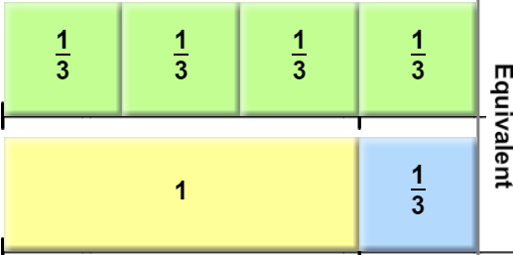

**Gizmo Warm-up**

1. Based on the tiles shown in the *Equivalent Fractions* Gizmo™, how many  tiles make a **whole**? (Hint: a whole is 1.) ______
2. Click the **Clear** button to clear the tiles. Use the up and down arrows to set both the **numerator** (top number) and **denominator** (bottom number) of the fraction to 1. Choose a color and click **Make Tile** to make a fraction tile. Drag your tile to the top line.

What is the size of the tile you made? ______________

1. Make 4 tiles that are the same size that you can put on the bottom row to make the top and bottom **equivalent** (equal) again. What **fraction** did you use to make your tiles? _________
2. Make 4 different tiles that are each equivalent to one whole. What fractions did you use?

_________________________________________________________________________

|  |  |  |
| --- | --- | --- |
| **Activity A:**  **Fraction basics** | Get the Gizmo ready:   * Click **Clear**. | 1012SE2 |

The tile-making tool at the bottom left corner of the Gizmo is called the Fractionator. Tiler Tim uses it to make his tiles. He sets the sizes of his tiles by entering a fraction. The cheapest tiles to make are **unit fractions**, which are fractions with a numerator of 1.

1. Make 5 different unit fraction tiles. Put them on the top bar in order from least to greatest.
2. List your unit fractions in order: __________________________________________
3. How does increasing the denominator of a fraction affect its size? _______________

___________________________________________________________________

1. What are the largest and smallest unit fraction tiles that the Fractionator can make?

Largest unit fraction: ________ Smallest unit fraction: ________

1. Name a unit fraction smaller than any the Fractionator can make. ________
2. One day the denominator on the Fractionator got stuck on 5 and Tiler Tim could only make tiles with denominator 5. Make five different tiles (all different sizes) using fractions with denominator 5. Put them on the bottom bar in order from least to greatest.
3. List your fractions in order: _____________________________________________
4. How does increasing the numerator of a fraction affect its size? ________________

___________________________________________________________________

1. 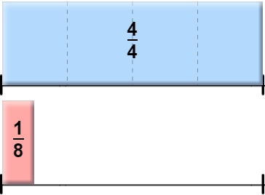Tiler Tim needs to finish tiling the bottom row on the right. He needs the total on the bottom to be equivalent to the whole on top. Set up the tiles in the Fractionator as shown.
2. First, finish tiling the bottom row with only unit fraction tiles. What fractions did you use?

_________________________________________

1. Challenge: Set the Fractionator to look like the picture above. This time add exactly *three* unit fraction tiles to complete the bottom row, for a total of four tiles.

What three unit fractions did you use? ____________________________________

|  |  |  |
| --- | --- | --- |
| **Activity B:**  **Equivalent fractions** | Get the Gizmo ready:   * Click **Clear**. | 1012SE4 |

1. Tiler Tim has an order for a lot of  tiles, but the Fractionator is acting up again and he can’t get the denominator set to 2.
   1. What are all the fractions Tim could use to make tiles equivalent to ? (Remember, the denominator can’t be 2.) ____________________________________________
   2. What do all the denominators of the fractions equivalent to  have in common?

___________________________________________________________________

* 1. Which denominators in the Fractionator *can’t* be used to make tiles equivalent to ?

___________________________________________________________________

* 1. Name a fraction equivalent to  that does not fit in the Fractionator. _____________

1. Help! The Fractionator is broken again! Now the denominator can’t be set to 6. Tiler Tim needs to finish tiling the bottom row shown below. Use 4 tiles that are equivalent to each of his 4 tiles shown. (They should line up perfectly.) Draw your tiles in, and label them.

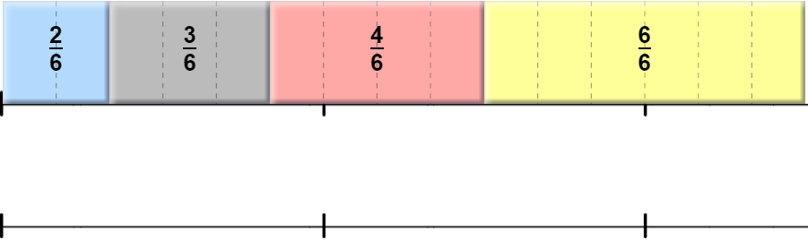

1. Without using the Fractionator, find a fraction that is equivalent to .
   1. What fraction did you find? ________
   2. Describe your method for finding the fraction: _______________________________

___________________________________________________________________

|  |  |  |
| --- | --- | --- |
| **Activity C:**  **Simplifying fractions** | Get the Gizmo ready:   * Click **Clear**. | 1012SE6 |

Tiler Tim wants to **simplify** the fractions he uses to make tiles. This will save him some money.

1. In the Gizmo, find two fractions that are equivalent to .
   1. What fractions did you use? ________ ________
   2. Which one of these three fractions do you think is “simplest” and why?

___________________________________________________________________

1. How can you tell if a fraction is as simple as possible? ________________________

___________________________________________________________________

1. How would you find a simpler form of the fraction ? ______________________________

_________________________________________________________________________

1. Click **Clear**. Set up the top row in the Gizmo as shown. Now help Tim tile the bottom row using the simplest form of each fraction on the top row. Sketch your answer below.

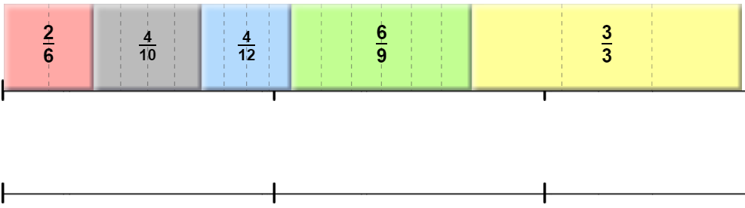

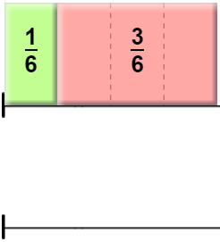

1. Click **Clear**. Set up the top row in the Gizmo as shown. Now help Tim tile the bottom row on the right so that it is equivalent to the top.

1. Describe one way to finish the tiling with only unit fraction tiles.

___________________________________________________

1. Describe how to finish the job with only one tile (in simplest form). Sketch and label in the diagram above.

___________________________________________________________________