Name: Date:

Student Exploration: Erosion Rates

[Note to teachers and students: This lesson was designed as a follow-up to the Weathering and River Erosion lessons. We recommend doing those activities before trying this one.]

Vocabulary: climate, erosion, precipitation, sandstone, shale, vegetation, valley, weathering

Prior Knowledge Questions (Do these BEFORE using the Gizmo.)

- Erosion is the removal and movement of soil, rocks, and other materials from one place to another on Earth’s surface. What are some forces that might cause erosion to occur?

- How quickly erosion occurs depends on many factors. In each box of the table below, circle the choice you think would cause erosion to occur more quickly.

Hard rocks | Soft rocks | Lots of rain | Little rain
Hot weather | Cold weather | Many plants | Few plants

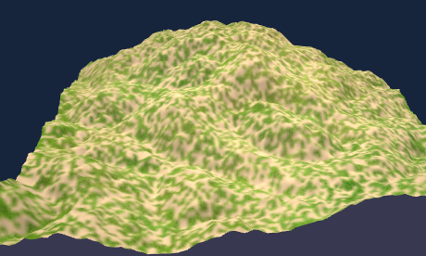
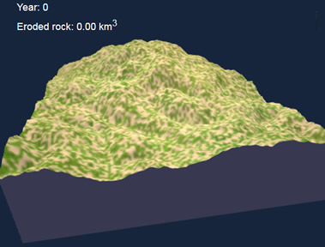
Gizmo Warm-up
In the River Erosion Gizmo, you learned about the ways that rivers erode soil and change landscapes over time. The Erosion Rates Gizmo models erosion in a simulated 3D landscape. Using the Gizmo, you will see how quickly erosion happens and observe the long-term effects of erosion on a landscape.

- Click Play (). Wait for about 20,000 simulated years, then click Pause (). If you want, you can drag the landscape to rotate the view. How much does the landscape change?

- Click Play, and wait for another 80,000 years or so. Based on what you see, does erosion tend to occur quickly or slowly? Explain.

Activity A:  Effects of climate on erosion rates | Get the Gizmo ready:  - Click Reset (). Check that Landscape 1 is shown. (If not, restart the Gizmo.)  - Select the Pause every 100,000 years checkbox. | 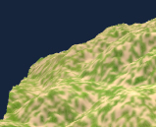

Introduction: Climate describes the average weather in an area over time. Climate takes into account factors such as temperature and amounts of precipitation, or how much it rains and snows. Climate also determines what types of vegetation, or plants, live in a region. In this activity, you will see how climate also affects erosion.

Question: How do climate and vegetation affect rates of erosion?

- Observe: The Gizmo shows a simplified model of erosion in a hilly area. Check that the Precipitation is 100 cm/yr (39 in/yr), the Average temperature is 20 °C (68 °F), and the Vegetation cover is 50%. Click Play, wait for 100,000 simulated years, and click Pause.

The amount of eroded rock is measured in cubic kilometers (km³). A cubic kilometer is a cube that measures 1 km on each side. How many km³ of rock were eroded?

- Predict: How do you think precipitation, temperature, and vegetation will affect how quickly rocks are eroded? Fill in each blank with “increase” or “decrease.”

As precipitation increases, the rate of erosion will .

As temperature increases, the rate of erosion will .

As the amount of vegetation increases, the rate of erosion will .

- Experiment: Click Reset. Set Precipitation to 10 cm/yr.

- Click Play and wait 100,000 years. How much rock was eroded?
- Click Reset, and repeat the experiment with the Precipitation set to 200 cm/yr. How much erosion occurred this time?
- How does precipitation affect the rate of erosion?

- Why do you think precipitation has this effect?

(Activity A continued on next page)
Activity A (continued from previous page)

- Experiment: Click Reset and Return to original settings. Use the same procedure to see how temperature and vegetation cover affect the rate of erosion. Fill in your findings below:

Erosion with temperature of 5 °C: Erosion with temperature of 35 °C:

Erosion with vegetation of 0%: Erosion with vegetation of 100%:

- Draw a conclusion: What can you conclude about the effects of temperature and vegetation on erosion rates?

- Infer: Weathering is the breakdown of rock into soil.

- How does weathering relate to erosion?

- In general, weathering tends to occur more rapidly in warm climates than in cool climates. How does this trend explain the effect of temperature on erosion rates?

- Explain: Why do you think increasing vegetation slows the rate of erosion?

- Compare: Click Reset and Return to original settings. Using the Gizmo, create a scenario where the maximum amount of erosion happens in 100,000 years. (Note: Do not change the rock type.) Which Gizmo settings did you choose?

Precipitation: Temperature: Vegetation:

How much erosion occurred in 100,000 years?

Click and drag to rotate the landscape. What changes do you notice?

Activity B:  Rock type and erosion | Get the Gizmo ready:  - Click Reset (). Check that Landscape 1 is selected and Pause every 100,000 years is on.

Introduction: Sandstone is a rock made from cemented grains of sand. It is very hard and is sometimes used in buildings. Shale is a softer rock made of clay and other tiny particles. In this activity, you will compare the erosion of sandstone to that of shale.

Question: How does rock type affect erosion?

- Predict: Which type of rock do you think will erode more quickly, and why?

- Experiment: In the dropdown menu, select Shale. Set Precipitation to 200 cm/yr, Average temperature to 35 °C, and Vegetation cover to 0%.

- Click Play and wait 100,000 years. How much rock was eroded?
- Click Reset. Select Sandstone. Click Play and wait 100,000 years. How much erosion occurred this time?
- How did the results compare to your prediction?

- Explore: With Sandstone still selected, click Play and wait 200,000 years. After the simulation pauses, rotate the landscape to see the features that were formed.

- What evidence do you see that water has eroded the landscape?

- Rotate the landscape to show the largest valley that forms. Click the Camera () at upper right to take a snapshot. Right-click the image, select Copy, and then paste the image into a blank document. You will turn in the document with this worksheet.

- Click Reset. Select Shale and play the simulation for about 125,000 years. (This length of time results in about the same volume of eroded rock as 200,000 years of sandstone erosion.) Take a snapshot and paste the image into your document.

- Compare the two images. What do you notice?

Hard rocks such as sandstone and limestone tend to form deep canyons and steep cliffs. Softer rocks such as shale erode into wider valleys with more gentle slopes. In places like the Grand Canyon, you can recognize the high cliffs formed from sandstone and limestone and the broad slopes formed by layers of shale.
Extension:  Long-term erosion | Get the Gizmo ready:  - Click Reset ().  - Check that Pause every 100,000 years is on. | 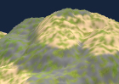

Introduction: Erosion can cause a variety of long-term changes to a landscape. In this activity, you will look at how a single landscape changes over time. Because the Gizmo generates random landscapes, each landscape will be unique.

Question: What long-term changes will erosion cause in a landscape?

- Predict: How do you think erosion will change a landscape over very long periods of time?

- Choose: You can start with any settings you want. First choose the Rock type. You can choose Sandstone, Shale, or Mixed. Then click New landscape a few times until you see one that you like. Choose values for Precipitation, Average temperature, and Vegetation cover. (Hint: More will happen if you choose high precipitation and warm temperatures.)

Rock type: Precipitation:

Average temperature: Vegetation cover:

- Take snapshots: Take a snapshot of the original landscape. Paste this snapshot into your image document. Click Play. Every time the Gizmo pauses, take another snapshot and add the snapshot to the document. You may need to shrink the images to fit. Time allowing, you will have images every 100,000 years until you reach one million years.

- Compare: Take a look at how the landscape changes over time. For each characteristic, describe how it changes as time goes by.

Height of hills:

Depth of valleys:

Length of rivers:

Other observations:

If possible, compare your landscapes to those of your classmates. Discuss as a class how the landscapes tend to change over time. (Note: This is a simulated landscape that may not exactly reflect how a real landscape might change over time.)

