Name: Date:

**Student Exploration: Estimating Sums and Differences**

**Vocabulary:** difference, estimate, sum

**Prior Knowledge Questions** (Do these BEFORE using the Gizmo.)

An **estimate** is a rough calculation, or best guess. A good estimate is reasonably close to the exact answer, and is also easy to do in your head.

1. Amy’s lunch costs $5.03, and her dessert is $2.99. To estimate her total cost, she rounds each price to the nearest dollar and adds. Fill in the blanks below to show her estimate.

$5.03 + $2.99 ≈ + =

1. Is the estimate above a good estimate? Explain.

**Gizmo Overview**

In the *Estimating Sums and Differences* Gizmo, you will use benchmarks (numbers used to make estimates) to add and subtract fractions.

Here’s how the Gizmo looks at first:

Here are the red and blue models for the given fractions. (Drag each one onto the benchmark fraction that it’s closest to.)

Here’s the problem for you to estimate.

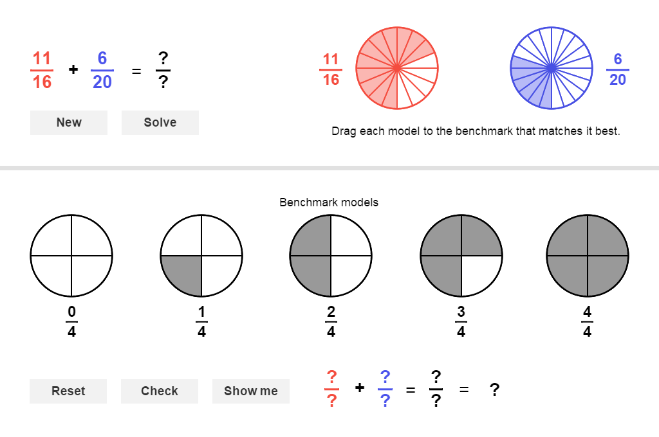

Here are the gray benchmark fractions. (Drag the red and blue models onto these.)

Read your feedback in the Gizmo after you click **Check**. If your answer is incorrect, click **Reset** and drag the red and blue models to different benchmark fractions. When you’re done, click **New** for a different problem to work on.

|  |  |  |
| --- | --- | --- |
| **Activity:**  **Choosing benchmarks** | Get the Gizmo ready:   * You should see the problem  + . If not, click **Refresh** in your browser. | 215SE2 |



1. When you begin, you should see the problem shown to the right.
2. First, compare the red and blue models for  and  to the gray benchmarks.

What benchmarks appear to be closest to each?  ≈  ≈

1. Drag the models for  and  and drop them on the benchmarks you chose. Click **Check** and try again if your estimate is incorrect. Then complete the equation below.

 +  ≈ + = =

1. Click **Solve** to see the exact sum. What do you notice about the exact sum and the estimate?



1. Click **New**. You should now see the problem shown to the right.
2. Notice that the numerator and denominator of  are very close in value. Fill in the equation to show the benchmark you should choose for this fraction.

=

1. Divide or use a calculator to find the decimal equal to . How can the decimal

help you find the benchmark for this fraction?

1. Drag each model to its benchmark. What is the estimated difference?

Check your answer in the Gizmo.

1. Click **New**. Work through more problems in the Gizmo.

**(Activity continued on next page)**

**Activity (continued from previous page)**

1. Use the benchmarks , , , , and  to estimate each answer. Write all your steps in the space below each problem.
2.  + 
3.  – 
4.  + 
5.  – 
6.  + 
7.  – 
8.  + 
9.  – 