Vocabulary: Exponential Growth and Decay

dictionary2

**Vocabulary**

* Exponential decay – a relationship in which a quantity decreases (decays) by a fixed percent each time period.
  + 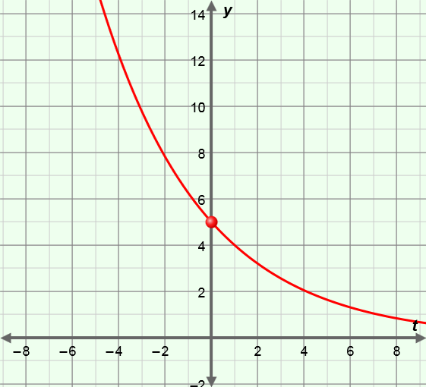An exponential decay function can be written in the form *y* = *C*(1 + *r*)*t*, where *C* ≠ 0 and *r* < 0.
    - *C* is the *initial value* (*y*-value when *t* = 0) and *r* is the *rate of change* of the function.
    - For example, *y* = 5(1 – 0.20)*t*, graphed to the right, is an exponential decay function.
      * *C* = 5, so the initial value (and   
        *y*-intercept) of this function is 5.
      * *r* = –0.2, or –20%, so each time *x* increases by 1, *y* loses 20% of its value (or, retains 80%).
* Exponential growth – a relationship in which a quantity increases (grows) by a fixed percent each time period.
  + 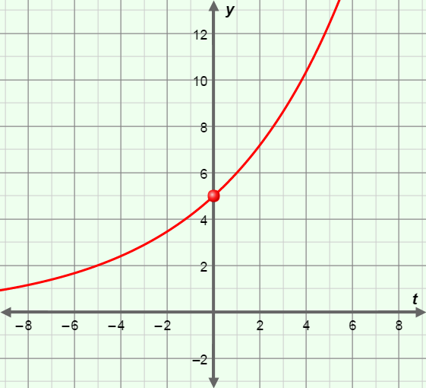An exponential growth function can be written in the form *y* = *C*(1 + *r*)*t*, where *C* ≠ 0 and *r* > 0.
    - For example, *y* = 5(1 + 0.20)*t*, graphed to the right, is an exponential growth function.
      * *C* = 5, so the initial value (and   
        *y*-intercept) of this function is 5.
      * *r* = 0.2, or 20%, so each time *x* increases by 1, *y* gains 20% of its value.