Name: Date:

**Student Exploration:** **Exponential Functions**

**Vocabulary:** asymptote, exponential function

**Prior Knowledge Questions** (Do these BEFORE using the Gizmo.)

You are given a penny on January 1, two pennies on January 2, four pennies on January 3, and eight pennies on January 4, and so on.

1. Assuming the pattern continues, how many pennies do you get on the following dates?

January 5 January 10 January 31

1. Explain your reasoning.

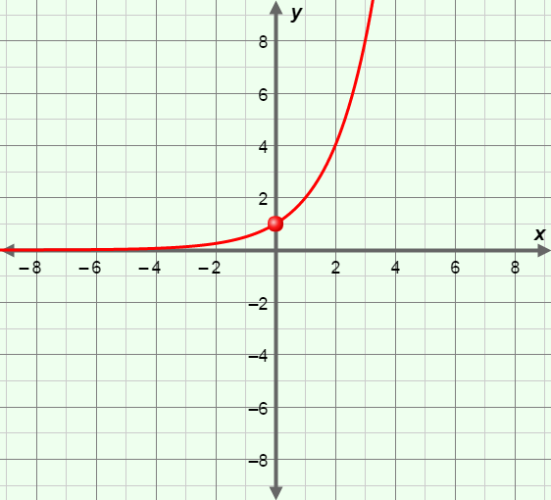**Gizmo Warm-up**

An **exponential function** contains a number raised to a variable exponent. In general, exponential functions have the form *y* = *a* • *bkx*. In the *Exponential Functions* Gizmo, you can explore the effects of the values of *a, b,* and *k* on the graph of the exponential function.

You can vary the values of *a, b,* and *k* by dragging the sliders. To enter a specific value, click on the number in the text field, type in the new value and hit **ENTER**.

1. Use the slider to vary the value of *b*.
   1. Describe the graph when *b* is increasing and greater than 1.

* 1. Describe the graph when *b* is decreasing and less than 1.

1. What point do all functions of the form *y* = *bx* have in common?

Explain why.

|  |  |  |
| --- | --- | --- |
| **Activity A:**  **Exponential basics** | Get the Gizmo ready:   * Select the **CONTROLS** tab. * Unselect all checkboxes. |  |

1. Consider the function, *y* = 3*x*. (Do not use the Gizmo yet.)

|  |  |
| --- | --- |
| ***x*** | ***y*** |
| –2 |  |
| –1 |  |
| 0 |  |
| 1 |  |
| 2 |  |

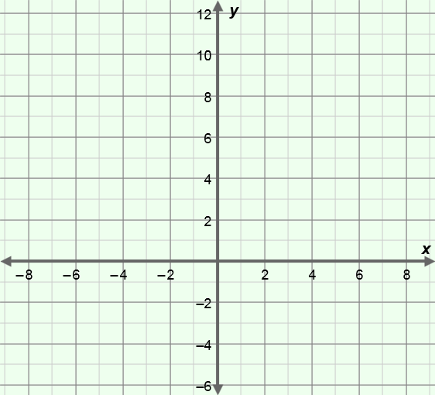

1. In the table to the right, fill in the *y*-values for *y* = 3*x*.
2. Then plot the points on the graph to the right. Connect the points with a smooth curve.
3. In the Gizmo, graph *y* = 3*x*. Click on the **TABLE** tab and check your answers. Fix any mistakes to the right, if needed.
4. What is the *y*-intercept of *y* = 3*x*?
5. What do you think the *y*-value is when *x* = 3? When *x* = 4?

Explain.

1. What do negative exponents mean? For example, how do you evaluate 3−2?

1. What is the *y*-value when *x* = −3? When *x* = −4?

Check your answers in the Gizmo. (Hint: You may want to use a calculator to convert your fractions to decimals. The Gizmo shows decimals.)

1. Describe the *y*-values of *y* = 3*x* as *x* approaches negative infinity (*x* 🡪 –∞).

1. What does the graph approach as *x* 🡪 –∞?

A line that a graph gets closer and closer to is called an **asymptote**.

1. With ***a*** and ***k*** set to 1, vary the ***b*** slider. Do exponential functions of the form *y* = *bx* have an *x*-intercept? Explain why or why not.

**(Activity A continued on next page)**

**Activity A (continued from previous page)**

|  |  |
| --- | --- |
| **Function** | ***y*-value at *x* = 1?** |
| *y* = | (1, ) |
| *y* = | (1, ) |
| *y* = | (1, ) |

1. Use the Gizmo to experiment with more functions of the form *y* = *bx*. Select the **Show probe** and **Show calculation.** Drag the probe to *x* = 1.
2. For at least three different exponential functions, *y* = *bx*, determine the *y*-value when *x* = 1. Record your findings in the table to the right.
3. In general, what point lies on any exponential function, *y* = *bx*, when *x* = 1?

Explain why.

1. Consider the graph to the right, containing the points (0, 1) and (1, 5).

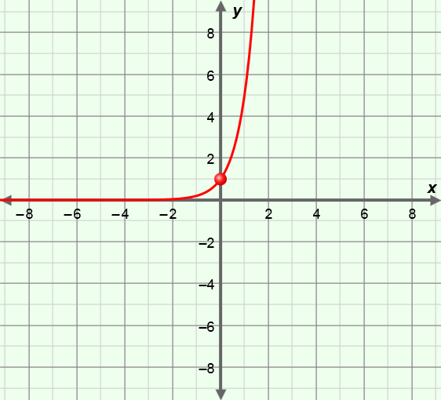

1. What function is graphed here?
2. Explain.

Check your answer using the Gizmo.

1. Graph each function below by hand. Then check your graphs in the Gizmo.
2. *y* =6*x*
3. *y* = *x*

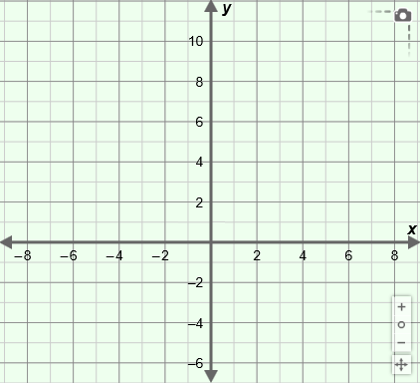

|  |  |  |
| --- | --- | --- |
| **Activity B:**  **The effects of *a* and *k* on the graph** | Get the Gizmo ready:   * Be sure the Gizmo the **CONTROLS** tab is selected and that all boxes are unchecked. * Set ***a***to1 and ***k***to 1. |  |

|  |  |
| --- | --- |
| ***y* = 2*x*** | |
| ***x*** | ***y*** |
| ─1 |  |
| 0 |  |
| 1 |  |
| 2 |  |

1. Consider the function, *y* = 2*x*. Complete the table of values by hand.
2. Do you think this function has any negative *y*-values on it?

Explain.

1. What do you think would happen to the graph when the *y-*values were multiplied by −1?
2. What would the equation of this new function be?

Explain.

Check your answers by graphing *y* = 2*x* in the Gizmo.

|  |  |
| --- | --- |
| ***y* = 3 • 2*x*** | |
| ***x*** | ***y*** |
| ─1 |  |
| 0 |  |
| 1 |  |
| 2 |  |

1. In the table to the right, fill in the missing *y*-values for *y* = 3 • 2*x*.
2. How do the *y*-values of *y* = 3 • 2*x* compare to those of *y* = 2*x*?

1. What is the *y*-intercept of *y* = 3 • 2*x*?

Explain why.

Check your answers by graphing *y* = 3 • 2*x* in the Gizmo.

1. Now use the slider to vary the value of *a*. Pay attention to the graph as you do.
2. What happens to the graph when *a* is positive and increasing?
3. What is true when *a* is negative?

Explain.

**(Activity B continued on next page)**

**Activity B (continued from previous page)**

1. Consider the functions, *y* =2*x* and *y* = 2−*x*. (Do not use the Gizmo yet.)
2. Complete the table of values for each function. Plot the points on the same coordinate plane. If possible, draw the graphs in two different colors.

|  |  |
| --- | --- |
| ***y* = 2-*x*** | |
| ***x*** | ***y*** |
| ─1 |  |
| 0 |  |
| 1 |  |
| 2 |  |

|  |  |
| --- | --- |
| ***y* = 2*x*** | |
| ***x*** | ***y*** |
| ─1 |  |
| 0 |  |
| 1 |  |
| 2 |  |

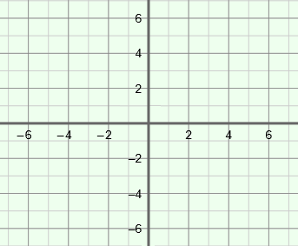

In the Gizmo, graph each function and click on the **TABLE** tab to check your values. If necessary, fix any mistakes above.

1. What is the *y*-intercept of *y* = 2−*x*?
2. What is the *y*-value when *x* = 1 of *y* = 2−*x*?
3. Name another exponential function that is equivalent to *y* = 2−*x*.

(Hint: Recall that *y* = 2−*x* = (2−1)*x*.)

Check your answer in the Gizmo.

1. In the blanks below, name another pair of equivalent exponential functions.

1. Graph the function, *y* = 23*x*, in the Gizmo.
2. What is the *y*-intercept?
3. What ordered pair lies on the graph at *x* = 1?
4. Name an equivalent function for *y* = 23*x*.

Check your answer using the Gizmo.

1. Explain why the functions are equivalent.

|  |  |  |
| --- | --- | --- |
| **Activity C:**  **Graphing exponential functions** | Get the Gizmo ready:   * Be sure the Gizmo shows the **CONTROLS** tab and that all boxes are unchecked. |  |

Graph each function by hand. Include at least two points on each graph. For questions 4-6, write an equivalent function in the space provided. Then check all your answers in the Gizmo.

1. *y* =4*x*

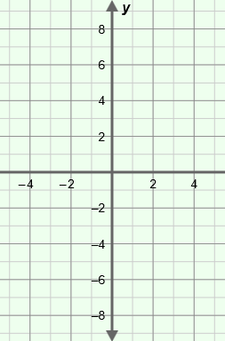

1. *y* = 5*x*



1. *y* = −3*x*

**

1. *y* = 7−*x* =



1. *y* = −*x* =



1. *y* =32*x* =

