Vocabulary: Exponential Functions

dictionary2

**Vocabulary**

* Asymptote – a line that a graph approaches more and more closely.
  + For example, the function *y* = 4*x*, which is shown below, has a horizontal asymptote at *y* = 0.
* Exponential function – a function of the form *y* = *a* • *bkx*, where *a* ≠ 0, *b* > 0, and *b* ≠ 1.
  + 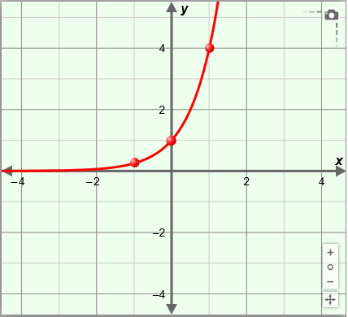An exponential function multiplies an initial value (*a*) by the same positive number (*b*) repeatedly.
  + For example, the function *y* = 4*x*, graphed to the right, is exponential.
    - The “key points” shown on the graph of *y* = 4*x* are (−1, ), (0, 1), and (1, 4).
    - For *y* = 4*x*, every time *x* increases by 1, *y* is multiplied by a factor of 4.