Name: Date:

**Student Exploration:** **Factoring Special Products**

**Vocabulary:** difference of two squares, factor, greatest common factor, monomial,  
perfect-square trinomial, polynomial

**Prior Knowledge Questions** (Do these BEFORE using the Gizmo.)

1. Find each product below.
2. (*x* + 3)(*x* + 5) =
3. (*x* + 5)(*x* + 5) =
4. (*x* + 5)(*x* – 5) =
5. When do the two middle terms add to zero?

**Gizmo Overview**

A **polynomial** is an expression consisting of one or more **monomials** (or terms) added to or subtracted from each other. In the *Factoring Special Products* Gizmo, you will **factor** given polynomials, if possible, which means to express them as a product.

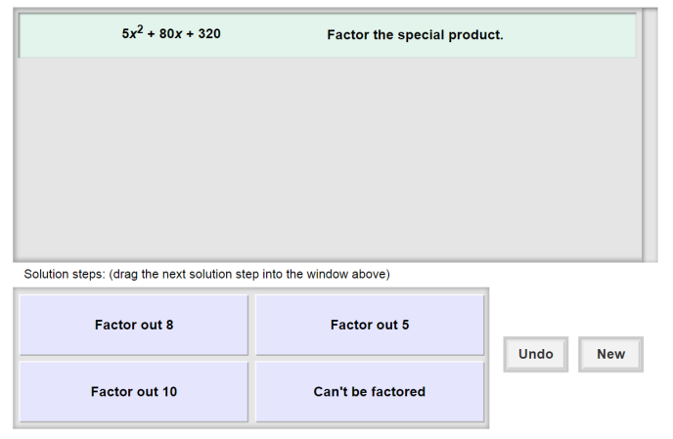Here’s how the Gizmo looks at first:

The polynomial for you to factor is here.

Click **Undo** to undo your last choice.

The tiles give you four choices for the next step. Choose the one you think is correct and drag it into the white area above.

Click **New** to go to a different problem.

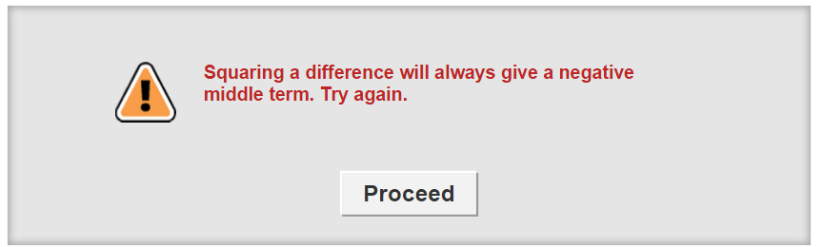

Read your feedback in the Gizmo.

(No feedback is given for correct answers.)

Click **Proceed** to go to the next step.

Continue until the polynomial is factored. Then click **New** for a new problem to work on.

|  |  |  |
| --- | --- | --- |
| **Activity:**  **Factoring polynomials** | Get the Gizmo ready:   * You should see the expression 5*x*2 + 80*x* + 320. If not, click **Refresh** in your browser. | 106SE3 |

1. You should see the polynomial shown to the right at the top of the Gizmo.
2. The **greatest common factor** (GCF) is the largest factor that divides evenly into a number or polynomial.

Does this polynomial have a GCF greater than 1? _______ If so what is it?

1. In the Gizmo, choose the correct first step. If your choice is incorrect, read the given feedback and try again. What factored expression do you get?
2. Now factor *x*2 + 16*x* + 64.
3. In the Gizmo, choose the next correct step. What is the answer?
4. Why do you think the trinomial *x*2 + 16*x* + 64 is called a **perfect-square trinomial**?

1. Given how 5*x*2 + 80*x* + 320 factors, how do you think 5*x*2 + 80*xy* + 320*y*2 factors?

5*x*2 + 80*xy* + 320*y*2 =

1. Click **New**. You should now see the polynomial shown to the right in the Gizmo.
2. Why do you think *z*2 – 36 is called a **difference of two squares**?

1. In the Gizmo, choose the correct factorization. What is the answer?
2. Do you think the polynomial *z*2 + 36 can be factored? Why or why not?

1. Click **New**. Work through more problems in the Gizmo. Be sure to read the feedback in the Gizmo along the way.

**(Activity continued on next page)**

**Activity (continued from previous page)**

1. Factor each polynomial, if possible. If the polynomial cannot be factored, write “Can’t be factored.” If it can, write all your steps in the space below each problem.
2. *x*2 – 100
3. *m*2 + 14*m* + 49
4. 6*y*2 – 24
5. *c*2 + 8*c* – 16
6. 12*z*2 – 60*z* + 75
7. 2*x*2 + 18*y*2
8. 9*r*4 – *s*4
9. *x*2 + 12*xy* + 36*y*2