Name: ______________________________________ Date: ________________________

Student Exploration: Factor Trees

Vocabulary: composite number, divisible, factor, factor tree, multiple, prime factorization, prime number, product

Prior Knowledge Questions (Do these BEFORE using the Gizmo.)

- When you multiply numbers, the answer is the product of those numbers. Name two different pairs of whole numbers whose product is 12.

  - 12 = _____ × _____
  - 12 = _____ × _____

  - Any whole number that can be multiplied by another whole number to equal 12 is a factor of 12. What do you think are the factors of 12? ________________________

- A composite number is a number that has more than two factors. A number greater than 1 that has only two factors (1 and itself) is called a prime number.

- Is 12 a prime or composite number? ______________________________________

- Name a prime number. __________

Gizmo Warm-up
Factoring a number is breaking it into a product of its factors. One way to do this is to make a factor tree. An example is shown to the right. The Factor Trees Gizmo allows you to factor numbers with factor trees. Or, you can reverse the process and build numbers by multiplying factors.

- The Gizmo shows the beginning of a factor tree: 14 = 2 × ?.

  - What number goes in place of the “?” to factor 14? __________

  - Drag that number from the Factors on the left. Place it on the ?. Both numbers at the bottom of your tree are prime numbers (yellow), so this factor tree is complete.

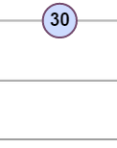
- Drag a 30 tile into the work area. Start factoring 30 by dragging any one of its factors below it. Then drag in the tile you need to complete that factor pair. If any factors are composite numbers (blue), factor them too. Continue until you can’t go any further. Sketch your factor tree here:

What product of primes makes 30? 30 = _____ × _____ × _____

Activity A:  Recycling numbers | Get the Gizmo ready:  - Be sure that Factor is selected at the top left.  - Click Clear. | 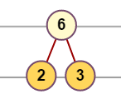

You are a new employee at the Number Factory. New people start out in the Number Recycling Center. Your job is to take old, worn-out numbers and break them down for parts.

- A customer brings in an old 15 to recycle. Drag a 15 tile into the work area. Your job is to recycle (factor) this 15. Factor it into primes in the Gizmo. Sketch your factor tree below.
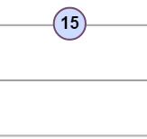
  - What prime factors were in the 15? ___________________

  - The prime factorization of 15 is the product of all of its prime factors. What is the prime factorization of 15?

15 = _____ × _____

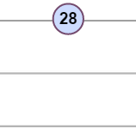
- Next comes an old 28 to recycle. Factor 28 into primes in the Gizmo.

- Sketch your completed factor tree to the right.

- What is the prime factorization of 28?

28 = ______________________________

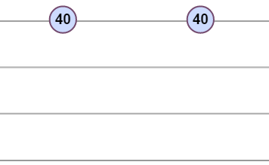
- Two old 40’s have come in for recycling. Jake and Elaina are each working on one. Jake first broke his 40 into 5 × 8. Elaina started by breaking her 40 into 4 × 10.

Is this a problem? Will Jake and Elaina end up with different prime factorizations of 40?

  - Click Clear. Make both factor trees in the Gizmo. Sketch them to the right.

  - What is the prime factorization of 40? 40 = _______________________________

- Click Clear. You are now ready to recycle any number that shows up at the Recycling Center! At the top left, click Random and click Make. Drag this new number tile into the work area and recycle it. Factor at least four numbers. Write their prime factorizations below.

A. ____________________________

C. ____________________________

B. ____________________________

D. ____________________________

Activity B:  Building numbers | Get the Gizmo ready:  - Select Build at the top left corner.  - Click Clear. | 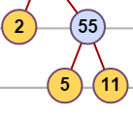

At the Number Factory you can also build composite numbers by multiplying prime factors.

- In Build mode, drag a 5 into the middle of the work area. Then drag a 2 right next to it. What number does this build? What is its prime factorization?

Number built: ________ Prime factorization: _________________________

- Build more numbers starting with the factor 5. (You can use more than two prime factors.)

  - What do a 5 and a 3 build? ______
  - What do a 5 and two 2’s build? ______

  - What are all the numbers you can build (up to 50) that include 5 as a prime factor?

___________________________________________________________________

  - You built all these numbers by multiplying whole numbers by 5. Therefore, they are all multiples of 5. Look at the list. What digits do all multiples of 5 end with?

___________________________________________________________________

- Donna Divider sees the “Multiples of 5” list and says, “Multiples of 5 are all divisible by 5! They can all be divided by 5 with no remainder!” Is Donna correct? Explain why this is so.

_________________________________________________________________________

_________________________________________________________________________

- Ivan in inventory has a whole bunch of numbers just sitting around. He wants to build a “Multiples of 2” set in his free time. How can he tell which numbers belong in this set?

_________________________________________________________________________

- Ivan also decides to try putting together the “Multiples of 3” set from the numbers sitting around. How can he know if a number is a multiple of 3? (Hint: Build a lot of different multiples of 3. Then look at the sum of the digits of each number.)

_________________________________________________________________________

Challenge: Each time you build a composite number from 0 to 50, it gets highlighted in the lower left part of the Gizmo. How many can you build? Can you build all composite numbers up to 50?

Activity C:  Division and factoring | Get the Gizmo ready:  - Select Factor at the top left corner.  - Click Clear. | 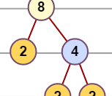

The employees at the Number Recycling Center think they have discovered something that can help people understand division better.

- In Factor mode, drag a 21 tile from the left side of the Gizmo into the work area.

- What is the prime factorization of 21? __________________________

- What does 21 ÷ 7 equal? 21 ÷ 7 = __________

- How are those two facts related? ________________________________________

___________________________________________________________________

- Do the same with a 28 tile.

- What is the prime factorization of 28? __________________________

- What does 28 ÷ 7 equal? 28 ÷ 7 = __________

- Explain how those two answers make sense together. ________________________

___________________________________________________________________

- In the Gizmo, find the prime factorizations of 40 and of 8. Then use these factorizations to explain why 40 ÷ 5 = 8.

_________________________________________________________________________

_________________________________________________________________________

- Factor 44 in the Gizmo. Then use this factorization to explain why 44 is not divisible by 7.

_________________________________________________________________________

_________________________________________________________________________

- Use prime factorizations to explain why all multiples of 8 must be divisible by 4.

_________________________________________________________________________

_________________________________________________________________________

