Name: Date:

**Student Exploration:** **Modeling the Factorization of *ax*2 + *bx* + *c***

**Vocabulary:** factor, monomial, polynomial, zero pair

**(*x* + 1)**

**(2*x* + 3)**

**Prior Knowledge Questions** (Do these BEFORE using the Gizmo.)

1. The lengths of the sides of a rectangle are (*x* + 1) and (2*x* + 3).

How can you find the rectangle’s area?

1. To multiply the binomials, multiply each term of (*x* + 1) by each term of (2*x* + 3). Fill in the blanks with the result.

(*x* + 1)(2*x* + 3) = + + +

1. Now combine any like terms. What is the simplified product?

The product is a **polynomial**, and each term in it is a **monomial**.

**Gizmo Overview**

You just multiplied two binomials to get a trinomial. You can reverse this process to **factor** the trinomial into a product of binomials. Each binomial is a factor of the trinomial. In the *Modeling the Factorization of ax2*+ *bx* + *c* Gizmo, you will use tiles to factor polynomials.

Here’s how the Gizmo works:

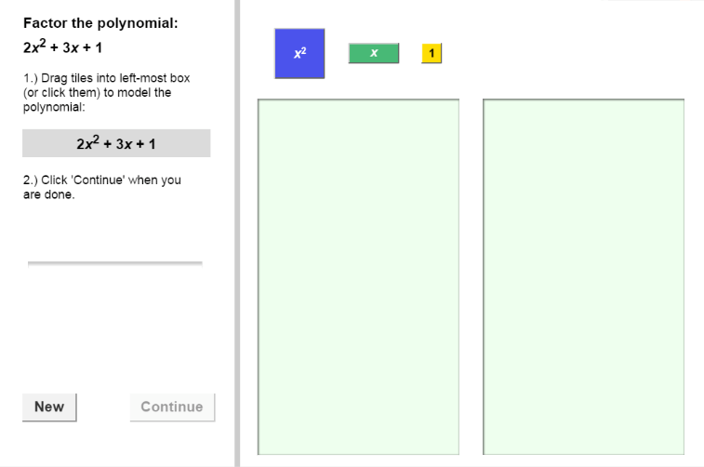

First you will model the polynomial by dragging or clicking to place the colored tiles here.

Then you will drag the tiles from the model of the polynomial to form a rectangle here.

The sides of the rectangle will be the factors of the polynomial.

The polynomial for you to factor is here.

Feedback will appear here.

|  |  |  |
| --- | --- | --- |
| **Activity A:**  **Modeling**  ***ax*2 + *bx* + *c*** | Get the Gizmo ready:   * You should see the polynomial 2*x*2 + 3*x* + 1. If not, click **Refresh** in your browser. | 110SE2 |

1. In this activity, you will use a rectangle to model a polynomial. The height and width of the rectangle are the factors of the polynomial.
2. Model 2*x*2 + 3*x* + 1 by dragging or clicking the blue ***x*2**-tiles, the green ***x***-tiles, and the yellow **1**-tiles into the left bin. How many of each type of tile did you use?

***x*2**-tile(s) ***x****-*tiles(s) **1**-tile(s)

1. Click **Continue**. Drag the ***x*2**-tiles anywhere in the right bin. If part of the tiles are hidden, click anywhere in the white space and drag to adjust their location. Notice that the height and width of the tiles are labeled along the sides.

What are the height and width of an ***x*2**-tile? height = width =

1. Now you will drag the ***x***-tiles into the right bin, lining up the sides that are *x* units long with the sides of the ***x*2**-tiles. Then drag the **1**-tile into the right bin and try to form a rectangle with all of the tiles. If you cannot form a rectangle, try a different arrangement of the ***x***-tiles and the **1**-tile.

When you have formed a rectangle, sketch it in the space to the right. Label your rectangle with its height and width.

1. Notice that the height and width of the rectangle are the factors of 2*x*2 + 3*x* + 1.

What are the factors?

1. When you multiply the factors of a polynomial, the product should be the original polynomial.
2. Multiply the factors you found above to verify that their product is 2*x*2 + 3*x* + 1. Show your work in the space to the right.
3. How do the constant terms in the factors combine to form 1, the constant term in   
   2*x*2 + 3*x* + 1?

1. How do the two coefficients of *x* in the factors combine to form 2, the coefficient of *x*2 in 2*x*2 + 3*x* + 1?

|  |  |  |
| --- | --- | --- |
| **Activity B:**  **Using zero pairs** | Get the Gizmo ready:   * Click **New**. You should see the polynomial  3*x*2 + 5*x* – 2. | 110SE3 |

1. In this activity, you will use a rectangle to model 3*x*2 + 5*x* – 2.
2. First, model 3*x*2 + 5*x* – 2 by dragging or clicking the blue ***x*2**-tiles, the green ***x***-tiles, and the red **–1**-tiles into the left bin. How many of each type of tile did you use?

***x*2**-tile(s) ***x****-*tiles(s) **–1**-tile(s)

1. Click **Continue**. Drag the tiles into the right bin and try to arrange them in a rectangle. Is it possible to make a rectangle with these tiles?
2. To make a rectangle, you will need to add **zero pairs** of tiles like the ones shown to the right.

A zero pair is two quantities that add to zero. Adding a zero pair to the model does not change the total value of the polynomial, but it can help you find the factors.

Why do you think you need to add zero pairs to get the **–1**-tiles to fit in the rectangle?

1. Drag one zero pair into the left bin. Then drag the ***x***-tile and **–*x***-tile into the right bin and try to make a rectangle. (One side of the rectangle should have only ***x***-tiles, and the other side only **–*x***-tiles.)

Is it possible to make a rectangle by adding only one zero pair?

1. If necessary, add more zero pairs. When you have formed a rectangle, sketch it in the space to the right. Label your rectangle with its height and width.
2. What are the factors of 3*x*2 + 5*x* – 2?

1. Multiply the factors to check them. Show your work in the space to the right.

**(Activity B continued on next page)**

**Activity B (continued from previous page)**

1. Click **New**. You should see the polynomial 4*x*2 – 9.
2. Model 4*x*2 – 9 using the blue ***x*2**-tiles and the red **–1**-tiles. Why are no *x*-tiles used to model 4*x*2 – 9?
3. The polynomial 4*x*2 – 9 can be written in the form *ax*2 + *bx* + *c*. What is the value of *b* for 4*x*2 – 9? *b* =
4. Click **Continue**. Drag the tiles into the right bin and try to make a rectangle. How many zero pairs do you think are needed to make a rectangle?
5. Add the zero pairs to the rectangle. Sketch your rectangle in the space to the right. Label your rectangle with its height and width.
6. What are the factors of 4*x*2 – 9?

1. Multiply the factors to check that their product is 4*x*2 – 9. Show your work in the space to the right.
2. Click **New**. Work through more problems in the Gizmo. After you have completed at least 5 problems, choose two polynomials from the Gizmo to factor yourself.

First draw a rectangle with tiles to model the polynomial. Then multiply the two factors to check. Show your work for both polynomials below. Check your answers in the Gizmo.

1. In general, what must be true about the value of *c* if zero pairs are needed to model a polynomial of the form *ax*2 + *bx* + *c*?

|  |  |  |
| --- | --- | --- |
| **Activity C:**  **Factoring  *ax*2 + *bx* + *c*** | Get the Gizmo ready:   * Click **New** if you need more practice factoring polynomials similar to those in this activity. | 110SE5 |

Sketch a model to factor each polynomial. Then multiply the factors to check your work.

1. 3*x*2 + 14*x* + 8
2. 2*x*2 – 7*x* + 5
3. 4*x*2 – 11*x* – 3
4. 9*x*2 – 1