Name: ______________________________________ Date: ________________________

Student Exploration: Fan Cart Physics

Vocabulary: acceleration, force, friction, mass, newton, Newton’s first law, Newton’s second law, Newton’s third law, velocity

Prior Knowledge Questions (Do these BEFORE using the Gizmo.)

- Imagine a horse pulling a cart. What would happen to the speed of the cart if several bags of cement were added to the cart? _______________________________________________

- Suppose several more horses were hitched up to the same cart. How would this affect the speed of the cart? __________________________________________________________
Although these questions may seem simple, they form the basis of Newton’s second law of motion. The Fan Cart Physics Gizmo can be used to illustrate all three of Newton’s laws.

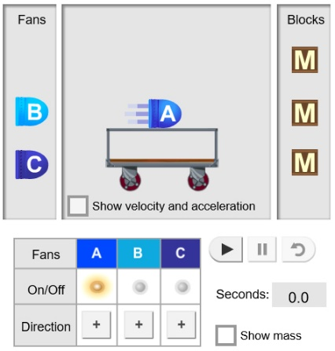
Gizmo Warm-up
The Fan Cart Physics Gizmo shows a common teaching tool called a fan cart. Place fan A on the cart and turn it on by clicking the On/Off button below.

- Look at the blue lines coming from the fan. In which direction is the air pushed? ____________________

- Press Play () and observe the cart. In which direction does the cart move? __________________
By blowing to the left, the fans exert a force on the cart that pushes it to the right. This illustrates Newton’s third law: A force in one direction results in an equal force in the opposite direction.

- The velocity (v) of the cart is its speed and direction. Click Reset (). Select the BAR CHART tab, and click Play. Does the velocity change or stay the same? _______________
A change in velocity is called acceleration (a).

Activity A:  Newton’s first law | Get the Gizmo ready:  - Click Reset.  - Remove all fans from the cart. | 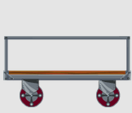

Question: What happens to the cart when there is no force?

- Form hypothesis: What will the motion of the cart be like when there is no force at all? (There is no friction in this model.) _____________________________________________

- Predict: Suppose a cart with no fans has a starting velocity of 2 m/s. What will be the velocity of the cart when it reaches the wall? _____________________________________

- Experiment: Check that there are no fans on the cart. On the DESCRIPTION tab, set the Initial velocity of cart to 2.0 m/s. Select the BAR CHART tab, and click Play.

What do you notice about the velocity of the cart? _________________________________

- Experiment: Click Reset. Place two fans on the cart, and point them in opposite directions. (Next to DIRECTION, click the button for one fan.) Turn both fans on, and click Play.

What do you notice about the velocity of the cart? _________________________________

- Analyze: Select the GRAPH tab.

- What do you notice about the graph of position vs. time (x vs t)? _______________

___________________________________________________________________

- What does the velocity vs. time (v vs t) graph show? _________________________

___________________________________________________________________

- What do you notice about the graph of acceleration vs. time (a vs t)? ____________

___________________________________________________________________

- Draw conclusions: Newton’s first law states that an object in motion will travel at a constant velocity unless acted upon by an unbalanced force. How do these experiments show this?

_________________________________________________________________________

_________________________________________________________________________

Activity B:  Newton’s second law | Get the Gizmo ready:  - Click Reset.  - Set the Initial velocity of cart to 0.0 m/s.  - Place three fans on the cart, all blowing to the left. | 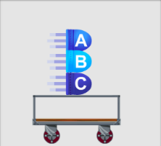

Question: How do mass and force affect acceleration?

- Experiment: Turn on the fans. Click Play and watch the cart, then select the TABLE tab.

- Scroll to the bottom of the table. What is the final velocity of the cart? ____________

- How long did it take the cart to reach the end of the track? _____________________

- Calculate: Acceleration is a measure of how much the velocity of the cart changes each second. To calculate acceleration, divide the final velocity by the amount of time it took to reach that velocity. The units of acceleration are meters per second per second, or m/s².

- What is the acceleration of the cart? (Include units.) __________________________

- Check your answer on the TABLE tab. Were you correct? _____________________

- Form hypothesis:

- How do you think changing the mass of the cart will affect its acceleration?

___________________________________________________________________

- How do you think the number of fans will affect the cart’s acceleration?

___________________________________________________________________

- Experiment: Select the BAR CHART tab and turn on Show numerical values. For each of the situations below, record the acceleration of the cart.

Load | Number of fans turned on | Acceleration
3 fans, 0 blocks | 1
3 fans, 0 blocks | 2
3 fans, 0 blocks | 3
3 fans, 2 blocks | 1
3 fans, 2 blocks | 2
3 fans, 2 blocks | 3

(Activity B continued on next page)
Activity B (continued from previous page)

- Analyze: Look at the acceleration values.

- How did doubling the force affect the acceleration of the cart? __________________

___________________________________________________________________

- A cart with two blocks and three fans has twice the mass as a cart with just three fans. How did doubling the mass affect the acceleration of the cart?

___________________________________________________________________

- Collect data: Select the DESCRIPTION tab. On the SIMULATION pane, turn on Show mass. This lists the total mass of the cart. Each fan exerts a force of 4.0 newtons (N). One newton is the force required to accelerate a 1-kg object at a rate of 1 m/s².

For each combination, record the total force, total mass, and acceleration. On the last column, multiply the mass (m) and acceleration (a).

Load | # fans on | Force | Mass | Acceleration | m · a
2 fans, 0 blocks | 2
1 fan, 2 blocks | 1
3 fans, 1 block | 3

What do you notice about the force and the product of mass and acceleration, ma?

_________________________________________________________________________

- Draw conclusions: Newton’s second law states that force is equal to mass times acceleration: F = ma. This law can be rearranged as a = F / m, or a = F ÷ m.

How does this experiment demonstrate Newton’s second law? _______________________

_________________________________________________________________________

_________________________________________________________________________

- Apply: Suppose the cart contains 2 fans and 3 blocks. Recall that each fan supplies a force of 4.0 N. The total mass of the cart will be 22.5 kg.

What will be the acceleration of the cart? ________ Check your answer using the Gizmo.

