Name: Date:

Student Exploration: Fast Plants® 2 – Mystery Parent

Note to teachers and students: The Fast Plants® Gizmo was created in collaboration with Wisconsin Fast Plants. The Fast Plants 2 – Mystery Parent lesson was designed as a follow-up to the Fast Plants 1 – Growth and Genetics lesson.

Vocabulary: chi-squared test, degrees of freedom, deviation, dihybrid Punnett square,
rosette-dwarf
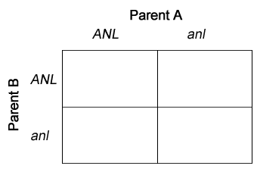

Prior Knowledge Questions (Do these BEFORE using the Gizmo.)
In the Fast Plants 1 lesson you learned about two alleles for stem color. ANL is the dominant allele for purple stems, and anl is the recessive allele for non-purple (green) stems.

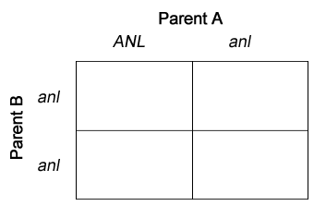
- Two ANL/anl plants are crossed. What percentage of the offspring plants will have purple stems?

- An ANL/anl plant is crossed with an anl/anl plant. What is the percentage of purple-stem offspring now?

Gizmo Warm-up
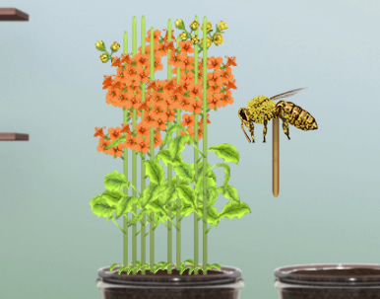
It is intern Mark’s first day at the Fast Plants laboratory, and he is eager to impress. He gathers pollen from a set of plants on one side of the room and carefully pollinates a set of plants on the other side. Then he goes out to lunch. When he returns, his supervisor Pam compliments Mark on the great job he did pollinating the flowers. “So, where did the pollen come from?” Mark scratches his head in confusion. He knows it came from somewhere over there, but which plants? He has no idea. “No problem,” says Pam. “We can figure it out from the offspring.”

In the Fast Plants 2 – Mystery Parent Gizmo, you will use genetics to determine the identity of the unknown parent plant. To begin, select the Mystery parent mode. Drag seed packet P1, the “mother” plants, to container 1 and F1, the offspring plants, to container 2. Click Play (), and then Pause () after 10 simulated days.

What are the traits of the P1 and F1 plants?

Activity A:  Creating a hypothesis | Get the Gizmo ready:  - On the Mystery parent mode, click Reset ().  - Turn on Auto grow and Show hints. | 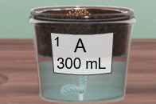

Introduction: In this lesson you will look at the stem color and leaf color of Fast Plants®. Recall that the stem color is controlled by two alleles: ANL (purple) and anl (green). The leaf color is controlled by the alleles YGR (green) and ygr (yellow-green, which we will refer to as “yellow”). The ANL and YGR alleles are dominant, while the anl and ygr alleles are recessive.

Question: What do the P1 and F1 phenotypes tell you about the P2 “father” plants?

- Grow: Plant the P1 seeds in container 1 and the F1 seeds in container 2. The F1 seeds are the offspring of the P1 mother plants and the mysterious P2 “father” plants. Click Play, and wait for the simulation to pause on day 9.

- View the plants with the magnifying glass. Then, turn on the clipboard. Observe the results, then turn on Add class data to see simulated data from 1,000 plants.

Are all the P1 plants the same? Are all the F1 plants the same?

- What is the stem and leaf color of the P1 plants?

- What is the stem and leaf color of the F1 plants?

- Form a hypothesis: Click the Develop hypothesis button. This opens up a window that will allow you to create a hypothesis about the P1, F1, and P2 plants.

- Drag the correct Phenotypes into the P1 phenotype and F1 phenotype boxes.

- Under P1 possible genotypes, drag labels from the Possible genotypes area into the spaces for stem and leaf genotypes, then do the same for the F1 genotypes. What are the possible genotypes for the P1 and F1 plants?

P1 possible genotypes: or

F1 possible genotypes: or

- Predict: Based on the P1 and F1 phenotypes and possible genotypes, you can make predictions about the phenotype and genotype of the “father” P2 plants. Fill in the P2 possible phenotypes and P2 possible genotypes areas, then list them below.

P2 possible phenotypes:

P2 possible genotypes:

Explain:

(Activity A continued on next page)
Activity A (continued from previous page)

- Analyze: Look over your possible genotypes.

- How do you know which stem alleles the P1 plants have?

- How do you know which stem alleles the F1 plants have?

- How do you know which stem alleles the P2 plants have?

- What do you know about the leaf alleles for the P1, F1, and P2 plants?

- Harvest: Click the X button to close the hypothesis window. Grab container 1 and drag it over the waste hole to remove the P1 plants, they will not be needed for the remainder of this activity. Click Play, pollinate the F1 plants with the bee stick, and then click Play again. After 44 days, use the tweezers to harvest a seedpod and drop it into the F2 bag.

What phenotype or phenotypes do you expect to see when you grow the F2 plants? Explain.

Activity B:  Identifying the father | Get the Gizmo ready:  - Click Reset. Check that Auto-grow is still selected. | 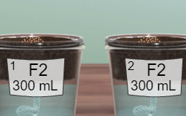

Introduction: At this point, you have identified the phenotypes of the P1 (mother) and F1 (offspring) plants. To determine the genotypes of the P1, F1, and P2 (father) plants it is necessary to look at the “grandchildren” F2 plants, the offspring of F1.

Question: What is the genotype of the P1, F1, and P2 (father) plants?

- Predict: Select Develop hypothesis. What are the two possible F1 genotypes? For each of these genotypes, predict what the F2 plants would look like, given that the F1 seeds are the offspring of the F1 plants. (Note: Assume all of the F1 plants have the same genotype.)

Possible genotype 1: Offspring phenotypes:

Possible genotype 2: Offspring phenotypes:

- Observe: Plant the F2 seeds in container 1 and container 2. Click Play, then wait for the simulation to pause after 9 days. Observe the resulting plants with the Magnifying glass.

What phenotypes do you see?

- Collect data: Select the clipboard to see the results. Fill in the first row of the table. Then, turn on the Add class data checkbox to see simulated results of 1,000 plants. Use this data to fill in the second row of the table.

Data source | Purple stem, green leaf | Purple stem, yellow leaf | Green stem, green leaf | Green stem, yellow leaf | Total
Single trial
Class data

- Infer: Click Develop hypothesis. Based on the phenotypes of the F2 plants, what do you think is the genotype of the F1 plants? Explain your reasoning.

(Activity B continued on next page)
Activity B (continued from previous page)

- Model: The possible allele combinations for two traits is shown by a dihybrid Punnett square. Based on the inferred F1 genotype, fill in the Punnett square below.
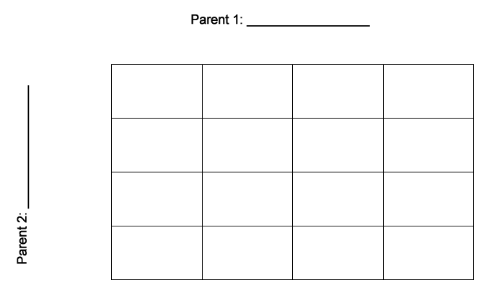

- Analyze: Based on the Punnett square, count the number of boxes that represent each phenotype combination. Then, predict the percentages of each combination. Fill in the bottom row with the observed percentages based on the F2 results in the Gizmo. (Hint: You can divide each of the class results by 10 to find the percentages.)

Data source | Purple stem, green leaf | Purple stem, yellow leaf | Green stem, green leaf | Green stem, yellow leaf
Number of boxes
Predicted F2 percentages
Observed F2 percentages

Are the actual results close to the predicted percentages?

If not, adjust your F1 genotype and repeat steps 5 and 6. Show your work on another page.

- Infer: Now that you know the F1 genotype, you can determine the P1 and P2 genotypes. On the hypothesis window, make any necessary adjustments to the alleles, and then select the correct P1 genotype, F1 genotype, and P2 genotype. If needed, drag the correct phenotype into the P2 phenotype box. Click Check. If necessary, make adjustments.

What is the P1 phenotype and genotype?

What is the F1 phenotype and genotype?

What is the P2 phenotype and genotype?

Explain how you know the P2 genotype:

Activity C:  Designing offspring | Get the Gizmo ready:  - On the Mode menu, select Design offspring.  - Check that Auto-grow is selected. | 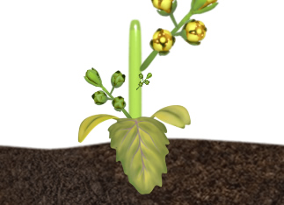

Question: How can you breed Fast Plants® to have any combination of traits?

- Observe: In the Design offspring mode, you will see two seed packets, C and D. Plant the C seeds in container 1 and the D seeds in container 2. Click Play and wait for day 9.

  - Move the magnifier over the C plants. What is the phenotype of these plants?

  - Observe the D plants with the magnifier. What is the phenotype of these plants?

  - Click Play and wait for day 15. How else do the D plants differ from the C plants?

The D plants exhibit a new trait, called rosette-dwarf. These plants are shorter than normal plants and have leaves that grow closer to the base of the stem than normal leaves.

- Pollinate: Use the bee stick to pollinate only the C plants, then return the bee stick to the bottom area. Use a clean bee stick to pollinate only the D plants. Click Fastplay ().

When the seeds have matured, harvest a C plant seedpod and place it in a bag. Label this bag “C1.” Then harvest a D plant seedpod and label the bag “D1.”

What do you think the phenotypes of the C1 and D1 seeds will be?

- Observe: Click Reset. Plant the C1 and D1 seeds in containers 1 and 2. Click Play. What are the phenotypes of the offspring plants?

C1 plants:

D1 plants:

- Infer: Are the C and D seeds homozygous for each trait? How do you know?

(Activity C continued on next page)
Activity C (continued from previous page)

- Pollinate: Click Play. When the simulation pauses, move the bee stick over the D1 plants and then over the C1 plants. Click Fastplay, then harvest a seedpod. Label the bag “F1.”

What do you think will be the phenotype of the F1 plants?

- Test: Click Reset. Plant and grow the F1 seeds.

  - What is the phenotype of the F1 plants?

  - Which three traits are dominant?

  - Which traits are recessive?

  - The rosette-dwarf trait is controlled by two alleles: ROS for the normal phenotype, and ros for the rosette-dwarf phenotype. Given this, what are the genotypes of the C plants, the D plants, and the F1 plants?

C genotype:

D genotype:

F1 genotype:

- Challenge: Turn on Show challenge. Now that you know the genotypes of the C and D plants, you can try creating custom combinations of traits in offspring plants. To solve each challenge, create a seed packet that contains seeds that meet the criteria of the challenge, and then click Submit.

Hint: If you have a variety of plants in a container, you can use the tweezers tool to remove unwanted plants and just keep the ones you want to use.

Each time you solve a challenge, take a screenshot of your successful seed packet with the “Congratulations” message. Paste these images into a document and hand it in with this worksheet.

Extension:  The chi-squared test | Get the Gizmo ready:  - On the Mode menu, select Mystery parent.  - Click Start over. | 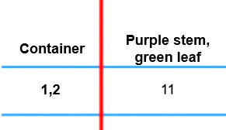

Introduction: In many experiments, it is not clear immediately if the evidence favors one theory or another. In these cases, statistical tests can be used to show how probable a given result will be. In this extension activity, you will learn about a test called the chi-squared test, or χ² test.

Question: How can you use a Chi-squared test to test a hypothesis?

- Create a hypothesis: Plant and grow the P1 and F1 seeds. Open the Develop hypothesis window and fill in all of the possible genotypes for P1, F1, and P2 as you did before. Suppose you started with the hypothesis that the P1 plants were anl/anl, YGR/YGR and the P2 plants were ANL/ANL, ygr/ygr.

If that were true, what would be the genotype of the F1 plants?
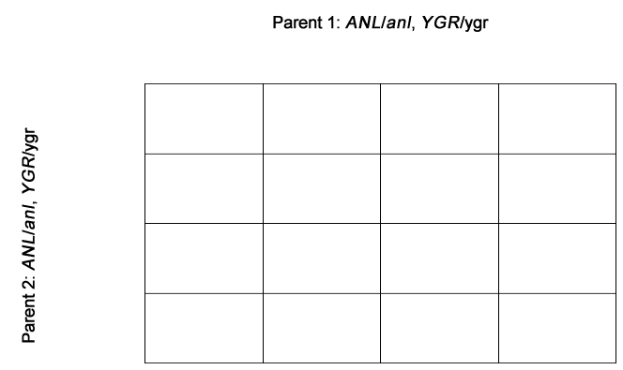

- Model: As you did before, throw away the P1 plants and pollinate the F1 plants. Harvest the resulting seeds into the F2 seed bag.

Suppose you had the hypothesis that the F1 plants were ANL/anl, YGR/ygr. Fill in the dihybrid Punnett square for this cross. If you want, color in the squares to show the corresponding stem and leaf colors.

- Predict: Suppose you had a total of 16 offspring from this cross. How many of each phenotype would you expect? Fill in the table with the expected values. Then, predict the number of offspring of each phenotype if there were 1,000 offspring, and fill in the second row of the table. (Hint: Divide by 16 and multiply by 1,000.)

Number of offspring | Purple stem, green leaf | Purple stem, yellow leaf | Green stem, green leaf | Green stem, yellow leaf
16
1,000
Observed

- Grow: Click Reset. Grow the F2 seeds in both containers. Open the clipboard and add the observed results of your trial to the table above. (Be sure Add class data is turned off.)

(Extension continued on next page)
Extension (continued from previous page)

- Calculate: A chi-squared test poses the question: If a given hypothesis is true, how likely is it that the difference between the observed and expected results is due to chance? If the probability is very low then the hypothesis can be rejected. If the probability is high it doesn’t mean the hypothesis is correct, just that it hasn’t been proven to be incorrect.

To do a chi-squared test, first compare the observed results to the expected results. For each phenotype, list the observed value (o) and the expected value (e). Then, find the deviation, or o – e. Square the deviations, and then divide by the expected values. Fill in the table below for the “single trial” data.

Phenotype | Purple stem, green leaf | Purple stem, yellow leaf | Green stem, green leaf | Green stem, yellow leaf
Observed (o)
Expected (e)
Deviation (d) = o – e
Deviation squared (d ²)
d ²/e

Sum all the d ²/e values to find the χ² value:

To find the degrees of freedom, subtract 1 from the number of possible phenotypes:

- Analyze: The table below shows the χ² values, degrees of freedom, and the probability that the difference between the expected value and the observed value was just due to chance, rather than due to a flaw in the hypothesis. First, find the row of the table that corresponds to the degrees of freedom. Then, read across to find the χ² value closest to the one you calculated. Then, read up to estimate the probability of a chance occurrence.

Degrees of freedom | Probability that the deviation is due to chance
 | 90% | 80% | 70% | 50% | 30% | 20% | 10% | 5% | 1%
1 | 0.016 | 0.064 | 0.148 | 0.455 | 1.074 | 1.642 | 2.706 | 3.841 | 6.635
2 | 0.211 | 0.446 | 0.713 | 1.386 | 2.408 | 3.219 | 4.605 | 5.991 | 9.210
3 | 0.584 | 1.005 | 1.424 | 2.366 | 3.665 | 4.642 | 6.251 | 7.815 | 11.341
4 | 1.064 | 1.649 | 2.195 | 3.357 | 4.878 | 5.989 | 7.779 | 9.488 | 13.277

What is the probability that the difference is due to chance?

Based on this test, should the hypothesis be rejected?

In general, the hypothesis is rejected if the probability that the deviation is due to chance is less than 5%. The chi-squared test cannot be used to accept a hypothesis, however.

- On your own: Turn on Add class data. Using this data, repeat the chi-squared test, using the predictions you made in question 3. Describe your findings on an attached page.

