Name: _____________________________ Date: ________________________

**Student Exploration:** **Flower Pollination**

**Vocabulary**: anther, cross-pollination, filament, fruit, ovary, ovules, petal, pistil, pollen, pollen tube, pollination, self-pollination, sepal, stamen, stigma, style

**Prior Knowledge Questions** (Do these BEFORE using the Gizmo.)

1. How do insects help a plant to reproduce? _______________________________________

_________________________________________________________________________

1. Apples, oranges, and watermelons are all examples of **fruits**. How are they all alike? _____

_________________________________________________________________________

1. Based on your answer to question 2, do you think that a pumpkin is a fruit? How about broccoli? _________________________________________________________________

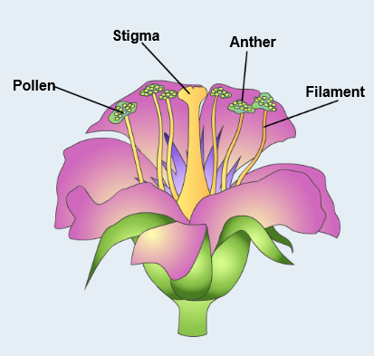

**Gizmo Warm-up**

**Pollination** is the transfer of **pollen** grains from the male part of a flower, called the **stamen**, to the female part of a flower, which is called the **pistil**. This fertilizes the female flower and enables it to produce seeds and fruit. In the *Flower Pollination* Gizmo, you will explore how this process works.

1. On the POLLINATION tab, check that **Self-pollination** is selected. How many flowers do you see? _________

Notice the different parts of the flower. The **stigma** is a sticky surface at the top of the female pistil. The male **stamen** consists of a long filament and a pollen-producing **anther**.

1. Select **Cross-pollination**. How many flowers do you see now? _________
2. How do you think **cross-pollination** may be different from **self-pollination**? ____________

_________________________________________________________________________

|  |  |  |
| --- | --- | --- |
| **Activity A:**  **Pollination** | Get the Gizmo ready:   * Select the POLLINATION tab. * Click **Self-pollination**. * Click **Start over**. | 635SE2 |

**Question: How are self-pollination and cross-pollination the same and how are they different?**

1. Observe: Follow the directions in the Gizmo to observe the steps of self-pollination. In your own words describe what happens in each step.

|  |  |
| --- | --- |
| 1 |  |
| 2 |  |
| 3 |  |
| 4 |  |
| 5 |  |

1. Think about it: Read the description of the last step carefully. Why do you think plants surround the seeds with a yummy fruit?

_________________________________________________________________________

1. Observe: Click **Start over**, then click **Cross-pollination**. Follow the directions to observe the steps of cross-pollination. How is cross-pollination different from self-pollination?

_________________________________________________________________________

1. Extend your thinking: In cross-pollination, pollengrains must get from one flower to another. What are some ways that this might happen? Discuss your answer with your teacher and classmates.

_________________________________________________________________________

_________________________________________________________________________

|  |  |  |
| --- | --- | --- |
| **Activity B:**  **Flower parts and pollination** | Get the Gizmo ready:   * Select the IDENTIFICATION tab. * Click **Start over**. * Check **Show information**. | 635SE3 |

**Goals: Identify the parts of the flower and describe the function of each.**

1. Complete the diagram: Drag the ten listed flower parts to the blanks in the diagram. When a part is labeled correctly, information about the part appears below.

When your diagram is complete, click the camera icon at upper right to take a snapshot. You can then paste the snapshot into a blank word-processing document.

1. Test yourself: Uncheck **Show information**. For each flower part below, write the letter of the correct description. Use the Gizmo to check your answers.

______ **Anther** A. A small leaf that protects the flower before it blooms

______ **Filament** B. They contain pollen

______ **Ovary** C. Tiny grains that contain sperm cells

______ **Ovules** D. The male part of the flower

______ **Petal** E. The part of the pistil between the stigma and the ovary

______ **Pistil** F. They grow from a pollen grain to an ovule

______ **Pollen** G. The female part of the flower

______ **Pollen tube** H. They contain the egg cells and develop into seeds

______ **Sepal** I. A part of the plant that attracts insects

______ **Stamen** J. A stalk that supports the anther

______ **Stigma** K. The sticky top of the pistil

______ **Style** L. The part of the pistil that contains the ovules

1. Make connections: How might having the anther atop a tall filament make it more likely that plants will be pollinated?

_________________________________________________________________________

1. Think and discuss: In some plants, the pistils don’t form until a few days after the stamens do. How might this keep a plant from self-pollinating?

_________________________________________________________________________

_________________________________________________________________________