Vocabulary: Eyes and Vision 2 – Focusing Light

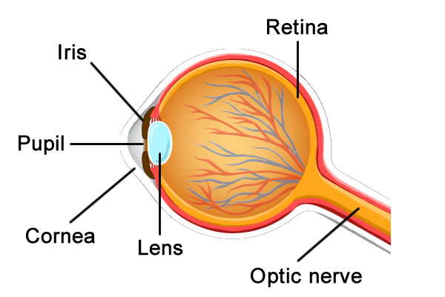
Vocabulary

- Cornea – a transparent layer at the front of the eye that protects the iris and pupil.
  - The cornea also bends light, helping to bring the image into focus.

- Diameter – the length of a line that goes from one edge of a circle to another, passing through the center.
  - The diameter describes how wide (or tall) a circle is.

- Focus – to bend light to form a sharp image.
  - In the eye, the lens bends light rays to form a focused image on the retina.
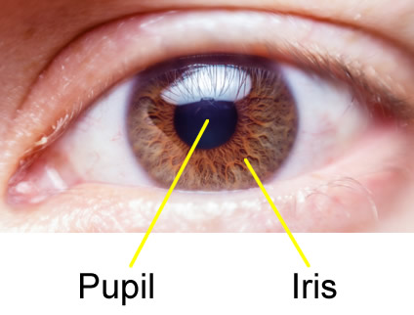
  - If an image is not focused, it will look blurry.

- Iris – the colorful structure surrounding the pupil.
  - The iris controls the size of the pupil.
  - The iris gives the eye its color. An iris may be brown, blue, green, gray, or a mixture of colors.

- Lens – a transparent rounded structure within the eye that focuses light.
  - Muscles in the eye can change the shape of the lens to focus on objects that are near or far away.

- Optic nerve – the nerve that connects the eye to the brain.
  - Signals from nerve cells in the retina are carried by the optic nerve to the brain, where the signals are converted into the images we see.

- Pupil – an opening in the center of the iris that allows light to enter the eye.
  - The size of the pupil changes in response to the brightness of light.

- Retina – a sheet of cells at the back of the eye.
  - The cells of the retina detect light. When stimulated by light, these cells send an impulse to the brain through the optic nerve.

