Vocabulary: Food Chain

Vocabulary

- Consumer – an organism that obtains energy by feeding on organic matter.
  - Organic materials are carbon-based compounds produced by living things.
  - All animals, all fungi, and even some plants are consumers.
  - A cow chewing grass, a person eating a steak, earthworms digesting manure, and mold growing on bread all represent consumers in action. In each case the organism is consuming organic matter.

- Ecosystem – a community of living things along with their natural environment.

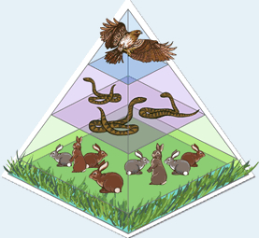
- Energy pyramid – a representation of a food chain that demonstrates how food energy decreases as you move up the food chain.
  - The energy pyramid has the shape it has because energy is lost on each level. For example, when rabbits eat grass, much of the energy they get from grass is used for movement, breathing, and other life functions. This energy cannot be used by the snakes that eat the rabbits.

- Equilibrium – a stable situation in which opposing forces are balanced.
  - If an ecosystem is in equilibrium, the population of each organism will not change much from year to year.

- Food chain – a sequence of organisms in which each organism feeds on the one below.
  - Example: Grass Rabbit Snake Hawk.
In this food chain, rabbits eat grass, snakes eat rabbits, and hawks eat snakes.

- Population – all organisms of a certain kind within a defined region.

- Predator – an animal that kills and eats other animals.

- Prey – an animal that is killed and eaten by other animals.

- Producer – an organism that converts simple inorganic matter (such as water and carbon dioxide) into organic matter (such as sugar and protein).
  - Most plants use the energy of the Sun to create organic matter from carbon dioxide and water. This process is called photosynthesis.
  - No sunlight reaches the ocean floor, but some bacteria can use energy from hot water vents on the ocean floor to produce organic material.

