Name: Date:

**Student Exploration: Fractions with Unlike Denominators**

**Vocabulary:** denominator, difference, equivalent, fraction, least common denominator (LCD), numerator, sum

**Prior Knowledge Questions** (Do these BEFORE using the Gizmo.)

1. Jenna has 4 fish and buys 6 more. Fill in the blanks to show how many fish Jenna has in all.

__________ fish + __________ fish = __________ fish

1. Joe adds 2 ninths and 3 ninths. Fill in the blanks to show the sum.

__________ ninths + __________ ninths = __________ ninths

**Gizmo Warm-up**

A **fraction** relates a part and a whole. The **denominator** (bottom number) tells how many equal parts each whole is divided into. The **numerator** (top number) is how many parts are referred to or shaded. The *Fractions* *with Unlike Denominators* Gizmo lets you add or subtract fractions with area models. To change a denominator, either drag the slider, or click on the number in the text field, type a new value, and hit **Enter**. To shade the models, simply click inside them.

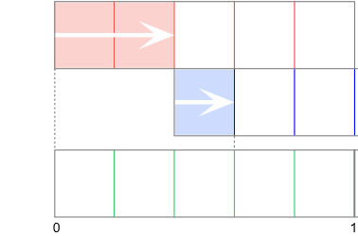

1. Click **Clear** and select **+**. Set all denominators (**Red denominator**, **Blue denominator**, and **Denominator of sum**) to 5. Click to shade 2 parts of the red model and 1 part of the blue model.
2. Shade the bottom model to the right and in the Gizmo to show the **sum**. (Be sure the right edge of your shading

lines up with the right edge of the blue shading.) If you need help, click **Show Me**.

+

=

1. What sum have you modeled? (The sum is shown at the top of the Gizmo.) Fill the sum in to the right.
2. 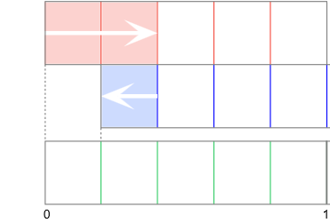Select **–** to subtract (find the **difference** of) the same two fractions.
3. Shade the bottom model to the right and in the Gizmo to show the difference. (Be sure the right edge of the shading lines up with the *left* edge of the blue shading.)

–

=

1. What difference have you modeled? Fill this difference in to the right.

|  |  |  |
| --- | --- | --- |
| **Activity A:**  **Like denominators** | Get the Gizmo ready:   * Click **Clear** and select **+**. * Set all three denominators to 3. | 220SE3 |

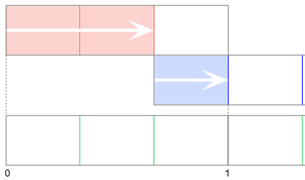

1. With **+** selected, shade 2 parts of the red model and 1 part of the blue model, as shown at the right.
2. The addition problem modeled is  + . Fill in the blanks below to find the sum.

__________ thirds + __________ third = __________ thirds

1. Express the equation you wrote above using fractions.

+

=

1. Shade the third model (the green one), both above and in the Gizmo, to show the sum. The right edge of the shading – where the vertical dashed line is – is the sum.

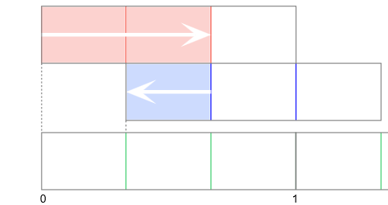

1. Click **Clear** and select **–**. Shade 2 parts of the red model and 1 part of the blue model, as shown:
2. The subtraction problem modeled is  – . Fill in the blanks below to find the difference.

__________ thirds – __________ third = __________ third

1. Express the equation you wrote above using fractions.

–

=

1. Shade the third model (the green one), above and in the Gizmo, to show the difference. The right edge of the shading – at the dashed line – is the difference.
2. Find each sum and difference. Then check your answers in the Gizmo.
3.  +  =  –  =
4.  +  =  –  =

|  |  |  |
| --- | --- | --- |
| **Activity B:**  **Unlike denominators** | Get the Gizmo ready:   * Click **Clear**. * Select **+**. * Set **Red denominator** to 5. * Set **Blue denominator** to 4. | 220SE6 |

1. With **+** selected, show  on the red model and  on the blue model.
   1. To add or subtract fractions with different denominators, you first need to convert them to **equivalent** (equal) fractions with common denominators. List fractions equivalent to  and . Stop when you find a denominator that is common to both lists.

 = _____________________________  = _____________________________

* 1. 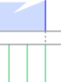Drag the green slider to the right. Stop when one of the vertical green lines aligns with the right dashed line, as shown in the picture. Look at the denominator of the green fraction. How does it compare to the common denominator you found above?

* 1. The **least common denominator** (LCD) is the lowest number that is a multiple of the denominators of a group of fractions. Use the LCD of the fractions and your answers from above to complete the equation.

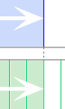

sum

20

20

20

 +  = + =

Shade the green model in the Gizmo to check the sum. Look at the far right edge of the shading where the small vertical dashed line is – that is the sum.

* 1. Select **–**. Shade the green model to show the difference of the same two fractions. Then complete the equation below.



difference

20

20

20

 –  = – =

Shade the green model in the Gizmo to check the difference. Look at the far right edge of the shading where the small vertical dashed line is – that is the difference.

**(Activity B continued on next page)**

**Activity B (continued from previous page)**

1. Click **Clear** and select **+**. Show  on the red model and  on the blue model.
   * 1. Drag the green slider to the right and then to the left to find common multiples of 6 and 4. What is the LCD of  and ? _________
     2. With **+** selected, shade the green model to show the sum of  and . Then use the model and LCD to complete the equation below. Check your answer in the Gizmo.

 +  = + =

* + 1. Fill in the blanks to find the difference of  and . Check your answer in the Gizmo.

 –  = – =

1. Find each sum or difference. Then check your answers in the Gizmo. (Note: The last two cannot be modeled in the Gizmo.)
2.  +  = + =
3.  –  = – =
4.  +  = + =
5.  +  = + =
6.  –  = – =

|  |  |  |
| --- | --- | --- |
| **Activity C:**  **Finding the missing number** | Get the Gizmo ready:   * Click **Clear**. * Select **+**. * Set all three denominators to 6. | 220SE10 |

1. Two fractions with like denominators have a sum of . One of the addends is .
   1. Show  on the red model and  on the green model. Shade the blue model to show a sum of . Use your model to fill in the blanks:  + = 

6

* 1. Set **Blue denominator** to 3. Shade the blue model until a sum of  is modeled. Use your model and your answer from above to fill in the blanks:

6

3

 + =  + = 

Notice that when the denominators are not the same, you have to find a common denominator before you can add. The same is true for subtraction.

1. The difference of  and another fraction is .
2. Click **Clear** and select **–**. Show  on the red model and  on the green model. What should you set **Blue denominator** to? __________
3. Shade the blue model until a difference of  is modeled. Use your model to fill in the blanks:  – = = 
4. Fill in the blanks. Then check your answers in the Gizmo.
5.  + = 
6.  – = 
7.  + = 