Name: Date:

**Student Exploration:** **Fraction Artist 1**

**Vocabulary:** denominator, fraction, numerator

**Prior Knowledge Questions** (Do these BEFORE using the Gizmo.)

1. Describe painting 1 (below) in as much detail as you can.
2. Describe painting 2 (below) in as much detail as you can.

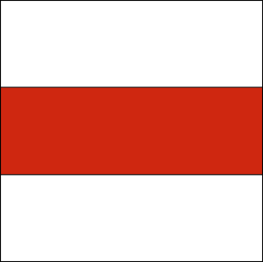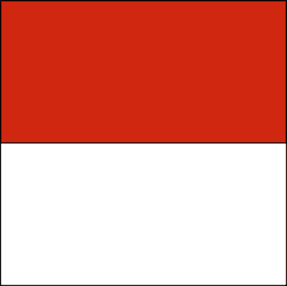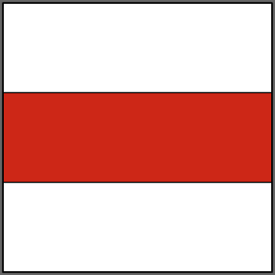

________________________________

________________________________

________________________________________________________________

________________________________

________________________________

_______________________________________________________________

**Gizmo Warm-up**

Some modern art is composed of just lines and colors. Notice that the paintings shown above were made by dividing the canvas into sections of different colors. You can use the *Fraction Artist 1* Gizmo to make these two paintings.

half tool

1. Select the **Divide canvas** tool. Then click inside the canvas to divide it into two halves.
2. On the palette, click **red**. Then click the top half of the canvas. You’ve created Painting 1!



1. Click **New painting**. Try to create Painting 2. (You’ll need to use a different **Divide canvas** tool.)
2. The three sections in Painting 2 are short and wide. Can you use the Gizmo to find a different way to divide the canvas into three equal-sized sections? Draw your canvas in the square to the right.

|  |  |  |
| --- | --- | --- |
| **Activity A:**  **Art apprentice** | Get the Gizmo ready:   * Click the **New painting** button. | 1038SE3 |

You have been hired as the apprentice to Gerhard the famous Fraction Artist. Gerhard would like you to divide some canvases he needs for his paintings.

1. Gerhard wants some canvases that are divided into *fourths*.
   1. In the Gizmo, use the **Divide canvas** tools to create a canvas with four equal-sized sections. Draw your canvas in the first square below.



* 1. Find two other ways to divide the canvas in the Gizmo into four equal-sized sections. Draw them in the other squares above.

1. Click **New painting**. Gerhard also needs some canvases divided into *sixths*.
   1. Begin by dividing a blank canvas into three equal-sized sections. Then continue dividing the canvas until it is divided into six equal-sized sections.
   2. Find three different ways to divide the canvas into six equal-sized sections. Draw them below.



1. Click **New painting**. You’ve divided canvases into two, three, four, and six equal-sized sections. Impress Gerhard by finding three new ways to divide the canvas. Draw them below. Label each with the number of equal-sized sections in it.



|  |  |  |
| --- | --- | --- |
| **Activity B:**  **Color by number** | Get the Gizmo ready:   * Click the **New painting** button. | 1038SE4 |

Gerhard the Fraction Artist has left you some notes for some paintings he’d like you to make.

1. Gerhard’s notes for the first painting say, “ red.” (Note: For the fraction , the 4 is the **denominator** and the 1 is the **numerator**.)
   1. To make the painting “ red,” divide the canvas into four equal-sized sections. Then color one of those sections red.
   2. To check your painting, select **Inspect colors** and move your mouse over the red section. The Gizmo should show that  of the painting is red because the painting has one red section (numerator) out of four equal-sized sections (denominator).
2. Click **New painting**. The instructions for the second painting say that it should be “ blue.”
3. What is the denominator of ? ________ Create that many equal-sized sections.
4. What is the numerator of ? ________ Color that many sections blue.
5. Use **Inspect colors** to make sure your painting is  blue.
6. Click **New painting**. The notes for the final painting are “ yellow and  blue.”

1. Make this painting. Use **Inspect colors** to see if you’ve matched the instructions.
2. Draw your painting to the right. (If you don’t have colored pencils, label yellow sections Y and the blue section B.)
3. Is it possible to make a painting that looks different but that still matches the instructions? Why or why not?

____________________________________________

____________________________________________

____________________________________________

|  |  |  |
| --- | --- | --- |
| **Activity C:**  **Off to art school** | Get the Gizmo ready:   * Click on the **New painting** button. | 1038SE5 |

You’ve had so much fun being an apprentice that you’ve decided to apply to art school.

* 1. The art school application wants you to make a painting that is  red and  blue.
  2. Divide the canvas into two equal-sized sections. Color it so that it’s  red.
  3. Continue dividing the canvas until it has four equal-sized sections. Do you think the painting is still  red? Why or why not?

___________________________________________________________________

* 1. There are two red sections out of four, so the painting is  red. But half of the painting is red, so it is also  red. So  is equal to .
  2. Keep dividing the canvas until it has eight equal-sized sections. What fraction of the painting is red?

_____________________________________________

* 1. Finish by making the painting  blue. Draw it to the right.

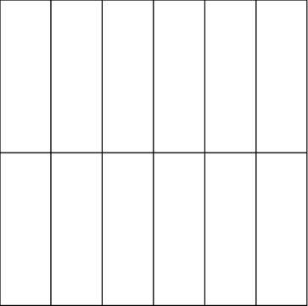

* 1. The application asks you to finish the painting to the right.
     1. Divide the canvas as shown. Then color it  blue.
     2. What other fractions also correctly express how much of your painting is blue?

__________________________________________

* 1. The final part of the application asks you to submit your own three-color painting.

1. Make your own painting with the Gizmo. Then draw it on a separate sheet of paper (or use the snapshot camera to copy and paste it into a word-processing document).
2. On a separate page, describe your painting in detail. Be sure to write what fraction of your painting is red, what fraction is blue, and what fraction is yellow.