Name: Date:

Student Exploration: Frog Dissection

Vocabulary: anatomy, appendix, diaphragm, dissect, fertilize, heart, large intestines, lungs, lymph vessels, ovary, oviduct, ovisac, rectum, sternum, testis, vasa efferentia, vertebrae

Prior Knowledge Questions (Do these BEFORE using the Gizmo.)

- Name some of the organs humans use to digest food.

- Do you think frogs have the same or different organs? Explain.

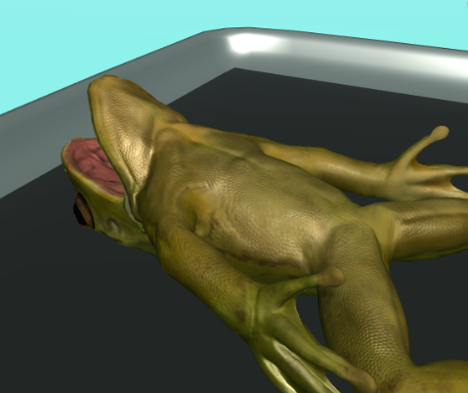
Gizmo Warm-up
Scientists dissect (cut up) other organisms to learn more about their anatomy, or body structure. In doing so, scientists can also learn more about human anatomy. In the Frog Dissection Gizmo, you will complete a virtual dissection of a female and male frog.

First, select the Female frog. Then click on the rotate button (). With the rotate button selected, click and drag on the frog to rotate it. Observe what the female frog looks like.

Now select Show male at the bottom left to switch to the male frog. Rotate around the male frog to observe what it looks like. Click Show male and Show female to toggle back and forth between the two frogs.

- Do you notice any differences between the male and female frog?

- Describe any differences you see.

Activity A:  Female frog anatomy | Get the Gizmo ready:  - Select Show female (if not already selected).  - Click Reset female. | 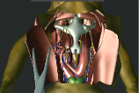

Introduction: Inside the frog’s torso are organs that allow the frog to move, breathe, circulate blood, digest food, excrete waste, reproduce, respond to stimuli, and fight off infections. You will dissect a female frog and identify the organs involved in these processes.

Question: How do you dissect a frog?

- Dissect: Select the Scalpel tool and click on the frog. What happens?

- Dissect: Select the Forceps tool. Click on the skin and muscles a few times.

What happens?

- Dissect: Pause for a few seconds. What happens to the skin and muscles?

Pins are needed to hold the skin and muscles in place or else they might fold back onto the body. Use the forceps to pull the skin and muscles open again and then use the Pins tool to pin the skin and muscles down. (After selecting Pins, click on the skin and muscle flaps.)

- Identify: Take a look at the Skeletal system diagram at the right side of the Gizmo. Find the outline of the sternum.

Do you see an organ in the frog’s chest on the left that looks like the sternum?

- Dissect: Select the Forceps. Click on and drag the sternum from the frog to the Skeletal system diagram. If you have dragged it into the correct position, the feedback below the diagram will say so. If there is a red outline, try again.

- Dissect: Carefully dissect all of the organs out of the frog’s chest and place them in the correct positions in the organ system diagrams on the right.

Click on the Right and Left arrows at the top of the Skeletal system diagram to switch to other body system diagrams. Continue dissecting until you have filled in all of the diagrams.

Hint: Don’t worry if you can’t complete an organ system diagram right away. Some organs are hidden behind other organs. If you place an organ in the incorrect position three times, a hint in the Gizmo will tell you which organ system the organ belongs to.
Activity B:  Organs in the female frog | Get the Gizmo ready:  - If necessary, dissect the female frog.  - Fill in all the female organ system diagrams. | 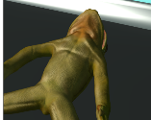

Introduction: If you are doing this after completing activity A, you should have finished dissecting the female frog. If not, do that now. (See activity A for instructions.)

Question: What is the anatomy of a female frog?

- Match: Go to the skeletal system diagram. Click on the different labels to read about the bones. Match each bone to its description.

____ Sternum
____ Coracoid
____ Scapula
____ Urostyle
____ Vertebrae
____ Sacral vertebra
____ Ilium
- A bone that is part of the shoulder. This bone is much smaller in humans.
- The long bone at the end of the spinal column.
- The hip bone.
- A bone in the middle of the chest that protects the heart.
- Bones that surround and protect the spinal cord.
- A bone that connects the spinal column to the ilium.
- A shoulder bone that connects the torso to the arm.

- Investigate: Switch to the lymphatic system and read the description of the lymph vessels.

What does the lymph system do?

- Match: Switch to the digestive system diagram. Click on the different labels to read about the organs. Match each organ to its description.

____ Esophagus
____ Small intestine
____ Liver
____ Pancreas
____ Gallbladder
____ Stomach
____ Large intestine
- A long, thin organ that digests food and absorbs nutrients.
- A large organ that stores and helps to digest food.
- An organ that produces enzymes that aid in digestion.
- A tube that connects the mouth to the stomach.
- An organ that absorbs water, electrolytes, and nutrients from digested food and pushes waste out of the body.
- An organ that filters blood and removes toxins.
- An organ that releases bile into the small intestine to aid in digestion.

(Activity B continued on next page)
Activity B (continued from previous page)

- Match: Switch to the circulatory and respiratory systems diagram. Click on the different labels to read about the organs. Match each organ to its description.

____ Lungs
____ Heart
____ Spleen
____ Veins
____ Arteries

- A muscle that pumps blood through the body.
- Organs that transfer oxygen and carbon dioxide between the blood and air.
- Vessels that carry blood from the body to the heart.
- Vessels that carry blood from the heart to the body.
- An organ that filters blood and removes old red blood cells.

- Compare: What do the lymphatic and circulatory systems have in common?

- Investigate: Look at the female frog’s reproductive system.

- In which organs are eggs produced?

After leaving the ovaries, eggs travel through the oviducts to the ovisacs before being released through the cloaca.

- What do you notice about the location of fat in the frog?

In a frog, fat bodies are considered a part of the reproductive system because they help warm the sex cells and also provide energy for mating.

- Match: Switch to the urinary system diagram. Click on the different labels to read about the organs. Match each organ to its description.

____ Kidney
____ Adrenal gland
____ Ureter
____ Bladder
- A tube that caries urine from the kidneys to the bladder.
- An organ that removes waste from the body.
- An organ that stores urine until it is released from the body.
- An organ that produces hormones.

- Investigate: Switch to the nervous system diagram and read the description of each organ.

What is the function of the nervous system?

Activity C:  Male frog anatomy | Get the Gizmo ready:  - Do this activity after dissecting the female frog.  - Select Continue.  - Under Choose frog, select Male.

Introduction: While male and female organisms share many of the same organs, they also have differences that define their sex.

Question: How is the anatomy of a male frog different from that of a female frog?

- Hypothesize: Which internal organs do you think are different in the male frog versus the female frog?

- Dissect: As you did with the female frog, dissect the male frog. Which organ system appears to be different from that of the female frog?

- Compare: When you are done filling in the diagrams, click Continue. Then click Compare.

- Compare the diagrams of the external anatomy. What three differences can you use to tell the male and female frog apart?

- Use the arrows to compare the other organ systems. Which organ system is different in the male and female frogs?
- What reproductive organs does the male frog have that the female frog does not?

- What reproductive organs does the female frog have that the male frog does not?

- Why do frogs have these different organs?

In male frogs, sperm cells produced in the testis are transported through the vasa efferentia and out of the frog’s body. In female frogs, eggs produced in the ovary are transported through the oviduct to the ovisac for storage. Male sperm cells fertilize the eggs after they are released from the female. Only fertilized eggs produce offspring.

Extension:  Frogs vs. humans | Get the Gizmo ready:  - Begin with a fully dissected male or female frog. | 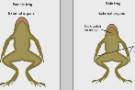
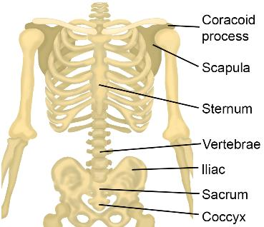
Question: What are the similarities and differences between frog and human anatomy?

- Compare: Compare the human skeletal system on the right to the frog skeletal system in the Gizmo.

- In humans, the sternum and ribs protect the heart and lungs.

Do frogs have a sternum?

Do frogs have ribs?

- How are the hip bones in a frog different from the human pelvis?

While human hips and legs are optimized for walking, frog hips and legs are optimized for leaping. The fog’s pelvis can slide up and down during jumping. The hinge connecting the frog’s ilium to its legs allows the frog to jump with accuracy.

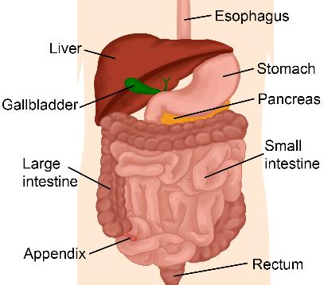
- Compare: Compare the human digestive system on the right to the frog digestive system.

- What do you notice?

- Which organs do the frog and human digestive systems have in common?

- Which organs do humans have that frogs do not?

The appendix is a small pouch at the end of the large intestine in humans. The appendix stores good bacteria in the body. The rectum is the final section of the large intestine and connects to the anus, where solid waste is eliminated. Frogs eliminate all waste (solid and liquid) through the cloaca.

(Extension continued on next page)
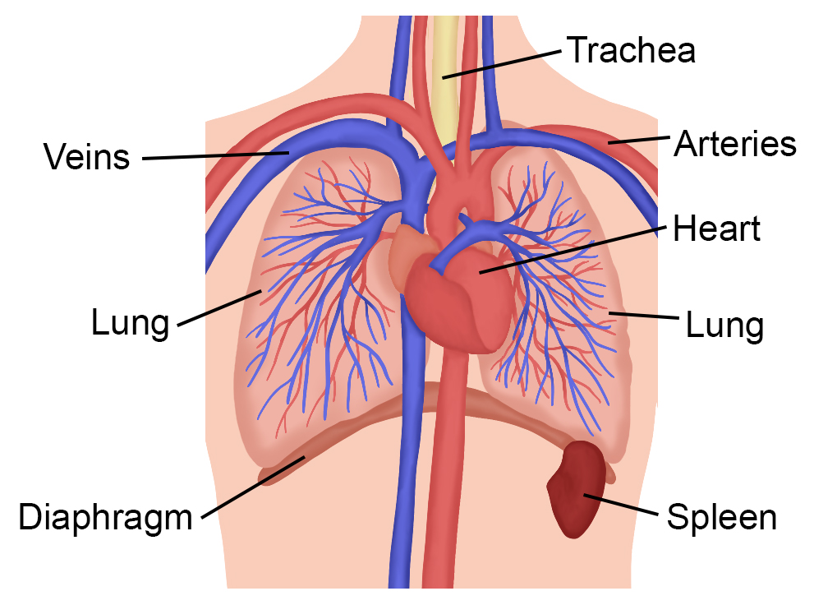
Extension (continued from previous page)

- Compare: Compare the human circulatory and respiratory system on the right to the frog circulatory and respiratory system.

- Which organs do the frog and human have in common?

- Which organ does a human have that frogs do not?
In humans, the diaphragm is a muscle that contracts (flattens) when you inhale, creating a vacuum effect that pulls air into the lungs. Frogs don’t have a diaphragm. They use muscles in the throat to pull air in. Frog can also breathe through their skin!

- Human hearts have four chambers. Read the description of the frog heart. How do frog hearts differ from human hearts?

A human heart has two ventricles, while a frog heart only has one ventricle. In the frog’s ventricle, oxygen-rich blood from the lungs mixes with oxygen-poor blood from the body. This makes frog hearts less efficient than human hearts.

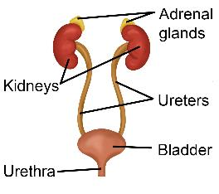
- Compare: Compare the human urinary system on the right to the frog urinary system.

Which frog organ is missing in humans?

Which human organ is missing in frogs?

Frog and human urinary systems are very similar. The main difference is that humans excrete liquid waste, or urine, through a tube called the urethra. (Solid waste is excreted from the rectum). Frogs excrete both liquid and solid waste through an opening called the cloaca.

- Discuss: Why do you think frog anatomy is so similar to human anatomy? If possible, discuss your answer with your classmates and teacher.

