Vocabulary: Frog Dissection

Vocabulary

- Anatomy – the internal and external body parts that make up an organism.

- Appendix – a finger-like projection at the beginning of the large intestine.
- Humans have an appendix but frogs do not.
- The appendix stores useful bacteria in the digestive system.
- The appendix is not a vital organ and is often removed if it becomes infected.

- Diaphragm – a muscle that separates the upper and lower chest cavity in mammals.
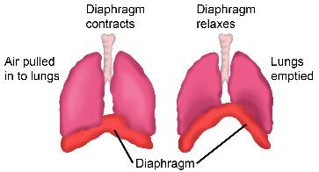
- When the diaphragm expands and contracts it pulls and pushes air in and out of the lungs.
- Frogs do not have a diaphragm. Instead, they fill their throat pouch with air, then use their throat muscles to push air into their lungs.

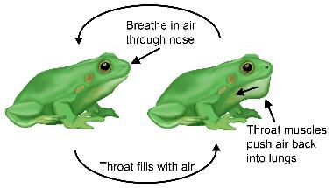
- Dissect – a process by which an organism is methodically cut up to study its internal anatomy.

- Fertilize – to combine a male sex cell (sperm) with a female sex cell (egg) to produce a fertilized cell. The fertilized cell with develop into a new organism.

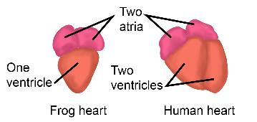
- Heart – an organ that pumps blood through the circulatory system.
- Humans have a four-chambered heart with two atria and two ventricles.
- Frogs have a three-chambered heart with two atria and only one ventricle.

- Large intestine – a long, tube-like organ in the digestive system between the small intestine and the rectum (in humans) or cloaca (in frogs).
- The large intestine is responsible for liquid reabsorption during digestion.

- Lungs – two spongy, air-filled organs in the chest where oxygen enters and carbon dioxide exits the bloodstream.

- Lymph vessels – a network of tubes that carry lymphatic fluid and white blood cells throughout the body.
- The lymph vessels are part of the immune system.

- Ovary – a female reproductive organ that produces egg cells.

- Oviduct – an organ in the female reproductive system through which egg cells pass after exiting the ovary.

- Ovisac – an organ in the female reproductive system that stores eggs after they exit the ovary and pass through the oviduct.

- Rectum – the last section of the large intestine in humans and other mammals.
  - Solid wastes are compacted and stored in the rectum before being eliminated through the anus.

- Sternum – a thick bone in at the front of the chest cavity in frogs and humans.

- Testis – a male reproductive organ that produces sperm.

- Vasa efferentia – an organ in the male frog’s reproductive system through which sperm cells pass after exiting the testis before the sperm exit the frog’s body.

- Vertebrae – a series of small bones that make up the spine of the organism.
- The vertebrae protect the spinal cord.

