Name: Date:

**Student Exploration:** **General Form of a Rational Function**

**Vocabulary:** asymptote, degree of a polynomial, discontinuity, rational function, root

**Prior Knowledge Questions** (Do these BEFORE using the Gizmo.)

1. Mavis Rent-a-Car rents cars for $50 plus $0.20 per mile. Find the cost of the trips below.

10 miles 100 miles 1000 miles *x* miles

1. Find the average cost per mile for the same four trips.

10 miles 100 miles 1000 miles *x* miles

**Gizmo Warm-up**

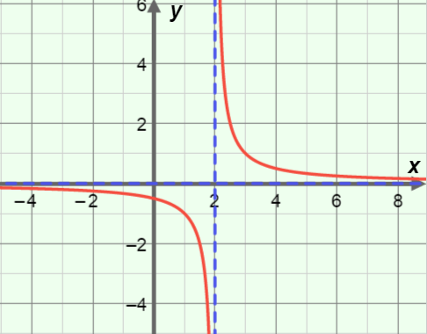A **rational function**, like the cost per mile of an *x*-mile trip from above, is a ratio of two polynomials. In the *General Form of a Rational Function* Gizmo, you can explore rational functions and their graphs.

In the Gizmo, at the top left, next to the numerator of the function, click the **–** button. This will remove the linear factor from the numerator and leave you with just a 1. Then click on the denominator of the fraction and drag the **root** slider to 2. This sets the denominator to (*x* – 2).

1. You now have graphed *y* =  in the Gizmo. Notice how the graph looks at *x* = 2.
2. Explain why the graph has a **discontinuity**, or a “break” at *x* = 2.

1. Select **Show asymptotes**. An **asymptote** is a line that a graph gets closer and closer to. Asymptotes are often shown as dotted lines.

What is the equation of the vertical asymptote in this graph?

1. A **root** of a function is a value that makes the function equal zero. With the denominator still selected, vary the **root** slider. What happens to the graph as you do this?

|  |  |  |
| --- | --- | --- |
| **Activity A:**  **Domain, vertical asymptotes, and holes** | Get the Gizmo ready:   * Be sure **Show asymptotes** is selected. | 137SE2 |

1. Without using the Gizmo, consider the function *y* = .
2. Fill in the missing *y*-values in the table below. Then plot those points on the grid.

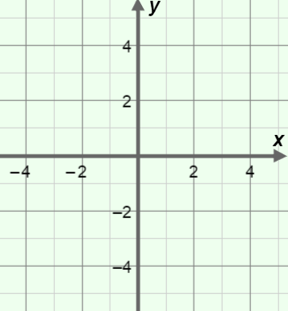

|  |  |
| --- | --- |
| ***x*** | ***y*** |
| –2 |  |
| –1 |  |
| –0.5 |  |
| 0 |  |
| 0.5 |  |
| 1 |  |
| 2 |  |

1. Why is *y* =  undefined at *x* = 0?

1. Describe the graph at *x* = 0.

1. What is the equation of the vertical asymptote?
2. What is the domain of the function *y* = ?

Graph the function in the Gizmo, and select **Show domain**, to check your answers.

1. In the Gizmo, click on the denominator to select it. Drag the **root** slider to 3. Then click **+** to increase the number of linear factors in the denominator, and drag the **root** slider to –4. The function *y* =  should now be graphed.
2. What are the roots of the denominator?
3. What are the equations of the vertical asymptotes?
4. What is the domain of this function?
5. Explain why the answers above are all related.

Check your answers by selecting **Show asymptotes** and **Show domain**.

**(Activity A continued on next page)**

**Activity A (continued from previous page)**

1. Set the number of factors in the denominator to 3 by clicking the **+**. Then adjust the roots to graph *y* = . How does this graph compare to the graph of *y* = ?

1. A rational function is graphed to the right. (Assume the numerator of the function is 1.)
2. 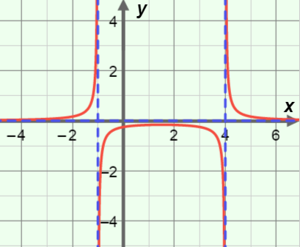What are the vertical asymptotes? and
3. What is the domain?
4. What equation do you think is graphed? Write your answer in the space to the right. Then check your answer in the Gizmo.

*y* =

1. Graph the function *y* =  using the Gizmo.
2. Describe the graph at both points of discontinuity (*x* = 1 and –3).

1. How can you simplify the function?

1. What is the value of the simplified function when *x* = 1?
2. What are the coordinates of the “hole”?
3. In general, when will a rational function’s graph have a “hole”? (Verify in the Gizmo.)

1. Explain how the graphs of *y* =  and *y* =  are different, and why.

|  |  |  |
| --- | --- | --- |
| **Activity B:**  ***x*-intercepts of rational functions** | Get the Gizmo ready:   * Click the **+** or **–** buttons so that the numerator and denominator both have one linear factor. | 137SE5 |

1. In the Gizmo, graph the function *y* = .
2. What is the root of the denominator of the function?
3. What appears in the graph at *x* = 1?
4. What is the root of the numerator?
5. What appears in the graph at *x* = –3?
6. Select the factor in the numerator. Drag the **root** slider to vary the root. What does the root of the numerator of a rational function seem to tell you about its graph?

1. Click **+** so the function has 2 or 3 factors in the numerator. Vary the roots again. Does this finding hold true when the numerator has multiple roots? Explain.

1. Why do any *x*-intercepts occur at the roots of the numerator?

1. Now graph the function *y* = .
2. Why isn’t *x* = –3 an *x*-intercept on this graph?
3. In general, when will a root of the numerator *not* be an *x*-intercept on the graph? (Verify this in the Gizmo.)

1. 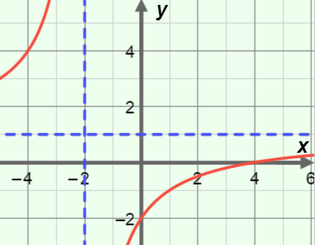A rational function is graphed to the right.
2. What is the *x*-intercept?
3. What equation do you think is graphed? Write your answer in the space to the right. Then check your answer in the Gizmo.

*y* =

|  |  |  |
| --- | --- | --- |
| **Activity C:**  **Horizontal and diagonal asymptotes** | Get the Gizmo ready:   * Click the **+** or **–** buttons so that the denominator has one linear factor and the numerator has none. * Select **Show unfactored form**. | 137SE7 |

1. 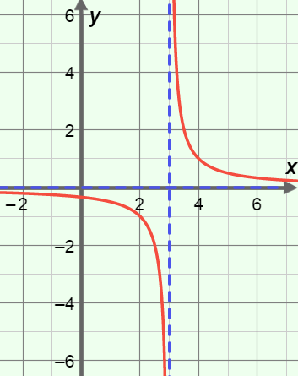In the Gizmo, graph *y* =  by selecting the denominator and moving the **root** slider to 3. Then select **Show asymptotes**. The graph is shown to the right.
2. What is the equation of the vertical asymptote?
3. As *x* approaches ∞, what happens to the *y*-values?

1. As *x* approaches –∞ what happens to the *y*-values?

1. Many graphs of rational functions have a horizontal asymptote, showing what the   
   *y*-values approach as *x* gets very large (approaches ∞) or small (approaches –∞).

In this graph, what is the equation of the horizontal asymptote?

1. Why does it make sense that the *y*-values approach 0 as *x* approaches –∞ or ∞?

1. The **degree of a polynomial** is the greatest exponent on *x*, if all the factors are multiplied out. For each rational function below, state the degree of numerator and denominator. Then graph it in the Gizmo, and state whether it has a horizontal and/or diagonal asymptote. If it does, give the equation. The first row has been filled in for you, as an example.

|  |  |  |  |  |
| --- | --- | --- | --- | --- |
| **Function** | **Degree of numerator** | **Degree of denominator** | **Horizontal asymptote?** | **Diagonal asymptote?** |
| *y* = | 0 | 1 | Yes,  *y* = 0 | No. |
| *y* = |  |  |  |  |
| *y* = |  |  |  |  |
| *y* = |  |  |  |  |

**(Activity C continued on next page)**

**Activity C (continued from previous page)**

1. Horizontal and diagonal asymptotes in the graphs of rational functions depend on the degrees of the numerator and denominator. Use the table below as you investigate this.

**Horizontal and diagonal asymptotes**

|  |  |  |  |  |  |
| --- | --- | --- | --- | --- | --- |
|  | | **Degree of numerator** | | | |
| 0 | 1 | 2 | 3 |
| **Degree of denominator** | 0 |  | | | |
| 1 | Horiz; *y* = 0 |  |  |  |
| 2 |  |  |  |  |
| 3 |  |  |  |  |

1. The previous question gave four rational functions. For each function, in the table above, write if its graph has a horizontal or diagonal asymptote (or neither). If it does, give its equation. The first one (*y* = ) has been recorded for you, under degree of numerator = 0 and next to degree of denominator = 1.
2. Fill in the table for the other three rational functions given in the previous question, all with a denominator of degree 1.
3. Complete the rest of the table by graphing other rational functions in the Gizmo.
4. Using the table, review your findings about horizontal asymptotes.
5. In general, when does the graph of a rational function have a horizontal asymptote?

1. When is the horizontal asymptote *y* = 0?

1. Using the table, review your findings for diagonal asymptotes.
2. When does the graph of a rational function have a diagonal asymptote?
3. Explain why the graph of *y* = does *not* have a diagonal asymptote.

|  |  |  |
| --- | --- | --- |
| **Activity D:**  **Practice with rational functions** | Get the Gizmo ready:   * Select **Show asymptotes** and **Show domain**. | 137SE9 |

For questions 1–3, write a rational function that satisfies the given conditions. Then graph your function in the Gizmo to check your answers.

1. Two vertical asymptotes, at *x* = 0 and *x* = 4.
2. One vertical asymptote, at *x* = –5, and one hole at *x* = 6.
3. A horizontal asymptote, at *y* = 1, and one   
   *x*-intercept, at (4, 0).

For 4 and 5, answer the questions about the graphs. Then check your answers in the Gizmo.

1. Consider the graph below, of an unknown rational function.
2. Consider the graph below, of an unknown rational function.

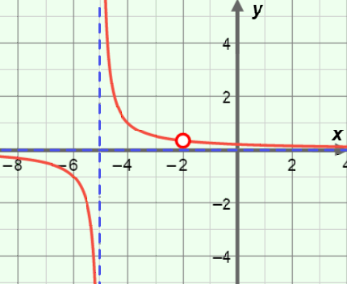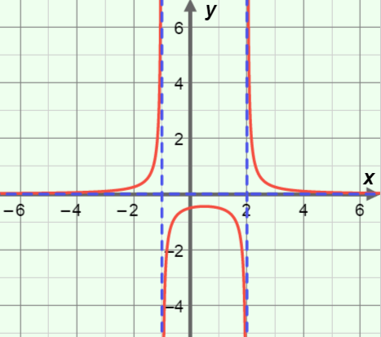

1. What is its domain?

1. What do you think is the equation of the function?
2. What is its domain?

1. What do you think is the equation of the function?