Vocabulary: General Form of a Rational Function

dictionary2

**Vocabulary**

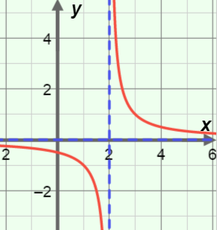

* Asymptote – a line that a graph approaches more and more closely.
  + For example, the graph of *y* = , which is shown to the right, has a horizontal asymptote of *y* = 0 and a vertical asymptote of *x* = 2.
* Degree (of a polynomial) – the greatest exponent on *x* in a polynomial.
  + For example, *y* = 4*x*3 – 5*x*2 + *x* – 7 and *y* = (*x* – 2)(*x* + 1)(*x* + 5) are both third-degree polynomials.
* Discontinuity – a point at which the graph of a function is undefined.
  + The function *y* = , graphed above, has a discontinuity at *x* = 2, where the vertical asymptote is.
    - 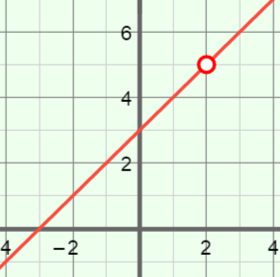This is called a *non-removable discontinuity* because it cannot be “fixed” with a single point.
  + The function *y* = , graphed to the right, has a discontinuity at *x* = 2, where the “hole” is.
    - A hole is a *removable* *discontinuity* because it could be “fixed” with a single point, in this case, (2, 5).
* Rational function – a ratio of polynomials.
  + For example, *y* = , *y* =  and *y* =  are rational functions.
* Root – an *x*-value for which the value of a function is zero.