Name: Date:

Student Exploration: Geometric Probability

Vocabulary: experimental probability, geometric probability, probability, theoretical probability

Prior Knowledge Questions (Do these BEFORE using the Gizmo.)
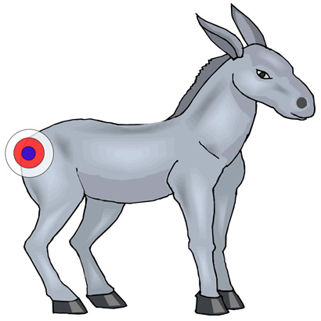
At a birthday party, Tim and his nine friends play “pin the tail on the donkey.” They use the poster shown to the right. Assume there is no way to cheat and the tail is equally likely to end up anywhere on the paper.

- About how many of the ten kids do you think will hit the target on the donkey?

- How would the chances of success change if the target were larger?

Gizmo Warm-up
In some cases, the probability, or likelihood, of an event depends on geometric properties such as length and area. The term geometric probability describes these situations. In the Geometric Probability Gizmo, you can explore the probability of a dart hitting a target based on its size.

- To begin, check that the Side length for red square (a) is set to 20, and the Side length for blue square (b) is set to 6.

- Out of 10 darts, about how many do you expect to hit the blue square?

- Click Throw 10. How many darts hit the blue square?

- Set a to 12 and b to 10. (To quickly set the value of a slider, type the value in the text box to the right of the slider, and press Enter.)

- How will this affect how many darts hit the blue square?

Explain.

- Click Throw 10. How many darts hit the blue square?

Activity:  Areas and probability | Get the Gizmo ready:  - Set a to 10 and b to 5.  - Check that Show area information is not selected.

- Select the TABLE tab. Click Throw 100. Record the number of darts in the target in the first square of the table below. Then repeat nine times for a total of 10 trials.

Trial | 1 | 2 | 3 | 4 | 5 | 6 | 7 | 8 | 9 | 10
Darts in target

- Were the results exactly the same in each trial?

- Out of 1,000 darts, how many darts hit the blue square?

- What percentage of darts hit the blue square?

This value is the experimental probability of darts hitting the target. The experimental probability is an estimate of the probability based on an experiment.

- Think about the sizes of the two squares.

- What is the side length of each square? Blue: Red:

- What is the area of each square? Blue: Red:

- What is the ratio of the blue-square side to the red-square side?

- What is the ratio of the blue-square area to the red-square area?

- Which ratio is closer to the probability estimate in question 1C?

- What percentage of the red square’s area is occupied by the blue square?

This number, which can be expressed as a fraction, decimal, or percentage, is the theoretical probability of a dart hitting the blue square.

- Why do you think it is the area ratio, and not the side-length ratio, that determines the probability of a dart hitting the blue square?

(Activity continued on next page)
Activity (continued from previous page)

- On the TABLE tab, click Clear. With a set to 10 and b set to 5, drag the blue square to another location. Press Throw 100 ten times.

- What is the experimental probability of hitting the blue square in this test?

- Did changing its location affect the probability of hitting the blue square?

- Confirm your answer by moving the blue square to other locations and finding the experimental probability for each location. Why didn’t the location have a significant effect on the experimental probability of hitting the blue square?

- On the CONTROLS tab, set a to 15 and b to 10.

- Find the theoretical probability of hitting the blue square. Show your calculations in the space to the right.

Theoretical probability:

- Select the TABLE tab. Click Throw 100 ten times.
How many darts hit the blue square, total?
- What is the experimental probability of hitting the blue square?

- How do the experimental and theoretical probabilities compare?

- Set up the Gizmo so that about 60% of the darts will hit the blue square. State the dimensions and areas of the blue and red squares. Test your setup by throwing darts.

Blue square side length and area:

Red square side length and area:

Theoretical probability of hitting the blue square:

Experimental probability of hitting the blue square:

How did you find your solution?

Extension:  Probability of at least one hit | Get the Gizmo ready:  - Turn off Show area information.  - Set a to 15 and b to 5.

Introduction: In some situations, mathematicians are interested in the probability of an event happening at least once, such as at least one dart hitting the target. The best way to solve this problem is to solve the opposite problem: what is the probability that no darts hit the target?

- With a set to 15 and b to 5, find the ratio of the blue square’s area to the red square’s area.

- What is the theoretical probability of a dart hitting the blue square?

- Suppose you threw 10 darts at the blue square several times. About how often do you think all no darts will hit the blue square?
- Select the TABLE tab. Click Throw 10 50 times (500 total darts). Scroll carefully through the table. In how many trials were there at least one hit?
- What is the experimental probability of at least one hit?

- Imagine throwing the darts one at a time. Each throw is not affected by any of the others. When two events are independent like this, the probability of both events happening is equal to the probability of the first event multiplied by the probability of the second event.

- What is the probability of the first dart not hitting the blue square?

- What is the probability of not hitting the blue square twice in a row?

- What is the probability of no darts in 10 hitting the blue square?

- What is the probability of at least one hit?

- How does the theoretical probability of at least one hit in ten throws compare to the experimental probability you found above?
- Challenge: If the probability of a dart hitting the blue square is P, what is the probability that no darts out of 10 will hit the blue square?
- Change b to 7. What is the new probability of zero hits out of 10?

- When b is 7, what is the probability of at least one hit out of 10?

- Test your answer in the Gizmo by clicking Throw 10 50 times. What were your results?

