Vocabulary: Geometric Probability

dictionary2

**Vocabulary**

* Experimental probability – an estimate of the likelihood of an event, based on the outcome of an experiment.
* If an event occurs *x* times in *y* trials, its experimental probability is .
* For example, if a coin is flipped 50 times and lands on heads 23 times, the experimental probability of heads is .

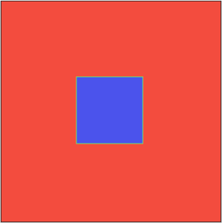

* Geometric probability – probability that depends on geometric properties such as length and area.
* For example, if darts are thrown at random at the squares shown to the right, the probability of a dart hitting the blue square depends on the areas of the two squares.
* Probability – the likelihood of an event, expressed as a number between 0 and 1.
  + A probability of 0 (or 0%) means that the event is impossible.
  + A probability of 1 (or 100%) means that the event is certain.
  + A probability of  (or 0.40, or 40%) means that an event will occur about 2 times out of every 5 trials, or 40% of the time.
* Theoretical probability – probability that is derived from logic and calculation.
* If all outcomes are equally likely, the theoretical probability of an outcome is equal to 1 divided by the number of possible outcomes.
* For example, the theoretical probability of rolling a “4” on a 6-sided number cube is , or about 0.167 (16.7%).