Name: Date:

Student Exploration: Graphs of Polynomial Functions

Vocabulary: absolute extrema, cubic function, end behavior, quadratic function,
quartic function, relative extrema

Prior Knowledge Questions (Do these BEFORE using the Gizmo.)

- The graphs below show the functions y = x, y = x², y = x³, and y = x⁴. Write the correct function on each graph. (Hint: If you are having trouble, evaluate each function at x = –2.)
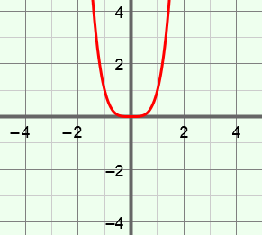
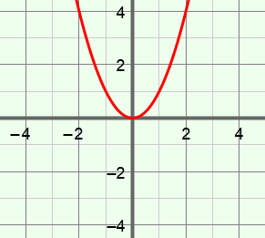
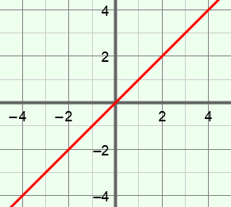
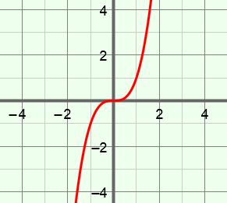
y =
y =
y =

y =

- What do the graphs of the two even-degree functions (y = x² and y = x⁴) have in common?

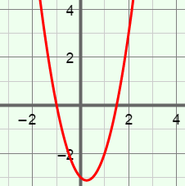
Gizmo Warm-up
In the Graphs of Polynomial Functions Gizmo, you will explore the intercepts and behavior of polynomial functions up to the fourth degree.

On the CONTROLS tab, set a and b to 0.0. You can change the values of a, b, c, d, and f by dragging the sliders, or by clicking in the text field, typing in a value, and hitting Enter.

- Drag the sliders to vary the values of c, d, and f to explore a variety of quadratic functions, or second-degree functions. (The degree of a polynomial is the greatest power of x.)

- Turn on Show intercepts. What is the maximum and minimum number of
x-intercepts a quadratic function can have? Maximum: Minimum:
- How many y-intercepts does a quadratic function have?

- Now just vary c, the coefficient of x². How does the sign of c affect the graph?

Activity A:  Intercepts | Get the Gizmo ready:  - On the CONTROLS tab, set a to 0.0, b to 0.5, c to –2.0, d to –1.0, and f to 4.0.  - Turn on Show intercepts. | 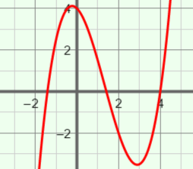

- The function graphed, y = 0.5x³ – 2x² – x + 4, is a cubic (third-degree) function.

  - How is the graph of this cubic function different from graphs of quadratic functions?

  - Increase the value of b, the leading coefficient. How does this affect the graph?

  - Vary b, c, d, and f to explore other cubic functions. In general, how many
x-intercepts can a cubic function have? Maximum: Minimum:

- Graph y = 0.5x⁴ + x³ – 2x² – 2x + 1 in the Gizmo. This is a quartic (fourth-degree) function.

- How is the graph of this quartic function different from the graphs of quadratic and cubic functions?
- Increase the value of a. How does the leading coefficient affect the graph?

- Vary a, b, c, d, and f to explore other quartic functions. In general, how many
x-intercepts can a quartic function have? Maximum: Minimum:

- Vary f, the constant term. Try this with quartic, cubic, quadratic, and linear functions.

  - What does the constant term tell you about the graph?

  - Explain why this makes sense.

(Activity A continued on next page)
Activity A (continued from previous page)

- Suppose a polynomial function has degree n.

- What do you think is the maximum number of x-intercepts of this function?

Explain.

- How many y-intercepts do you think this function has? Explain.

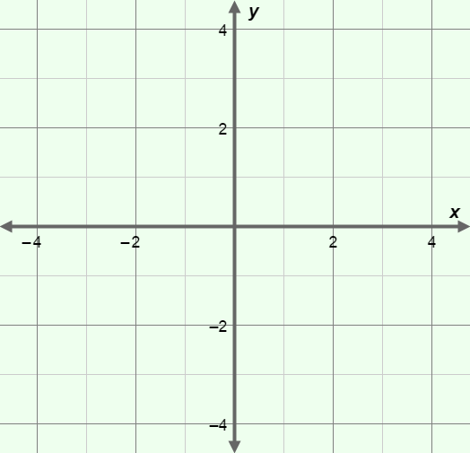
- Consider the function y = 2x³ + 4x² – x – 1.

- What do you know about the graph just from looking at the function?

- Graph y = 2x³ + 4x² – x – 1 in the Gizmo to check your answer. Sketch the graph on the coordinate plane to the right. Draw and label the x- and y-intercepts with their coordinates.

- Consider the function y = x⁴ + x³ – 3x² – x + 2.

- What do you know about the graph just from looking at the function?

- Graph y = x⁴ + x³ – 3x² – x + 2 in the Gizmo to check your answer. Sketch the graph on the coordinate plane to the right. Draw and label the x- and
y-intercepts with their coordinates.

Activity B:  Relative extrema | Get the Gizmo ready:  - On the CONTROLS tab, set a to 0.0, b to 0.0, c to 1.0, d to 2.0, and f to –4.0.  - Turn off Show intercepts. | 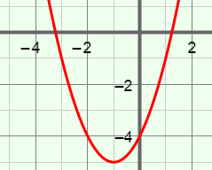

The shape of the graph of a polynomial function is described by the number of “peaks” and “valleys” (or when it changes from increasing to decreasing, or vice versa). Relative extrema, the highest or lowest points in certain sections of the graph, occur at each peak or valley.

- The function graphed in the Gizmo should be y = x² + 2x – 4.

  - How many relative extrema does the graph of this quadratic function have?

In this graph, the relative extremum is also the absolute extremum, the highest or lowest point of the entire graph.

  - Is this absolute extremum a maximum or a minimum?

  - Vary c, d, and f to explore other quadratic functions. What is the maximum number of relative extrema for a second-degree polynomial function?
- Graph y = x³ + x² – 3x – 2 in the Gizmo.

- Sketch the graph of y = x³ + x² – 3x – 2 on the grid to the right. Mark and label any relative extrema as “relative maximum” or “relative minimum.”

How many relative extrema does the graph of this cubic function have?

relative maximum(s)

relative minimum(s)

total relative extrema

- Vary b, c, d, and f to explore other cubic functions. What is the maximum number of relative extrema for a third-degree polynomial function?
- Does a third-degree polynomial function ever have any absolute extrema?

Explain.

(Activity B continued on next page)
Activity B (continued from previous page)

- Graph y = x⁴ – 3x³ + x² + 2x – 1 in the Gizmo.

- Sketch the graph on the coordinate plane to the right. Mark and label any relative extrema as “relative maximum” or “relative minimum.”

How many relative extrema does the graph of this quartic function have?

relative maximum(s)

relative minimum(s)

total relative extrema

- Vary a, b, c, d, and f to explore other quartic functions. What is the maximum number of relative extrema for a fourth-degree polynomial function?
- Does a fourth-degree polynomial function ever have any absolute extrema?

Explain.

- Suppose a polynomial function has degree n.

- What do you think is the maximum number of relative extrema of this function?

Explain.

- If n is odd, do you think the function will have any absolute extrema?

Explain.

- If n is even, do you think the function will have any absolute extrema?

Explain.

Activity C:  End behavior | Get the Gizmo ready:  - Click the button to reset the graph.  - On the CONTROLS tab, set a to 0.0, b to 0.5, c to –5.0, d to 0.0, and f to 3.0.  - Check that Show intercepts is turned off. | 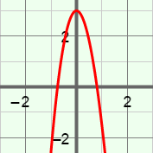

- The end behavior of a graph describes what happens to the y-values as x approaches infinity and negative infinity. Check that y = 0.5x³ – 5x² + 3 is the graph shown in the Gizmo.

  - Based on the part of the graph you can see, what appears to happen to y as x approaches infinity?
  - Next to the graph, click the button three times to zoom out. Based on this view, what happens to y as x approaches infinity (∞)?
  - What happens to y as x approaches negative infinity (–∞)?

- The greatest exponent of an odd-degree function is odd. Examples of odd-degree functions are y = x + 6, y = 2x³, and y = x⁷. In the Gizmo, experiment with functions of degree 1 and 3.

- Fill in the blanks to show what happens to y as x approaches infinity or negative infinity when the leading coefficient of an odd-degree function is positive.

as x → ∞, y → as x → –∞, y →

- Fill in the blanks to show what happens to y as x approaches infinity or negative infinity when the leading coefficient of an odd-degree function is negative.

as x → ∞, y → as x → –∞, y →

- The greatest exponent of an even-degree function is even. Examples of even-degree functions include y = 3x², y = x⁴ – 5x³ + 8, and y = 2x⁸ + x⁵ – x. In the Gizmo, experiment with functions of degree 2 and 4.

- Fill in the blanks to show what happens to y as x approaches infinity or negative infinity when the leading coefficient of an even-degree function is positive.

as x → ∞, y → as x → –∞, y →

- Fill in the blanks to show what happens to y as x approaches infinity or negative infinity when the leading coefficient of an even-degree function is negative.

as x → ∞, y → as x → –∞, y →

(Activity C continued on next page)
Activity C (continued from previous page)

- Fill in the blanks in the following table to summarize what you have discovered about the end behavior of odd- and even-degree functions.

 | Odd-degree function | Even-degree function
Positive leading coefficient | as x → ∞, y →  as x → –∞, y → | as x → ∞, y →  as x → –∞, y →
Negative leading coefficient | as x → ∞, y →  as x → –∞, y → | as x → ∞, y →  as x → –∞, y →

- Describe the end behavior of each of the following polynomial functions.

- y = x¹⁰ + 5x⁷ – 3 as x → ∞, y → as x → –∞, y →

- y = –2x⁵ – 4x² + x as x → ∞, y → as x → –∞, y →

- Extension: The highest-degree term of a function determines the end behavior of its graph. The lower-degree terms affect the behavior of the graph in other ways.

- Click the button to reset the graph. Graph y = 0.5x⁴. Note the shape of the graph. Next, set b to 2.0 to graph y = 0.5x⁴ + 2x³. What do you notice about the shape of the graph near the origin? (Hint: For comparison, look at the graph of y = 2x³.)

- Set b back to 0.0 and set c to –4.0 to graph y = 0.5x⁴ – 4x². What do you notice about the shape of this graph near the origin?

- In general, why do you think the lower-degree terms have more influence near the origin, while the highest-degree term dominates farther away from the origin?

