Vocabulary: Graphs of Polynomial Functions

Vocabulary

- Absolute extrema – the highest or lowest points of the graph of a function.
- The highest point is an absolute maximum, and the lowest point is an absolute minimum.

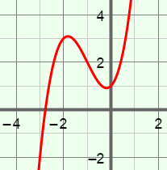
- Cubic function – a function defined by a polynomial of degree 3.
- The graph of the cubic function y = x³ + 3x² + x + 1 is shown to the right.

- End behavior – the behavior of the graph of a function as x approaches infinity and negative infinity.
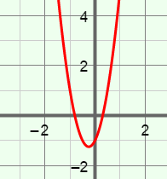
- Quadratic function – a function defined by a polynomial of degree 2.
- The graph of the quadratic function y = 4x² + 2x – 1 is shown to the right.
- The graph of a quadratic function is always a parabola.

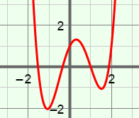
- Quartic function – a function defined by a polynomial of degree 4.
- The graph of the quartic function y = x⁴ – x³ – 3x² + 2x + 1 is shown to the right.

- Relative extrema – the highest or lowest points in a section of a graph of a function.
- The highest point in a given section is called a relative maximum or local maximum.
- The lowest point in a given section is called a relative minimum or local minimum.

