Name: ______________________________________ Date: ________________________

Student Exploration: Gravity Pitch

Vocabulary: escape velocity, gravity, orbit, orbital velocity, trajectory, velocity

Prior Knowledge Questions (Do these BEFORE using the Gizmo.)

On their summer vacation, a family is standing at a scenic overlook at the top of a tall cliff. Young Alice (age 2) tosses a rock over the edge and giggles as she watches it fall. Brother Darrell (age 8) thinks he can do better and hurls another rock over the edge. Papa Billy chuckles, picks up a nice round rock, and flings it off the cliff as hard as he can.
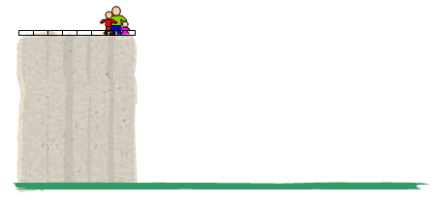
- In the picture to the right, draw the trajectory, or path, that each rock would take. Label the three trajectories “Alice”, “Darrell” and “Billy” (or just A, D and B).

- What would happen if Billy could throw the rock as fast as a rocket?

_________________________________________________________________________
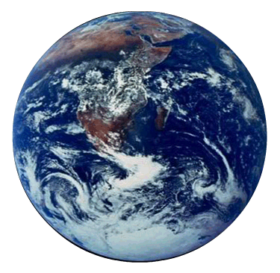

Gizmo Warm-up: Which way does gravity pull?

- Use the slider to set the Velocity to 0.0 km/s (kilometers per second). Velocity is basically the same thing as speed, but has direction as well. In this case the pitcher is simply dropping the ball. Click Play ().

  - What direction does the ball go? _______________

  - Sketch the pitcher and the trajectory of the ball on the diagram.

- Click Reset () and drag the pitcher to several new positions. Click Play and watch him drop the ball each time. Sketch the pitcher and the trajectory of each ball on the diagram.

  - What do you notice? __________________________________________________

  - The ball is pulled by a force called gravity. In what direction does gravity always pull the ball? ____________________________________________________________

Activity A:  How far does it go? | Get the Gizmo ready:  - Click Reset.  - Drag the pitcher back to the top.  - Set the Velocity to 1.0 km/s (2,232 miles per hour). | 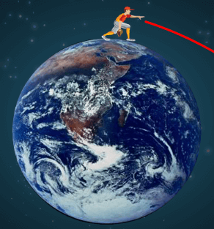

Question: Why do objects go around, or orbit, other objects?
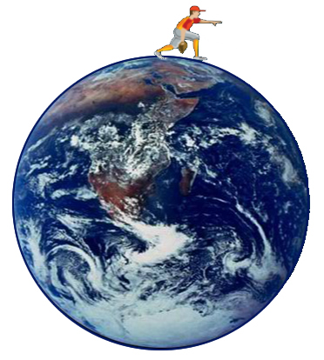
- Observe: Click Play and observe the ball’s trajectory. (Note: The pitcher is very tall – about 1500 km (930 miles) tall!)

- Predict: How would the trajectory of the ball change as the pitcher throws it harder and harder? Explain below, and draw several predicted trajectories on the diagram.

_______________________________________________

_______________________________________________

- Collect data: Throw the ball at velocities of 3, 5, and 7 km/s. If necessary, use the Fast forward button () to speed things up and the “–” zoom control to see a larger area. For each throw, sketch and label the trajectory and record the Distance traveled in the table below.

Velocity | Distance traveled
3 km/s
5 km/s
7 km/s

- Analyze: What happens? _____________________________________________________

_________________________________________________________________________

_________________________________________________________________________

- Draw conclusions: What force causes objects to stay in orbit? ________________________

  - Run Gizmo: Test 8 km/s and 9 km/s. (If you have a lot of spare time, try 10 km/s as well.) Use the “–” zoom control. What happens?

_________________________________________________________________________

_________________________________________________________________________
Activity B:  Comparing planets | Get the Gizmo ready:  - Click Reset.  - On the Planet menu, choose Venus.  - Set the Velocity to 1 km/s. | 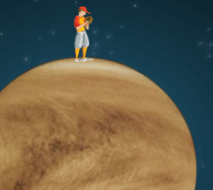

Question: How would the gravity of other planets affect a pitched ball?

- Observe: Look at the Planet mass and Planet radius of Venus. The mass of a planet is how much matter it contains. The radius of a planet is the distance from the center to the surface. Compared to Earth, what are the mass and radius of Venus?

Venus mass: _________ × Earth’s mass Venus radius: _________ × Earth’s radius

- Predict: Will the pitcher have to throw the ball faster or not as fast to send a ball into orbit around Venus? _____________ Why? _________________________________________

- Run Gizmo: Orbital velocity is the velocity needed to make a circular orbit. Use the Gizmo to find the orbital velocity of the ball on Venus. Make the orbit as circular as you can.

  - What is the orbital velocity on Venus? _____________________________________
  - Do the same on Earth. What is the orbital velocity on Earth? ___________________

  - Based on this, which planet do you think has stronger gravity, Venus or Earth? Explain. ____________________________________________________________

- Predict: Select Mars. Estimate what the orbital velocity will be on Mars: ________________
Why did you choose that value? _______________________________________________

- Run Gizmo: Adjust the Velocity until you create a circular orbit on Mars.

  - What is the orbital velocity on Mars? ______________________________________

  - How does gravity on Mars compare to Earth and Venus? _____________________

- Extend your thinking: The escape velocity is the smallest velocity needed for the baseball to escape from the planet’s gravity and fly off into space, never to return. When the ball reaches escape velocity, the Distance traveled will read “infinity.”

  - Which planet do you think has the lowest escape velocity? ____________________

  - Use the Gizmo to test your prediction. Were you correct? _____________________

Activity C:  Design a planet | Get the Gizmo ready:  - Click Reset.  - On the Planet menu, select Custom.  - Set the Velocity to 7.0 km/s. | 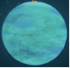

Question: How does a planet’s mass and radius affect a pitched ball?

- Observe: Using the sliders, try a variety of values for Planet mass and Planet radius for your custom planet. Observe the trajectory of the ball each time.

- Form hypotheses: Fill in the blanks below:

As its mass increases, the strength of a planet’s gravity ____________________________.

As its radius increases, the strength of a planet’s gravity ____________________________.

- Run Gizmo: Set Planet mass to 0.0 of Earth (no mass), Planet radius to 1.0 of Earth (equal to Earth). Press Play and record results. Repeat for masses of 1.0 (equal to Earth) and 2.0.

Planet mass | Planet radius | Velocity | What happened?
0.0 | 1.0 | 7.0 km/s
1.0 | 1.0 | 7.0 km/s
2.0 | 1.0 | 7.0 km/s

- Analyze: How does increasing the mass affect the gravity of the planet? How do you know?

_________________________________________________________________________

_________________________________________________________________________

- Experiment: Do the same kind of experiment, but now keep the Planet mass at 1.0 and change the Planet radius. Record results in a notebook or on a separate sheet of paper.

  - What do you notice? __________________________________________________

  - How does changing the radius affect the strength of a planet’s gravity? ___________

___________________________________________________________________

- Apply: Using what you have learned, create a planet with the strongest possible gravity. What are the mass and radius of this planet? _____________________________________

