Name: ______________________________________ Date: ________________________

Student Exploration: Heat Absorption

Vocabulary: absorb, greenhouse, radiation, reflect, thermal energy

Prior Knowledge Questions (Do these BEFORE using the Gizmo.)

- Is it usually hotter outside when the Sun is low in the sky, such as early in the morning, or when the Sun is high in the sky, around noon? ____________________________________

- If you want to stay cool on a hot, sunny day, should you wear black or white? Why?

_________________________________________________________________________

_________________________________________________________________________

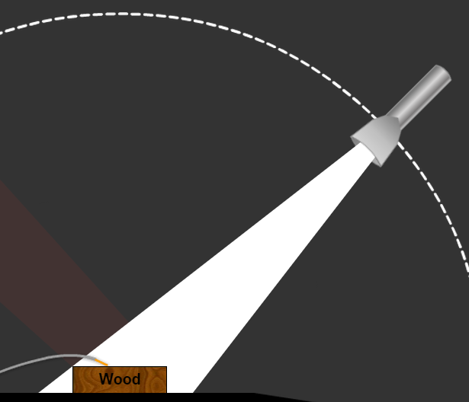
Gizmo Warm-up
In the Heat Absorption Gizmo, a powerful flashlight can shine on a variety of materials. Make sure that the Light color is set to White.

- Drag the Wood under the beam of light. What do you notice? _____________________________________
____________________________________________

- What is the color of the light that is reflected off the wooden block? ___________________

- Click Play () to start the clock.

  - What happens to the temperature of the wood? _____________________________

  - The light that is not reflected away is absorbed by the wood. What does the absorbed light energy do to the wood? ____________________________________
___________________________________________________________________

Energy that is transmitted through space by light waves is called radiation. The wood gets hotter because it gains thermal energy from the light waves.

Activity A:  Angle of light | Get the Gizmo ready:  - Click Reset ().  - Check that Light color is still set to White.  - If necessary, drag the Wood under the light. | 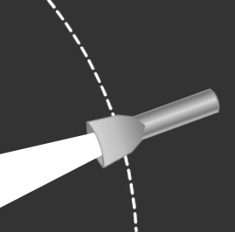

Question: How does the angle of light affect heating?

- Observe: Drag the flashlight to several different angles. When is the light beam most concentrated on the piece of wood? ____________________________________________

- Form hypothesis: How will the angle of light affect how much the piece of wood is heated?

_________________________________________________________________________

_________________________________________________________________________

- Predict: Which angle will result in the hottest piece of wood? _________________________

- Experiment: For each angle listed below, record the final temperature of the wood after 3 hours of heating with the flashlight.

 | 20° angle | 40° angle | 60° angle | 80° angle | 90° angle
Final temperature

- Draw conclusions: Why did increasing the angle of the beam of light cause the wood to heat up more? _________________________________________________________________ _________________________________________________________________________
_________________________________________________________________________

- Apply: St. Louis, Missouri, is located near the middle of the United States. On June 21, the noon Sun rays hit St. Louis at an angle of 75°. On December 21, the noon Sun rays hit at an angle of 28°. How will this affect the temperature in St. Louis on these dates?

_________________________________________________________________________

_________________________________________________________________________

_________________________________________________________________________

Activity B:  Colored materials | Get the Gizmo ready:  - Click Reset.  - Drag the flashlight so that the Light angle is 75°. | 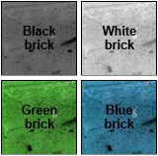

Question: How do colored materials absorb and reflect light?

- Observe: Drag the red brick under the flashlight beam. Try three different Light colors: red, blue, and green.

  - What color(s) reflect off a red brick? ______________________________________

  - What colors of light are absorbed by the brick? ______________________________

- Predict: Predict what color(s) of light will heat the red brick the most and the least.

Most heating: _______________________ Least heating: _______________________

- Collect data: Heat the red, green, and blue bricks under each color of light. Record results.

 | Red light | Blue light | Green light
Red brick final temperature
Green brick final temperature
Blue brick final temperature

- Analyze: Based on your data, what light colors were absorbed and reflected by each brick?

Red brick reflects ____________ light, absorbs ____________ and ____________ light.

Green brick reflects ____________ light, absorbs ____________ and ____________ light.

Blue brick reflects ____________ light, absorbs ____________ and ____________ light.

- Extend your thinking: White light is a combination of red, green, and blue light. Why is it cooler to wear a white shirt on a sunny day than a black shirt?

_________________________________________________________________________

_________________________________________________________________________

_________________________________________________________________________

Activity C:  Comparing materials | Get the Gizmo ready:  - Click Reset.  - Change the Light color to white. | 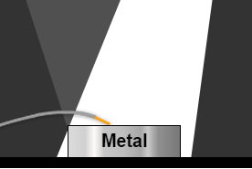

Question: Which materials are easiest to heat up?

- Predict: In this activity you will compare how metal, wood, water, and brick heat up.

  - Which substance do you think will heat up the most? ________________________

  - Which substances will heat up the least? __________________________________

- Experiment: Using white light, heat up each of the following substances for 3 hours.

 | Metal | Wood | Water | Black brick | White brick
Final temperature (no glass cover)

- Analyze: Based on the results, which substances do you think reflected the most light?

_________________________________________________________________________

- Experiment: A greenhouse is a building with a glass roof and walls. Light can get in, but the heated air inside cannot escape.

Click Add glass cover to simulate conditions in a greenhouse, and heat up each substance. Record your results below.

 | Metal | Wood | Water | Black brick | White brick
Final temperature (under glass)

- Analyze: What effect did the glass cover have? ___________________________________

_________________________________________________________________________

- Extend your thinking: Why is it dangerous to leave an infant or pet in a car on a sunny day with the windows rolled up?

_________________________________________________________________________

_________________________________________________________________________

