Name: Date:

Student Exploration: Histograms

Vocabulary: frequency, frequency table, histogram, interval, line plot
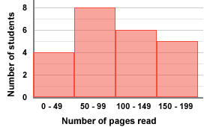

Prior Knowledge Questions (Do these BEFORE using the Gizmo.)
Mr. Graham asks his students how many pages they have read this week. The graph to the right summarizes their responses.

- Based on the graph, how many students read between 100 and 149 pages?

- Suppose Mr. Graham made a graph showing the exact number of pages each student read.

How would this graph be different from the graph that is shown?

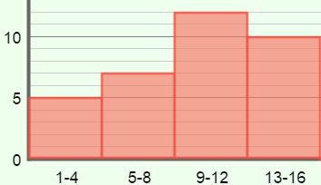
Gizmo Warm-up
When there are many data values, it is often helpful to group them into intervals, or ranges of values. A histogram is a graph that shows numerical intervals on the x-axis and how many values fall in each interval, or frequency, on the y-axis. You can explore these graphs with the Histograms Gizmo.

- To begin, check that Show line plot and Show intervals are on. The Size of interval should be set to 4. Below the histogram, turn on Show bar heights.

- Above the line plot, click Clear. Drag three points between 1 and 4 on the line plot. What do you notice on the histogram?
- Drag four points to the next interval, from 5 to 8. How does this affect the histogram?

- Drag more points to the line plot. What does the height of each bar in the histogram tell you?

Activity:  Making a histogram | Get the Gizmo ready:  - Click Clear. Check that Show bar heights is on.  - Set the Size of interval to 1. | 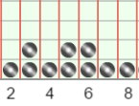

- Students in Mrs. Arbeloa’s class are surveyed to see how many video games they own. Here are their responses: 1, 2, 3, 3, 4, 5, 5, 6, 6, 7, 8, 13, 14, 14, 16, and 19.

- Click in the line plot to match the data set above. The line plot should look like this:
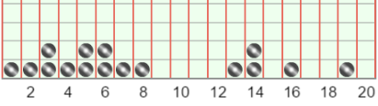

Based on the line plot, how many students are in Mrs. Arbeloa’s class?

- Before making a histogram, it is helpful to make a frequency table. The frequency table lists how many data points fall into each interval. Use your line plot to fill in the frequency table below, with an interval of 4. The first one is done for you.

Interval | 1–4 | 5–8 | 9–12 | 13–16 | 17–20
Frequency | 5

- Now you are ready to create a histogram. In the space below, draw a histogram by drawing rectangles. The height of each rectangle should equal the frequency of that interval. The first has been done for you.
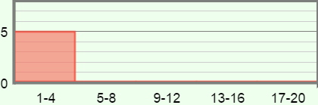

To check your frequency table and histogram, select the TABLE tab. Under Size of interval, choose 4. Make corrections if necessary.

- Based on the histogram, what are some conclusions you can draw?

- Change the Size of interval to 5. How does this change the histogram?

(Activity continued on next page)
Activity (continued from previous page)

- Click New. Under Size of interval, select different intervals for the same data set.

- How does the histogram change when the interval becomes smaller?

- How does the histogram change when the interval becomes larger?

- No matter which interval you choose, does the total height of all the bars in the histogram ever change? Explain your answer.

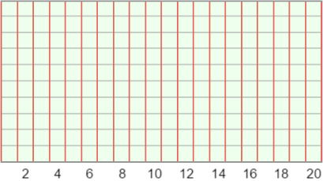
- Select the CONTROLS tab. Under Size of interval, select 1. Click New to generate a new data set. Copy the line plot of the data set from the Gizmo into the blank line plot to the right.

Based on the line plot, create a frequency table and histogram below, with an interval of 5. (Do not do this in the Gizmo until you are finished.)
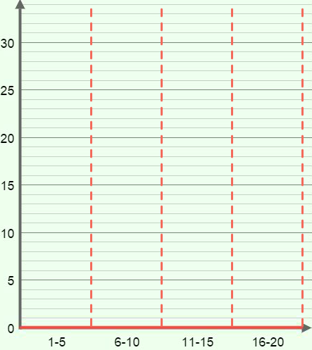
Interval | Frequency
1–5
6–10
11–15
16–20

When you are finished with your frequency table and histogram, check your answer in the Gizmo by setting the Size of interval to 5.

