Vocabulary: Histograms

Vocabulary

- Frequency – the number of times a given value occurs in a data set.
  - For example, in the data set 1, 2, 3, 3, 5, 8, 10, the frequency of the number “3” is two.

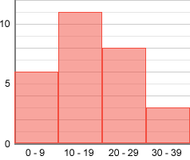
- Frequency table – a table that shows the number of data values in each given interval.

- Histogram – a graph that uses bars or rectangles to show how many data values are in each interval.
  - On a histogram, the x-axis is divided into equal-sized intervals.
  - The frequency of data values in each interval is shown by the height of the bars in the histogram.

- Interval – a set or range of numbers, defined to be between two values.
  - The histogram shown above has intervals of 0–9, 10–19, 20–29, and 30–39.

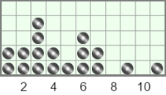
- Line plot – a graph in which each data value is represented by a dot above a number line.
  - For example, the line plot at right represents the following data set: 1, 1, 2, 2, 3, 3, 3, 3, 4, 4, 5, 6, 6, 6, 7, 7, 9, and 11.
  - Line plots are also known as dot plots.

