Name: ______________________________________ Date: ________________________

Student Exploration: Homeostasis

Vocabulary: dehydration, heat stroke, homeostasis, hypothermia, thermoregulation

Prior Knowledge Questions (Do these BEFORE using the Gizmo.)

Homeostasis is the ability to maintain a stable environment inside the body. For example, your body does things to maintain constant blood sugar levels and body temperature.

- What are some things you do to stay cool on a hot day? ____________________________

_________________________________________________________________________

- What can you do to warm up on a cold day? _____________________________________

_________________________________________________________________________

- What things does your body do automatically to cool down or warm up? ________________

_________________________________________________________________________

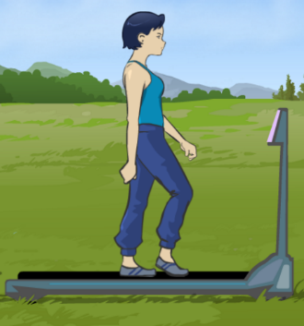
Gizmo Warm-up
The Homeostasis Gizmo shows a person on a treadmill. Notice the Air temperature and Body temperature thermometers.

- What are these temperatures? Air: ________ Body: ________

- Click Play () and wait for a while. What happens to the body temperature? ___________________________________________

- Click the Run button and wait for a while. How does exercise affect body temperature?

_________________________________________________________________________

- Set the Sweat slider to 5 L/hour (liters per hour). How does sweating affect body temperature? ______________________________________________________________

Activity A:  Automatic sweating | Get the Gizmo ready:  - Click Reset ().  - Turn on the Automatic sweating checkbox. | 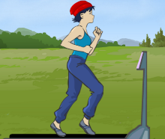

Question: How does the body maintain a stable temperature?

- Form hypothesis: In normal conditions, a person can sweat to help maintain his body temperature. How do you think sweating will be affected by air temperature?

_________________________________________________________________________

_________________________________________________________________________

- Run Gizmo: Check that Automatic sweating is selected. Drag the hat and sweatshirt to the person. Click Jog. Press Play and observe. Once in a while, you will need to drag the energy bar or water bottle to him so he can eat or drink.

Click Pause () once per hour (simulated time). Each time, record the Air temperature, Body temperature, and Sweat level.

Time | Air temp. (°C) | Body temp. (°C) | Sweat (Liters/hour)
1 hour
2 hours
3 hours

- Analyze: Look at the values on the table.

    - How does the air temperature affect the sweat level? ____________________________

______________________________________________________________________

    - The ability to maintain a steady internal temperature is called thermoregulation. How well did thermoregulation work in this case? ___________________________________

- Draw conclusions: How does sweating help with thermoregulation? ___________________

_________________________________________________________________________

- Extend your thinking: Why do you need to drink water to stay cool on a hot day? _________

_________________________________________________________________________
Activity B:  Controlling your body temperature | Get the Gizmo ready:  - Click Reset.  - Turn off Automatic sweating. | 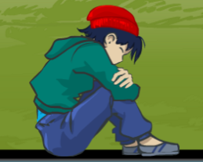

Question: How well can you maintain constant internal conditions for the runner?

- Observe: The Homeostasis Gizmo allows you to control clothing, exercise, sweat, food, and drink. Use the Gizmo to explore what happens when things go wrong.

  - What is it called when body temperature goes below 30°C? ____________________

  - What is it called when body temperature goes above 41°C? ___________________

  - What is it called when you don’t drink enough water? _________________________

- Challenge: Click Reset. Then click Play. Try to maintain a constant body temperature as the air temperature goes up and down. Every hour, click Pause and record the data asked for in the table below. (Click Reset and try this more than once if you like.)

Time | Air temp. (°C) | Body temp. (°C) | Clothing | Exercise | Sweat (L/hour)
1 hour
2 hours
3 hours
4 hours

- Analyze: Look at your data.

    - How good were you at thermoregulation? __________________________________

    - What did you do to cool down when it was hot? _____________________________
___________________________________________________________________
___________________________________________________________________
    - What did you do to warm up when it was cold? ______________________________
___________________________________________________________________
___________________________________________________________________

