Name: Date:

Student Exploration: Honeybee Hive

Vocabulary: beeswax, drone bee, cell, forager bee, hexagon, honey, larva, nectar, nurse bee, pollen, queen bee, royal jelly, waggle dance, worker bee

Prior Knowledge Questions (Do these BEFORE using the Gizmo.)

1. What do bees collect when they visit flowers, and what do they use if for?

- How do you think bees tell other bees where to find good flower patches?

Gizmo Warm-up
Honeybees are insects that collect nectar and pollen from flowers. The bees in this hive are having trouble. They can’t find enough food! In the Honeybee Hive Gizmo, you will play the role of a robot bee that helps the bees forage for pollen and nectar.

To begin, click Continue. Click on each of the bees until you find a drone bee. What are the different parts of the bee called? Use the image in the Gizmo to fill in the diagram below.

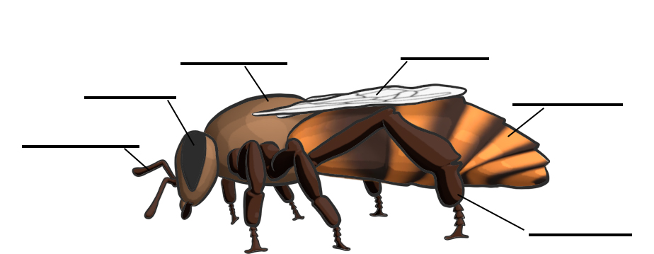

Activity A:  Inside the hive | Get the Gizmo ready:  - Make sure you are inside the hive. If not, select Start over to reset the Gizmo. | 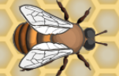

Question: What are the different parts of a bee hive and what type of bees live there?

- Explore: Click on all of the different types of bees to learn more about them. Use the information in the pop-ups to answer the following questions.

- Which bee lays all of the eggs?

- What are the names of two kinds of worker bees?

- Compare the nurse bees and foragers. How does a worker bee’s job change as it gets older?
- What other jobs do worker bees do?

- Are worker bees male or female?

- What are the male bees in the hive called?

- What does the male bee do?

- Explore: Click on the cells in the hive to learn about what a hive is made of and what is stored in the hive. Use the information to answer the following questions.

- What are the cells in the hive made of?

- Where does it come from?

- How many sides does a cell have? This shape is a hexagon.

- What is a bee called after it first hatches?

- What happens when a larva is fed royal jelly?

- What happens to flowers when bees collect pollen?

- How do bees make honey?

Activity B:  Waggle dance | Get the Gizmo ready:  - Select Start over to reset the Gizmo. | 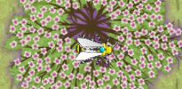

Introduction: Forager bees explore outside the hive to find flowers with lots of nectar and pollen. But if they find a good flower patch, how do they tell the other bees where to go? The answer may surprise you. They dance!
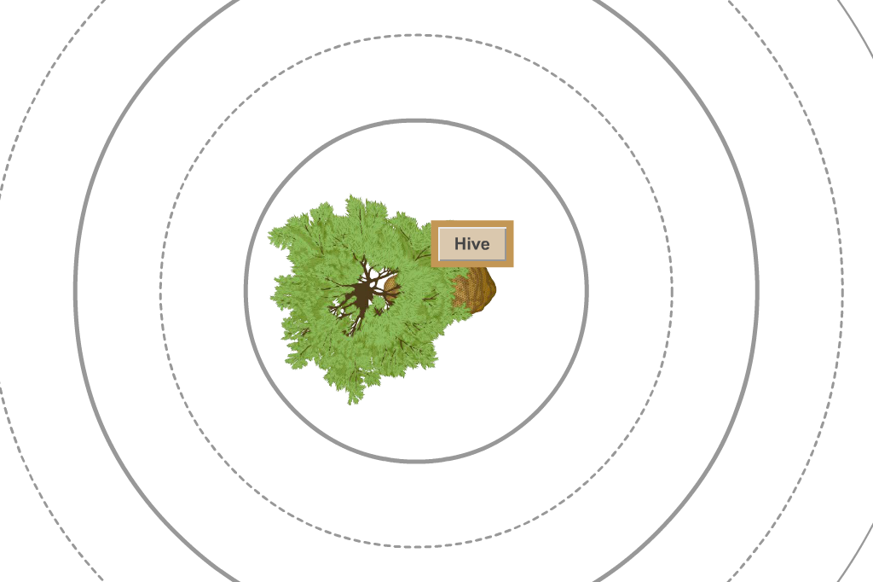
Question: How do bees communicate with each other?

- Find: Select the Outside arrow to go outside. Click Continue and turn on Show distance hints.

Select a few of the different flower patches and trees you see outside. Which one has the most pollen and nectar? Mark its location on the map at right.

Pollen amount: Nectar amount:

- Design: Select the Hive button to go back inside. Bees communicate with each other with a special dance called a waggle dance. But how does this dance show the bees where to go to find food? You will find out by programming a robot bee to dance.

Select the Design waggle dance button to open up the design screen. Click on the robot bee and rotate it to change the direction it is facing. Draw an arrow on the image on the right to show what direction you chose.

Click on one of the circles to choose the length of the waggle dance. Outline the circle you selected on the image above.

Select Start waggle dance. Observe the dancing robot bee and how the other bees react.

What do the other bees do?

- Observe: Go Outside and look at the bees.

- What distance did the forager bees fly?

- What direction did the forager bees fly?

- Did they fly the same distance and direction as your waggle dance?

(Activity B continued on next page)
Activity B (continued from previous page)

- Experiment: Go back inside and click Design waggle dance again. Experiment with different waggle dances until the forager bees find the correct flower patch. If you run out of honey, you can click Start over.

- How do you get the bees to fly in the right direction?

- How did you get the bees to fly the right distance?

- Observe: Go back inside. How much honey is in the hive?

- Forage: The bees will run out of honey soon! Bees use nectar to make honey. Select another flower patch outside with lots of nectar. Design a waggle dance to send the bees to the patch you chose. Click Start waggle dance and follow the bees outside.

- Did the bees fly to the plant that you chose? If not, try again until they do.

- What happens to the nectar and pollen, as shown by the bars at the top of the Gizmo?
- Go back inside. How much honey is in the hive now?

- Does it look like there is more honey and pollen in the hive? How can you tell?

- How many bees are in the hive?

- Did the number of bees go up from the beginning?

- Save the hive: Outside, look for more plants with pollen and nectar. Use waggle dances to show the bees where to go. Repeat until you have filled the hive with honey and bees.

What happens when the hive is full of bees?

- Summarize: From what you saw, how do bees use dance to communicate?

Activity C:  Telling direction using the sun | Get the Gizmo ready:  - Select Start over to reset the Gizmo. | 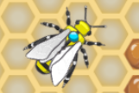

Introduction: In activity B, you saw that the forager bees would fly in the direction that the robot bee danced. But when bees go outside, how can they know in what direction they should travel?

Question: How do the bees know what direction to fly?

- Observe: Go outside. On which side of the hive is the sun: north, south, east or west?

- Test: Go inside and design a waggle dance that will send the bees towards the sun. In what direction does the robot bee dance to get the bees to fly north?
When the sun is to the north, the bees dance upward to send the foragers north. In this example, the top of the hive represents the direction of the sun.

- Observe: Go outside and select New time of day. What changes?

- Predict: Go inside. Select Design waggle dance. Make sure the robot bee is pointing up.

- In which direction do you think the robot bee will dance?

- In which direction do you think the forager bees will fly?

- Test: Select one of the circles and click Start Waggle Dance.

- In which direction is the robot bee dancing?

- After the forager bees leave the hive, follow them outside.

In which direction did the forager bees fly?

- Was this the direction that you thought the forager bees would fly?

- In question 2, you found that a waggle dance that goes up tells bees to fly towards the sun. Is this still true? Explain.

(Activity C continued on next page)
Activity C (continued from previous page)

- Experiment: Experiment with the Gizmo until you think you have figured out how to get the bees to fly to the north when the sun is in the west.

- What did you find?

- With the sun still in the west, how do you get the foragers to fly to these directions?

West:

North:

East:

South:

- Experiment: When you are outside, select New time of day. Design a waggle dance that will send the foragers towards the sun.

- In what direction is the sun?

- What direction of the waggle dance sends the foragers towards the sun?

- Think and discuss: Write a general rule about the position of the sun and the direction the robot bee dances to send the foragers to the correct place.

- Think and discuss: What does this mean about how the bees use the sun to communicate?

