Name: ______________________________________ Date: ________________________

Student Exploration: Human Evolution - Skull Analysis

Vocabulary: bipedal, canine, cranial capacity, cranium, evolve, foramen magnum, hominid, hominin, index, maxilla, orbit, palate, skull

Prior Knowledge Questions (Do these BEFORE using the Gizmo.)

- Label one of the skulls below as human and the other as a chimpanzee skull.
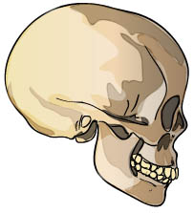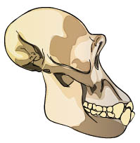

__________________ ___________________

- What features did you use to identify which skull was human and which was chimpanzee?

_________________________________________________________________________

_________________________________________________________________________

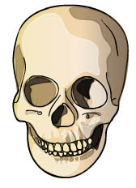
Gizmo Warm-up
In 1924, a fossilized skull that looked very similar to a chimp skull was discovered. But the skull most definitely did not belong to a chimp. The location of the foramen magnum—a hole in the skull where the spinal cord exits—indicated that the individual was bipedal, or walked on two legs. This fossil was some of the earliest evidence of human evolution.

Using the Human Evolution – Skull Analysis Gizmo, you will discover some of the ways that skulls can be used to learn about human evolution. Start by comparing two modern hominids: a human and a chimpanzee.

- Examine the Front view of the Homo sapiens (modern human) skull. Then, use the Select skull menu to examine the same view of the Pan troglodytes (chimp) skull.

How do the skulls compare? __________________________________________________

_________________________________________________________________________

- Now, examine the Bottom view of the two skulls. How do they compare? ______________

_________________________________________________________________________

_________________________________________________________________________

Activity A:  Foramen magnum | Get the Gizmo ready:  - Select the Homo sapiens (modern human) skull. | 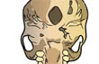
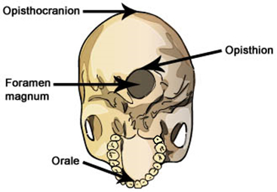
Introduction: Skulls, even from the same species, can have a wide variety of shapes and sizes. To compare skulls, scientists use measurements of certain features to calculate indexes. An index is a ratio of one measurement to another.

An important index for measuring hominid skulls is the opisthion index. This index indicates the position of the foramen magnum in the base of the cranium. The opisthion index can indicate whether a hominid species was bipedal or not.
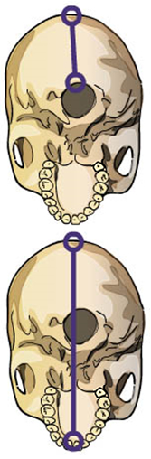
Question: How does the location of the foramen magnum indicate if a species was bipedal?

- Measure: Select the Bottom view. To determine the opisthion index for humans and chimps, follow the steps below and complete the table.
- Turn on Click to Measure Lengths. Measure the distance from the opisthocranion to the opisthion, as shown at top right. Record the opisthocranion-opisthion distance in the table below.
- Measure from the opisthocranion to the orale, as shown at bottom right. Record the opisthocranion-orale distance in the table.
- To calculate the opisthion index, divide your first measurement by your second measurement. Multiply this number by 100.

Species | Opisthocranion-opisthion distance (cm) | Opisthocranion-orale distance (cm) | Opisthion index
Homo sapiens
Pan troglodytes

- Analyze: The opisthion index is an indicator of where the foramen magnum is situated. The greater the opisthion index, the closer the foramen magnum is to the center of the cranium. This position is usually found in species that stand upright. A low value for the opisthion index occurs when the foramen magnum is situated in the rear of the cranium. This may indicate that the species walked on its knuckles or on four legs.

Using the index values you calculated, what can you conclude about humans and chimps?

_________________________________________________________________________

_________________________________________________________________________

(Activity A continued on next page)
Activity A (continued from previous page)

- Gather data: Humans, chimpanzees, and the other great apes are hominids. Hominids evolved from a common ancestor that lived about 13 million years ago. Hominins are hominids that belong to the lineage that led to humans.

Measure the opisthion index of the other hominids available in the Gizmo. (Note: the foramen magnum was not preserved in the Homo naledi skull.)

Species | Opisthocranion-opisthion distance (cm) | Opisthocranion-orale distance (cm) | Opisthion index
A. afarensis
A. africanus
P. boisei
H. habilis
H. erectus
H. heidelbergensis
H. sapiens neanderthalensis
H. floresiensis

- Analyze: Hominins are characterized by bipedalism.

- Based on their opisthion indexes, which of the hominids in the Gizmo are hominins?

___________________________________________________________________

___________________________________________________________________

- Based on opisthion indexes, which hominin skulls are most similar to human skulls?

___________________________________________________________________

___________________________________________________________________

- Explain: Why do you think the foramen magnum is positioned near the rear of the cranium for knuckle-walking species and near the center of the cranium for bipedal species?

_________________________________________________________________________

_________________________________________________________________________

_________________________________________________________________________

_________________________________________________________________________

Activity B:  Cranial capacity | Get the Gizmo ready:  - Select Side view.  - Turn off Ruler, and turn on Click to measure area. | 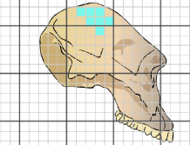

Introduction: The brain is housed inside the cranium. The internal volume of the cranium is called the cranial capacity. The larger an organism’s cranial capacity is, the larger its brain tends to be.

Question: How does the cranial capacity compare amongst hominids?
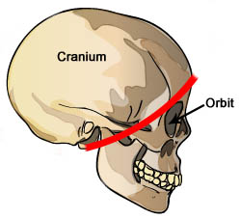
- Measure: To estimate the cranial capacity of each skull in the Gizmo, measure the area of the part of the cranium that houses the brain. This part of the cranium is roughly behind the red line in the diagram at right. You can also use the three skull images below as a guide for measuring the rest of the skulls in the Gizmo.

After you measure the area of each cranium, multiply the result by 5. This will give you a very rough estimate of the species’ cranial capacity.
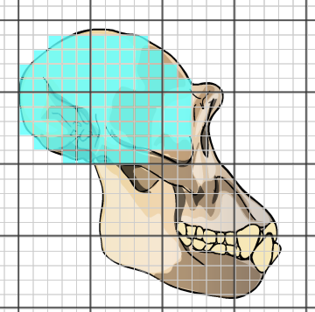
Pan troglodytes
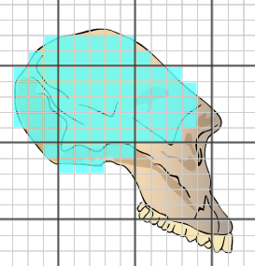
Australopithecus afarensis
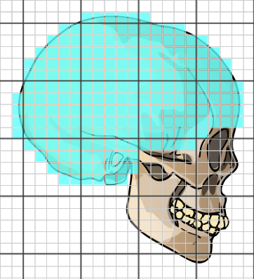
Homo sapiens

Species | Area of cranium (cm²) | Estimated cranial capacity (cm³)
Pan troglodytes
A. afarensis
A. africanus
P. boisei
H. habilis
H. erectus
H. heidelbergensis
H. s. neanderthalensis
H. floresiensis
H. naledi
H. sapiens
(Activity B continued on next page)
Activity B (continued from previous page)

- Analyze: Examine the estimated cranial capacities you calculated.

- Which species probably had the largest cranial capacities?

___________________________________________________________________

___________________________________________________________________

- What do you think cranial capacity is a good indicator of? _____________________

___________________________________________________________________

___________________________________________________________________

- Did any hominids have a larger cranial capacity than humans? If so, which species?

___________________________________________________________________

- Compare: Turn off the Area tool. Using the Front view, compare the size and shape of the forehead of a chimpanzee and the forehead of a modern human. How are they different?

- How are they different? ________________________________________________

___________________________________________________________________

- Why do you think humans have such large foreheads in comparison to chimps?

___________________________________________________________________

___________________________________________________________________

- Draw conclusions: Compare the data you collected in activity A with the data you collected in this activity. Which evolved first in hominins: bipedalism or large brains? Explain.

_________________________________________________________________________

_________________________________________________________________________

_________________________________________________________________________

_________________________________________________________________________

Activity C:  Maxilla and mandible | Get the Gizmo ready:  - Select Side view.  - Turn on Click to measure angles. | 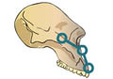

Introduction: Teeth and the bones around the mouth give a great deal of information about both a species’ diet and how it eats. Take a look at the skull features below.
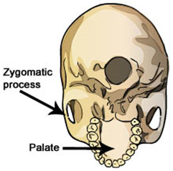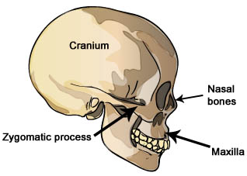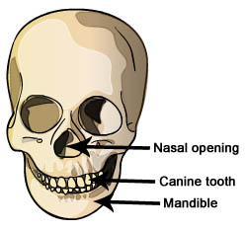

Question: How do the mouths of hominids compare?
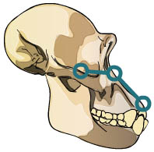

- Measure: As shown at right, place one of the protractor’s circles on the top of the zygomatic process. Place the vertex of the protractor at the top of the nasal opening (Hint: You may have to look at the Front view in order to see where the top of the nasal opening is in relation to the orbit). Place the other circle on the edge of the maxilla. The resulting angle is the maxillary angle. Complete the table. (Note: You will not be able to do this measurement on incomplete skulls.)

Species | Maxillary angle | Species | Maxillary angle
Pan troglodytes |  | Homo erectus
Australopithecus afarensis |  | Homo heidelbergensis | —
Australopithecus africanus |  | Homo sapiens neanderthalensis | —
Paranthropus boisei |  | Homo floresiensis
Homo habilis | — | Homo sapiens

- Observe: Select the Bottom view and look at the size and shape of each species’ palate. How does the maxillary angle and palate shape relate to the size of each species’ mouth?

_________________________________________________________________________

_________________________________________________________________________

(Activity C continued on next page)
Activity C (continued from previous page)

- Compare: Compare the human’s and chimp’s teeth.

- How many teeth are found in each species’ maxilla?
Pan troglodytes: _____________ Homo sapiens: _____________
- How do the size and shape of human canines compare with chimp canines?
___________________________________________________________________

- Form hypothesis: Chimps and humans eat similar foods. What do you think could explain the differences between the maxillary angle, teeth, and palate of these two species?

_________________________________________________________________________

_________________________________________________________________________

- Infer: What is the relationship between the evolution of bipedalism, the increase in cranial capacity, and the decrease in tooth and mouth size of hominins? (Hint: As cranial capacity increased, the use of sophisticated stone tools became more common.)

_________________________________________________________________________

_________________________________________________________________________

- Summarize: On a separate sheet of paper, record the age of each fossil. Then, look over all the data you collected. Summarize how hominins changed as they evolved. _____________
_________________________________________________________________________

_________________________________________________________________________

_________________________________________________________________________

_________________________________________________________________________

- Evaluate: Of the fossils presented in this Gizmo, Homo floresiensis is the youngest. In what ways does this species NOT follow the pattern of human evolution you described above?

___________________________________________________________________

_________________________________________________________________________

_________________________________________________________________________

