Vocabulary: Hyperbolas

dictionary2

**Vocabulary**

* Asymptote – a line that a curve approaches as the curve goes to infinity.
* A hyperbola has two asymptotes that intersect at the center.

**Hyperbola**

* Conic section – a curve formed by the intersection of a plane and one or two right circular cones.
* For example, the intersection of the plane and the two cones shown to the right is a hyperbola.
* Parabolas, hyperbolas, ellipses, and circles (which are special ellipses) are all conic sections.
* 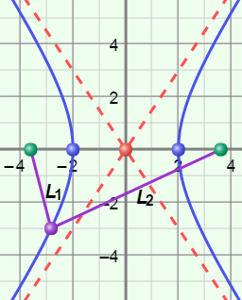Foci of a hyperbola (focus points) – the two fixed points, located on the line that contains the transverse axis, that define a hyperbola.
  + The absolute value of the difference of the distances from any point on a hyperbola to the foci is constant and equal to 2*a*.
* Hyperbola – the set of all points in a plane for which the absolute value of the difference of the distances from two fixed points, the foci, is constant.
  + |*L*1 – *L*2| = 2*a*, where *a* is the distance from the center to either of the vertices.

***a***

***c***

***b***

* Pythagorean Theorem – a theorem stating that, for any right triangle, *a*2 + *b*2 = *c*2, where *a* and *b* are the lengths of the legs of the triangle and *c* is the length of the hypotenuse.
* Standard form of the equation of a hyperbola – the equation representing a set of points in the coordinate plane for which the absolute value of the difference of the distances from two fixed points, the foci, is constant.
  + If the hyperbola opens horizontally, standard form is  –  = 1.
  + If the hyperbola opens vertically, standard form is  –  = 1.
  + In either case, the point (*h*, *k*) is the center of the hyperbola.
* Transverse axis – the line segment through the center of a hyperbola with endpoints at the vertices.
* Vertices of a hyperbola – the point on each branch of a hyperbola closest to the center.