Name: Date:

Student Exploration: Independent and Dependent Events

Vocabulary: dependent events, event, experimental probability, independent events, outcome, probability, sample space, theoretical probability

Prior Knowledge Questions (Do these BEFORE using the Gizmo.)
Maurice has a paper bag with three hard candies: two blueberry and one green apple. Yvonne and Kate ask if they can each have one.

- Yvonne closes her eyes and picks a candy from the bag, hoping for a blueberry. What are the chances she will pick a blueberry candy?

- Yvonne picks a blueberry on the first try and pops it into her mouth. Kate wants a green-apple candy. What are the chances Kate will pick green-apple?
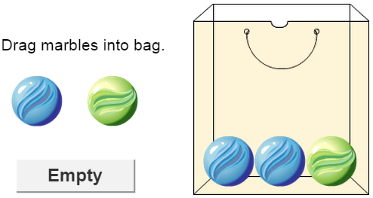
Gizmo Warm-up
The Independent and Dependent Events Gizmo models the candy experiment by simulating drawing colored marbles from a bag. You can choose whether or not the marbles are replaced after each draw. Any single result from an experiment like this is an outcome. A set of outcomes is called an event.

To begin, drag two blue marbles and one green marble into the bag. Set Replace marbles after each draw? to No and set the Number of draws to 2. This means the marbles will not be replaced after each draw.

- Look at the THEORETICAL tab on the right side of the Gizmo. Notice the notation B is used for drawing a blue marble and G for a green marble.

- What 4 outcomes of this experiment are listed in the Gizmo?

- Which of these outcomes is impossible?

The set of all possible outcomes makes up the sample space of the experiment.

- Select the EXPERIMENTAL tab. Click Run 1 trial 10 times. How many times did BG (blue first, then green) occur?
Activity A:  Compound independent events | Get the Gizmo ready:  - Select the EXPERIMENTAL tab. Click Clear.  - Create a bag with 1 blue and 1 green marble.  - Set Replace marbles after each draw? to Yes and the Number of draws to 2. | 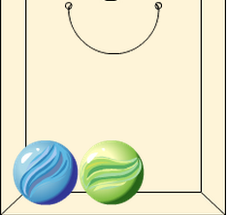

- For this experiment, there are two marbles in the bag, one blue and one green. Note that each time a marble is drawn, it will be replaced (put back in the bag) before the next draw.

- What are the four possible outcomes of this experiment?

Note that order matters in this experiment, so BG (B, then G) is a different outcome from GB (G, then B).

- Do you think any of these outcomes more likely than the others?

Explain.

- The probability of an event is the likelihood that it will occur. Probability ranges from 0 (impossible) to 1 (certain) and may be expressed as a fraction, decimal, or percent.

What do you think is the probability of each outcome? (Hint: Use percentages.)

The expected probability of an event is the theoretical probability of the event.

- Check your theoretical probabilities by selecting the THEORETICAL tab.
Were your probabilities correct? If not, make corrections as needed.

- On the EXPERIMENTAL tab, click Run 1000 trials.

- What were the results?

- The results of an experiment give the experimental probability of each outcome. What were the experimental probabilities of each outcome in your experiment?

- How close were the experimental probabilities to the theoretical probabilities you guessed in the first problem? Explain.

(Activity A continued on next page)
Activity A (continued from previous page)

- With the same bag of marbles (one blue, one green), consider drawing the marbles one at a time, replacing the marble after each draw.

- What is the probability of drawing a blue marble in the first draw?

- What is the probability of drawing a blue marble in the second draw?

- Is there any difference in these probabilities?

When the first event does not affect the probability of the second event, they are independent events. These events are independent because the marbles were replaced after each draw.

- Multiply the probability of drawing a blue marble with the first draw by the probability of drawing a blue marble with the second draw.
- Select the THEORETICAL tab. What is the theoretical probability of BB?

In general, you can determine the theoretical probability of compound independent events by multiplying the probability of the first event (P(A)) by the probability of the second event (P(B)). In symbols, this is written P(A, then B) = P(A) • P(B).

- Select the EXPERIMENTAL tab. Add a second green marble to the bag, so that the bag now contains 1 blue and 2 green marbles. Check that Yes is still selected under Replace marbles after each draw?

- What is the probability of selecting a blue marble in the first draw?

- What is the probability of selecting a blue marble in the second draw?

- What is the probability of drawing 2 blue marbles in a row (BB)?

- Find the theoretical probabilities of the other possible outcomes (BG, GB, and GG). Show each calculation. Express each probability as a fraction and percentage.

BG GB GG

- Click Run 1000 trials ten times, a total of 10,000 trials. What was the percentage of each outcome? BB BG GB GG
- Select the THEORETICAL tab. Were your theoretical probabilities correct?

If not, recheck your calculations above.

Activity B:  Compound dependent events | Get the Gizmo ready:  - On the EXPERIMENTAL tab, click Clear.  - Create a bag with 1 blue and 2 green marbles.  - Set Replace marbles after each draw? to No and the Number of draws to 2. | 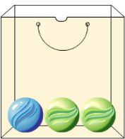

- In this experiment, there are 1 blue and 2 green marbles in the bag, and the marbles will not be replaced after they are picked. Think about how this situation is different from the situation in which the marbles are replaced after every draw.

- Is it possible to draw two blue marbles from the bag without replacement?

- What are the possible outcomes of this experiment?

Recall that order matters, so BG (B, then G) is different from GB (G, then B).

- What do you think is the probability of each outcome?

- Click Run 1000 trials ten times, for a total of 10,000 trials. What is the experimental probability of each outcome?

- When marbles are not replaced, the probabilities of the second event depends on what happens in the first event. For example, if a blue marble is drawn first, it is impossible to pick a blue marble on the second draw. In this case, the events are dependent events.

- What is the probability of drawing a blue marble first?
- If you draw a blue marble first, there are now 0 blue marbles and 2 green marbles left in the bag. What is the probability of drawing a green marble next?
- What is the probability of drawing a blue first, then a green? P(B, then G) =

- Use the same method to calculate the theoretical probabilities of the other outcomes. Show your calculations.

P(G, then B) P(G, then G)

- Select the THEORETICAL tab. Were your theoretical probabilities correct?

If not, recheck your calculations above.

(Activity B continued on next page)
Activity B (continued from previous page)

- Select the EXPERIMENTAL tab. Create a bag with 2 blue and 3 green marbles. Check that marbles are not replaced and the Number of draws is 2.

- In the space below, calculate the theoretical probability of each outcome. Express each answer as a fraction and percent. Show your work. Use the Gizmo to check.

P(B, then B)

P(B, then G)

P(G, then B)

P(G, then G)

- Click Run 1000 trials ten times. What were the experimental probabilities of each outcome?

- Challenge: Select the EXPERIMENTAL tab. With the bag of 2 blue and 3 green marbles and replacement set to No, set Number of draws to 3. Below, list the possible outcomes and their theoretical probabilities. Show your work. Use the Gizmo to check your answers.

