Name: Date:

**Student Exploration:** **Investigating Angle Theorems**

**Vocabulary:** complementary angles, linear pair, supplementary angles, vertical angles

**Prior Knowledge Questions** (Do these BEFORE using the Gizmo.)

1. Tony has a collection of 200 sports cards. He counts and finds that 40 of them are football cards. What does this tell you about the rest of his collection?

1. Suppose Tony has only football and baseball cards. Now what can you say about the rest of his collection?

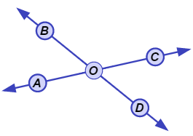**Gizmo Warm-up**

In the *Investigating Angle Theorems* Gizmo, you can manipulate a dynamic figure to explore the properties of different angles.

1. In the Gizmo, select **Vertical angles** from the **Conditions** menu. You should see two intersecting lines like the ones shown to the right.
2. Name the two pairs of angles that do not share a side. (They are nonadjacent.)

and and Both pairs are **vertical angles**.

1. Drag the points to resize the angles. What appears to always be true about the measures of the vertical angles?

Turn on **Show angle measures** and continue to resize to check if this is always true.

1. Select **Form a linear pair** to view a **linear pair** of angles (adjacent angles whose non-common sides form a straight line).
2. Name the linear pair by naming the adjacent angles.
3. Adjust the angles by dragging point *B*. What seems to always be true about the measures of a linear pair of angles?

Turn on **Show angle measures**. Drag point *B* to check if this is always the case.

|  |  |  |
| --- | --- | --- |
| **Activity A:**  **Complements and supplements** | Get the Gizmo ready:   * Under **Conditions**, select **Complementary to congruent angles**. * Be sure **Adjacent** is selected. | 185SE2 |

1. Both pairs of angles shown (∠*AXB* and ∠*BXC*, and ∠*DYE* and ∠*EYF*) are **complementary**.
   1. Drag points *B* and *E* to view a variety of complementary angles. What is true about the measures of two complementary angles?
   2. What must be true about ∠*AXB* and ∠*DYE*?

Why?

Turn on **Show angle measures** and drag point *B* to verify for a variety of angles.

* 1. Select **Nonadjacent** and drag the points. Which two angle pairs are complementary?

and and

* 1. What must be true about ∠*CXD* and ∠*GZH*?

Turn on **Show angle measures**. Experiment to see if this is always true.

* 1. What is true of any pair of angles that are complementary to congruent angles?

1. Select **Complementary to same angle** and drag points *A*, *B*, *C*, and *D*.
2. What are the two pairs of complementary angles in this figure?

and and

1. What must be true about ∠*AOC* and ∠*DOB*?

Why?

Turn on **Show angle measures** and drag the points to verify this.

1. Select **Nonadjacent** and run a similar test. What is true about angles that are complementary to the same angle?

**(Activity A continued on next page)**

**Activity A (continued from previous page)**

1. Select **Supplementary to congruent angles**. Both angle pairs shown (∠*AXB* and ∠*BXC*, and ∠*DYE* and ∠*EYF*) are **supplementary** and form linear pairs.
   1. Drag points *B* and *E* to view a variety of supplementary angles. What can you say about the measures of two supplementary angles?
   2. What must be true about ∠*AXB* and ∠*DYE*?

Why?

* 1. Select **Nonadjacent** and run a similar test. What is true about angles that are supplementary to congruent angles?

1. Select **Supplementary to same angle**. Drag the points to view a variety of figures.
2. Name two pairs of supplementary angles that contain ∠*BOC*.

and and

1. What must be true about ∠*AOB* and ∠*COD*?

Why?

Turn on **Show angle measures** and create a variety of figures to verify this.

1. Select **Nonadjacent** and run a similar test. What is true about angles that are supplementary to the same angle?
2. Select **Vertical angles** and turn on **Show angle measures**. Drag point *A* until ∠*AOB* is a right angle.
3. What is true about the four angles formed? Experiment to see if this is always true.
4. Explain why this is always the case.

|  |  |  |
| --- | --- | --- |
| **Activity B:**  **Using angle concepts** | Get the Gizmo ready:   * Select **Supplementary and congruent** under **Conditions**. | 185SE3 |

1. Drag the points to see several pairs of angles that are supplementary and congruent.
2. What is true about the measures of angles that are supplementary and congruent?

Turn on **Show angle measures** to check. Then, select **Nonadjacent** to check that this also applies to nonadjacent angles.

1. In the space to the right, use algebra to show why both angles must measure 90°.
2. Solve each problem. Show all of your work. Then, if possible, check in the Gizmo.

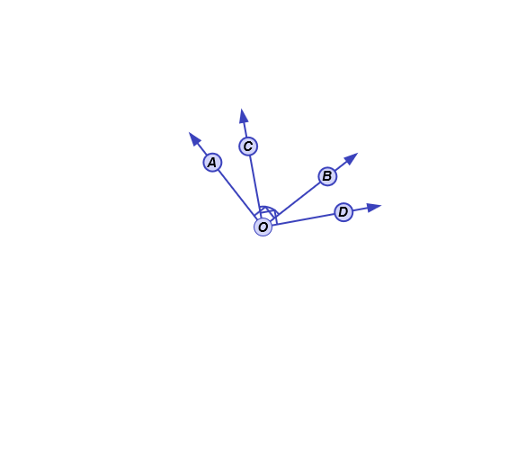

**62°**

1. Suppose ∠*AXB* and ∠*BXC* are complementary and congruent. What are their measures?
2. Suppose ∠*AXB* and ∠*BXC* form a linear pair. If ∠*AXB* is a right angle, what is *m*∠*BXC*?
3. Find the measures ∠*AOC* and ∠*DOB*.

**50°**

**(4*x* + 10)°**

**2*y*°**

1. Find the values of *x* and *y*.