Vocabulary: Isosceles and Equilateral Triangles

Vocabulary
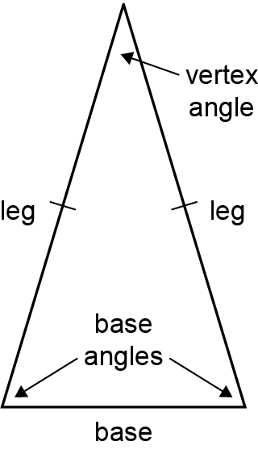
- Base (of an isosceles triangle) – the side of an isosceles triangle that is not congruent to the other two.
- The base is opposite the vertex angle and adjacent to the base angles.

- Base angles – the angles that are adjacent to the base of an isosceles triangle.
- The base angles are opposite the legs.

- Equiangular – having all angles congruent.
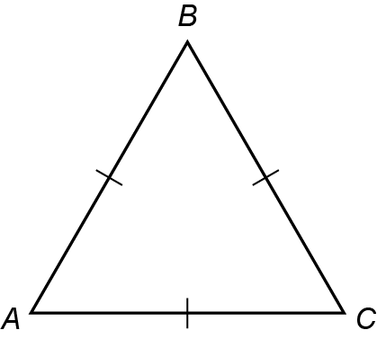
- An equiangular triangle has three 60° angles.

- Equilateral – having all sides congruent.
- An equilateral triangle has three congruent sides.
- For example, ΔABC at the right is equilateral.

- Isosceles – having at least two sides congruent.

- Legs (of an isosceles triangle) – the congruent sides of an isosceles triangle.

- Vertex angle – the angle opposite the base of an isosceles triangle.
- The vertex angle is adjacent to the legs.

