Name: Date:

Student Exploration: Isotopes

Vocabulary: atomic number, band of stability, half-life, isotope, isotope notation, mass number, radioactive, radioisotope

Prior Knowledge Questions (Do these BEFORE using the Gizmo.)

- What particles make up an atom?

- Which of these are found in the nucleus?

- Which particles are charged?

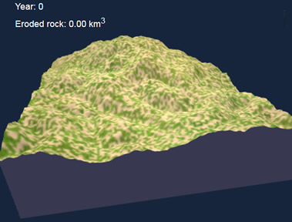
Gizmo Warm-up
You may think that all atoms of an element are the same, but that is not the case. Atoms of an element can come in several different versions. Some of these versions are stable, while others can break down. In the Isotopes Gizmo, you will explore different versions of the elements.

To begin, check that Hydrogen-1 is selected. Check that Show isotope notation is selected.

- Click the up and down arrows for protons and neutrons and notice what changes.

  - Which particle determines the element?

  - Which particle creates a different version of the same element?

Atoms of the same element with different numbers of neutrons are called isotopes.

- Set protons and neutrons to 6.

- Which isotope was created?

- What percentage of the element consists of this isotope?

- Add a neutron. Which isotope do you have now?

- What percentage of the element consists of this isotope?
Activity A:  Isotope notation | Get the Gizmo ready:  - Set protons to 2 and neutrons to 2.  - Check that Show isotope notation is selected. | 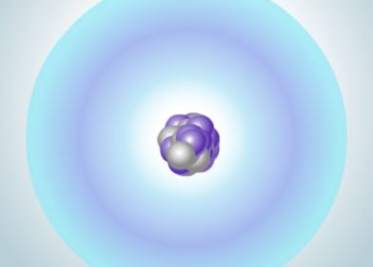

Question: How are isotopes written down?

- Explore: Below the helium atom you see the isotope notation for helium-4. Add and subtract protons and neutrons a few times using the arrow buttons. Notice how the isotope notation changes when you do this.

- What does the top number equal?

- Which particle determines the atomic number?
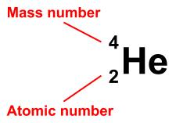
In isotope notation there are two numbers to the left of the element symbol. The top number is the mass number (A). The mass number is the sum of the protons and neutrons. The bottom number is the atomic number (Z). The atomic number is the number of protons.

- Apply: Turn off Show isotope notation. Set protons to 3 and neutrons to 4.

Write this isotope using isotope notation. Check your answer in the Gizmo.

- Observe: Set the protons to 8 and the neutrons to 9.

  - How is the isotope written at the top left of the gray box?

  - What does the number next to the element name indicate?

- Practice: Turn off Show isotope notation. Use what you have learned to fill in the table. When you are finished, check your answers in the Gizmo.
Protons | Neutrons | Mass number | Isotope notation | Symbol
17 |  | 35 |  | Cl
 |  |  | $${}_{\text{1}}^{\text{1}}{ \text{H}}$$
 | 30 | 56 |  | Fe
 |  |  | $${}_{\text{14}}^{\text{31}}{ \text{Si}}$$
95 | 148 |  |  | Am

Activity B:  Band of stability | Get the Gizmo ready:  - On the graph, make sure the x-axis and y-axis range from 0-20. If not, click the [o] zoom control. | 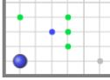

Introduction: Some atoms are stable, while others are radioactive. In a radioactive atom, the nucleus has the potential to break down, or decay, and change into a different element. For example, radon-222 is radioactive. When it decays, its nucleus loses enough protons and neutrons to become polonium-218. Radioactive isotopes are also called radioisotopes.

Question: How can we predict whether an isotope will be stable or radioactive?

- Observe: Use the Gizmo to create a carbon-12 isotope.

  - Is this isotope stable or radioactive?

  - Add a neutron to create carbon-13. Is this isotope stable or radioactive?

  - Add another neutron. Is this isotope stable or radioactive?

  - What is the half-life of this isotope?

The half-life of a radioisotope is the time it takes for 50% of the atoms in a sample to decay. The shorter the half-life, the more unstable the nucleus.

- Collect data: Set protons to 1 and neutrons to 0. Below the graph, click Save point. Notice on the graph the stable isotopes are shown in blue and the radioactive isotopes in green.

Add protons and neutrons and use the Save point button to record data for the first seven elements. Try to find all of the stable isotopes. (Note: You can drag the point direction to any location on the graph.)

  - Do the stable isotopes appear to fall on a line?

  - How many stable isotopes have equal numbers of protons and neutrons?

  - Turn on Show neutron:proton ratio. Drag the blue line until it lines up with most of the blue points. Approximately what n:p ratio do most stable isotopes have?

- Explore: Investigate the different radioactive isotopes you have saved.

- Which radioisotope is most stable, and what is its half-life?

- In general, how does the half-life change as you move farther away from the stable isotopes?
(Activity B continued on next page)
Activity B (continued from previous page)

- Investigate: Next to the graph, click the [–] button once to zoom out. The x- and y-axes should each range from about 0 to 70. Click inside the graph until you have found three or four stable isotopes that have at least 50 protons. Save these points.

  - Which stable isotopes did you find?

  - Do these have approximately equal numbers of neutrons and protons?

  - Turn on Show neutron:proton ratio. Adjust the line until it lines up with the stable isotopes. Approximately what n:p ratio do these isotopes have?

- Analyze: If necessary, continue to save points on the graph until the Show all button activates. When it does, click Show all. Zoom out on the graph until you can see all of the elements. The green area identifies all of the known radioactive isotopes. The blue area shows the stable isotopes. This area is known as the band of stability.

  - How does the slope of the band of stability change as the number of protons increases?
  - If necessary, turn on Show neutron:proton ratio. What is the n:p ratio for the heaviest stable isotopes?
  - Zoom in on the graph and drag the graph until you can see the top end of the band of stability. What is the heaviest stable isotope?
Two main forces are at work in the nucleus of the atom. The strong nuclear force holds protons and neutrons together. At the same time, the electromagnetic force pushes protons apart. As the size of the nucleus increases, the number of neutrons needed to hold the protons together increases faster than the number of protons. Above a certain mass, all atomic nuclei are unstable.

- Apply: Turn off Show all and Show neutron:proton ratio. Predict whether the following isotopes will be stable. Give a reason for each answer. Check your answers in the Gizmo.

- ${}_{8}^{20}{ O}$

- ${}_{20}^{40}{ Ca}$

- ${}_{81}^{203}{ Tl}$

- ${}_{92}^{238}{ U}$

