Vocabulary: Least-Squares Best Fit Lines

Vocabulary
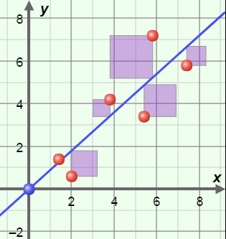
- Least-squares best fit line – a line that estimates the linear relationship between two variables in a scatter plot.
  - The least-squares best fit line is also called the least-squares regression line.
  - The least-squares fit line is the line that minimizes the total sum of the squares of the residuals, as shown by the purple squares in the image to the right.

- Outlier – a value that is significantly different from the other values in a data set.
  - In a scatter plot with a trend line, the outliers are usually the points farthest from the trend line.

- Residual – the difference between an observed value in a data set and its predicted or theoretical value.
  - In a scatter plot with a trend line, the residual of a point is the vertical difference from the data point to the trend line (the difference between y-values).

- Scatter plot – a graph of (x, y) points that shows the general relationship between two variables, x and y.
  - Generally, the variable on the horizontal (x) axis is the independent variable, and the variable on the vertical (y) axis is the dependent variable.

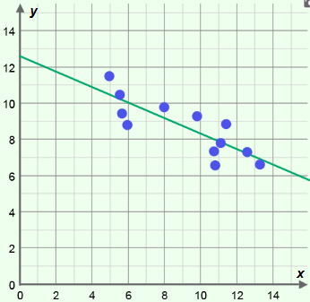
- Trend line – a line that fits the points in a scatter plot well.
trend line
- The slope of the trend line indicates the type of correlation the variables have.
- A positive slope indicates a positive correlation, a negative slope indicates a negative correlation, and a slope of zero indicates no correlation.
- For example, the trend line shown to the right suggests a negative correlation between the variables.

