Name: _____________________________ Date: ________________________

Student Exploration: Levers

Vocabulary: effort, first-class lever, fulcrum, lever, load, mechanical advantage, second-class lever, third-class lever

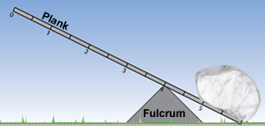
Prior Knowledge Questions
(Do these BEFORE using the Gizmo.)

- A lever is a rigid plank or bar that pivots on a fulcrum. Look at the lever in the picture. Where would you push on the lever to lift the rock?

____________________________________

- Where are some places that you see levers in everyday life? ________________________

_________________________________________________________________________
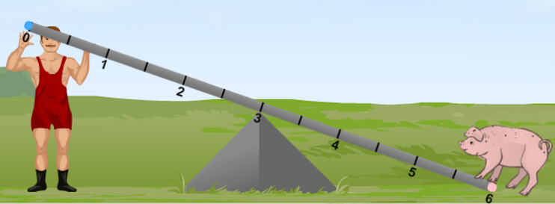

Gizmo Warm-up
In the Levers Gizmo, the strongman tries to lift animals by pushing down or pulling up on the lever. The force of his push or pull is the effort The weight of the animal is the load. Both forces are measured in newtons.
- You can move the fulcrum to the left or right by dragging it.
- You can drag animals to any spot on the lever.
- You can move the strongman by dragging him.
- You can change the strongman’s Effort with the slider.

- Drag the pig to the lever. Try to arrange the lever so that the strongman can lift the pig. What did you do so that he could lift it?

_________________________________________________________________________

- Did the strongman pull up or push down to lift the pig? ______________________________

- How much effort was needed to lift the pig? ______________________________________

Activity A:  First-class levers | Get the Gizmo ready:  - Remove the pig from the lever.  - Drag the turkey onto the lever. | 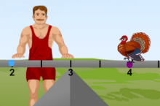

Question: In a first-class lever, the fulcrum is between the effort (strongman) and the load (turkey). How are first-class levers helpful?

- Observe: Place the turkey, strongman, and fulcrum at a variety of positions. Each time, pay attention to the smallest amount of Effort needed to lift the turkey. (Note: In this simulation, the lever itself has no mass.)

- Form hypothesis: When does a lever make it easiest to lift the turkey? _________________

_________________________________________________________________________

- Experiment: Place the fulcrum at position 3, the turkey at position 4, and the strongman at position 2. Slowly increase the Effort until the turkey is lifted.

  - What is the smallest force that can lift the turkey? ___________________________

  - How does this effort compare to the turkey’s weight? _________________________

- Revise and repeat: Move the strongman further away from the fulcrum and lift the turkey.
  - What is the smallest force that can lift the turkey now? ________________________
  - Which moves more, the turkey or the strongman’s hands? _____________________

- Draw conclusions:

  - How does a first-class lever help you lift a turkey? ___________________________

___________________________________________________________________

  - What is the “price” that you pay for using less force? _________________________

___________________________________________________________________

- Predict: What will happen if the turkey is farther from the fulcrum than the strongman?

_________________________________________________________________________

- Test: Check your prediction using the Gizmo. Were you correct? _____________________

Activity B:  Mechanical advantage | Get the Gizmo ready:  - Turn on Show grid.  - Place the fulcrum at position 5.  - Drag the sheep to position 6. | 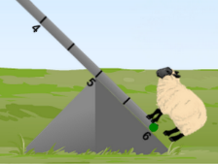

Question: How are forces and distances related?

- Observe: Move the strongman to a few places on the lever and find the smallest effort needed to lift the sheep at each place. What do you notice? _________________________
_________________________________________________________________________

- Form hypothesis: As the strongman gets further from the fulcrum, what happens to the effort needed to lift the sheep? _____________________________________________________

- Experiment: Place the strongman at position 3. He is now 2 meters from the fulcrum. Find the smallest effort needed to lift the sheep. Record it in the table below. Repeat with the strongman at a distance of 3 meters and 4 meters from the fulcrum. (Positions 2 and 1.)

Distance from  fulcrum to sheep | Distance from  Fulcrum to strongman | Smallest effort needed  to lift a 1200 N sheep
1 meter | 2 meters
1 meter | 3 meters
1 meter | 4 meters

- Analyze: When the strongman’s distance from the fulcrum is doubled (like from 2 m to 4 m), what happens to his effort needed to lift the sheep? ________________________________

- Calculate: The mechanical advantage of a lever is how much it multiplies your effort. If you can lift a 1200-N sheep with only 600 N of effort, the lever doubled your effort, so its mechanical advantage is 2. (Notice you can just divide load by effort: 1200 ÷ 600 = 2.)

Calculate the mechanical advantage of the lever with the strongman at each distance:

2 meters: _______________ 3 meters: _______________ 4 meters: _______________

- Predict: What force will the strongman need when he’s 5 m from the fulcrum? ___________

Test your prediction using the Gizmo. Were you correct? ____________________________
Activity C:  Second- and third-class levers | Get the Gizmo ready:  - Place the fulcrum at position 6. | 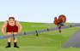

Question: So far, you have studied first-class levers. How do other kinds of levers work?

- Set up Gizmo: In a second-class lever, the load is between the fulcrum and the effort. Set up a second-class lever with the turkey between the fulcrum and the strongman.

- Run Gizmo: Find the smallest effort to lift the turkey using a second-class lever. How does this effort compare to the load? ________________________________________________

- Observe: Does the strongman push this lever up or down to lift the turkey? _____________

- Experiment: With the fulcrum still at position 6, put the turkey at position 3 and the strongman at position 0. Find the smallest force needed to lift the turkey.

  - What was the force needed to lift the 100-N turkey? __________________________

  - What is the mechanical advantage of this lever? ____________________________

- Set up Gizmo: In a third-class lever, the effort is between the fulcrum and the load. Set up a third-class lever with the strongman between the turkey and the fulcrum.

- Run Gizmo: Find the smallest effort to lift the turkey using a third-class lever.
  - Is the effort larger or smaller than the load? ________________________________
  - How far was the turkey lifted relative to the strongman’s hands? ________________
___________________________________________________________________

- Predict: Do you think you can lift the pig with a second-class lever? ___________________
How about a third-class lever? ________________________________________________

- Challenge: Try to lift the pig using second-class and third-class levers. Describe your results.

_________________________________________________________________________

_________________________________________________________________________

