Name: Date:

Student Exploration: Solving Linear Systems (Standard Form)

Vocabulary: elimination method, solution, standard form, substitution method,
system of linear equations

Prior Knowledge Questions (Do these BEFORE using the Gizmo.)

- The point (3, 1) is on the line whose equation is 2x + y = c. What is the value of c?

- The point (3, 1) is also on the line whose equation is x – 2y = d. What is the value of d?

- Do you think the lines have any other points in common? Explain.

Gizmo Warm-up
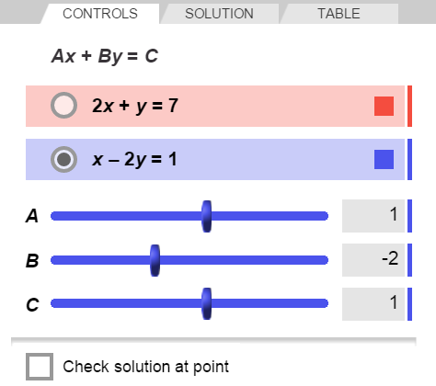
The equations 2x + y = 7 and x – 2y = 1 form a system of linear equations in standard form (Ax + By = C, where A, B, and C are real numbers, and A and B are not both zero). In the Solving Linear Systems (Standard Form) Gizmo, you can use graphing or algebra to solve such systems.

On the CONTROLS tab, select the top equation. Set A to 2, B to 1, and C to 7 to graph 2x + y = 7. Then select the bottom equation. Set A to 1, B to –2, and C to 1 to graph x – 2y = 1. (To quickly set the value of a slider, type the number into the text box to the right of the slider and press Enter.)

- The solution of an equation contains the value or values that make the equation true. Select Check solution at point. Drag the green point to (5, 2).

Is (5, 2) a solution of both 2x + y = 7 and x – 2y = 1? Explain.

- Drag the green point to (1, 5). Is (1, 5) a solution of both equations?

- Drag the green point to the purple point. Is (3, 1) a solution of both equations?

Activity A:  Using substitution | Get the Gizmo ready:  - On the CONTROLS tab, turn off Check solution at point. | 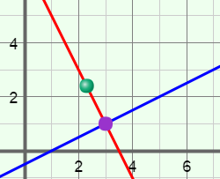
You can use algebra to solve two equations in two variables by reducing the equations to one equation in one variable. One way to do this is to use the substitution method.

- Consider the system 2x + y = 7 and x – 2y = 1.

- Solve 2x + y = 7 for y. What does y equal? y =
x – 2( ) = 1

- In the space to the right, substitute the expression for y into x – 2y = 1 and solve the equation for x.

- In the space to the right, substitute the x-value you found above into either equation and solve for y.

- What is the solution of this system of equations? ( , )

Graph 2x + y = 7 and x – 2y = 1 in the Gizmo. Then select the SOLUTION tab and choose Substitution to check your work.

- Why do you think this method is called substitution?

- Consider the system of equations x + y = 2 and x + 3y = –6.

- Solve x + y = 2 for either variable. Then use the substitution method to solve the system. Show your work to the right. Check your answer in the Gizmo.

- Solve x + 3y = –6 for x. Then use the substitution method to solve the system. Show your work to the right.

- Does it matter which equation in the system you solve for a variable first?

Activity B:  Using elimination | Get the Gizmo ready:  - On the CONTROLS tab, turn off Check solution at point. | 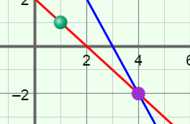

- One way to solve a system of linear equations algebraically is to use the elimination method. Consider the system of equations x – y = 3 and 2x + y = 6.

- The second equation above states that 2x + y is equal to 6. So, if you take the first equation (x – y = 3) and add 2x + y to the left side, and add 6 to the right side, you are adding equal quantities to each side. This means you still have a true equation.
x – y = 3
2x + y = 6

In the space to the right, add the two equations and solve the resulting equation. Notice what happens to y.

Why do you think this method is called elimination?

- In the space to the right, substitute the x-value you found above into either equation and solve for y.

In the Gizmo, graph the equations on the CONTROLS tab. Then select the SOLUTION tab and choose Elimination to check your work.

- Consider the system of equations 2x + 3y = 4 and x + 4y = –3.

- Multiply each side of the equation x + 4y = –3 by –2.

- How do you think the solution of the system 2x + 3y = 4 and x + 4y = –3 compares to that of the system 2x + 3y = 4 and –2x – 8y = 6?
Explain.

- In the space to the right, add
–2x – 8y = 6 to 2x + 3y = 4. Then solve the resulting equation.

- In the space to the right, solve for x. Check your answer in the Gizmo.

(Activity B continued on next page)
Activity B (continued from previous page)

- Consider the system of equations 3x + 2y = –7 and 2x – 5y = 8.

  - Suppose you want to add the equations to eliminate y. By what numbers should you multiply each equation?
  - Multiply each equation by the numbers above. Then solve the system. Show your work to the right.

  - At what point do you think the graphs of these equations intersect? ( , )

Check your answer in the Gizmo.

- Consider the system of equations 4x – 7y = –4 and 4x – 7y = 5.

- Do you think this system has a solution? Explain.

- Select the CONTROLS tab and graph this system. How are the lines related?

- Use elimination to solve this system. Show your work. Check in the Gizmo.

- How does this result tell you there is no solution?

- Graph the system of equations x – 2y = –2 and 3x – 6y = –6 in the Gizmo.

- How are the graphs related?

- Use elimination to solve this system. Show your work. Check in the Gizmo.

- How does this result tell you there are infinitely many solutions?

Activity C:  Practice solving systems | Get the Gizmo ready:  - Select the CONTROLS tab. | 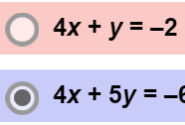

- Consider the system of equations 4x + y = –2 and 4x + 5y = –6.

- Would you use the substitution method or the elimination method to solve this system algebraically? Why?

- Use the method of your choice to solve the system in the space to the right. Then graph the system in the Gizmo. Select the SOLUTION tab and check your answer.

- You can use the substitution method or the elimination method to solve any system of linear equations. However, in some cases, one method might be a little easier than the other.

Fill in the table below with a system of linear equations you would solve using substitution, and a system you would solve using elimination. Explain why you would use the chosen method to solve each system. Then solve each system and check in the Gizmo.

 | Easier method: Substitution | Easier method: Elimination
System of equations
Explanation (Why is this method easier?)
Solution

(Activity C continued on next page)
Activity C (continued from previous page)

- Use substitution or elimination to solve each system. Show your work below each system. Check your answer in the Gizmo.

- x + y = –1
x – y = 3 Solution:

- 3x – 2y = 3
x + 2y = 1 Solution:

- 4x + y = 3
3x – 2y = 5 Solution:

- 2x + 5y = –6
3x + 2y = 2 Solution:

- 6x – 8y = 3
6x – 8y = –3 Solution:

- 2x + 4y = –4
x + 2y = –2 Solution:

