Vocabulary: Solving Linear Systems (Standard Form)

Vocabulary

- Elimination method – an algebraic method for solving systems of equations that involves adding or subtracting the two equations to eliminate one of the variables.

- Solution – a value or values that make an equation or system of equations true.
- For example, (2, 7) is a solution of the equation y = 3x + 1 because it makes the equation true: 7 = 3(2) + 1.

- Standard form (of a linear equation) – a linear equation of the form Ax + By = C, where A, B, and C are real numbers, and A and B are not both zero.

- Substitution method – an algebraic method for solving systems of equations that involves solving one equation for a variable and substituting the resulting expression into the other equation.

- System of linear equations – a set of two or more linear equations that contain the same variables.
- A system of linear equations can have one solution, no solution, or infinitely many solutions, as shown below:
Graph | Intersecting lines  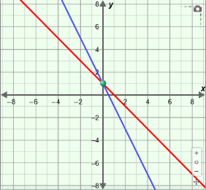 | Same line  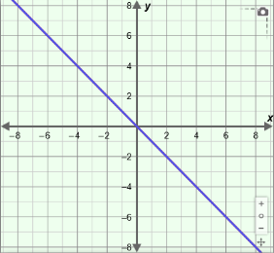 | Parallel lines  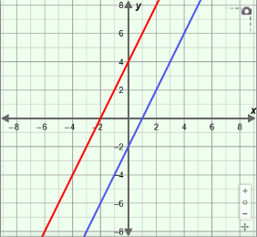
Number of solutions | exactly one | infinitely many | none
Type of system | consistent and independent | consistent and dependent | inconsistent

